

**DATABASES**

October 2023 -- February 2024

**SCHOOL OF INFOCOMM TECHNOLOGY**

Diploma in Information Technology

Diploma in Data Science

**Databases Assignment**

**(40 % of DB Module)**

**8 Jan 2024 – 28 Jan 2024 (3 Weeks)**

|  |  |  |  |  |  |
| --- | --- | --- | --- | --- | --- |
| Deliverables | | Deadline | | Submission | |
| Softcopy | | Sunday 28 Jan 2024, 23:59 pm | | BrightSpace Assignment  Submission link | |
| Hardcopy | | Monday 29 Jan 2024, 10:00 am | | Blk 31 Level 8 (Admin  Office),  Pigeon-holes (Databases) | |
| DB Class Group | | | T03 | |  |
| Team Number | | | Group 1 | | Team Grade: |
| Tutor | | | Mr Andy Tan | |  |
| Members | Student No. | | Student Name | | Individual Grade |
| 1 | | Yeo Jin Rong (S10258457) | |  |
| 2 | | Liang Dingxuan(S10258272) | |  |
| 3 | | Ng Jing Zhan Garrett (S10257347) | |  |
| 4 | | Ng Kai Huat Jason (S10262552) | |  |

**Introduction:** 3

**ER Model:** 3

ER-Map Changes: 3

List of Mapped Relations: 5

Data Dictionary: 6

Listing of SQL Commands for Table Creation: 33

Data Definition Language: 33

Data Manipulation Language: 42

Content of all the Tables: 53

List of SQL Queries and Result Sets: 65

Assumptions: 90

Generalised Assumptions: 90

Entity-Related Assumptions: 90

Conclusion: 97

Appendix A: 98

Appendix B: 100

Appendix C: 111

Appendix D 132

Appendix E 144

# **Introduction:**

MyCondoApp is equipped with a sophisticated database architecture designed to cater to distinct account types, each aligned with the specific roles within the condominium community. The account classifications include Condo Management, Owners, and Tenants, reflecting their unique responsibilities and access levels. All account registrations undergo a meticulous approval process facilitated by the dedicated staff of MyCondoApp, ensuring a secure and controlled environment.

Users within the MyCondoApp ecosystem possess the capability to seamlessly reserve facilities by leveraging designated time slots through a robust booking system. Furthermore, they can provide valuable feedback, meticulously categorized for streamlined analysis. The platform facilitates the application process for both permanent and temporary vehicle labels, enhancing parking management within the condominium premises.

An integral feature of MyCondoApp is the messaging system, allowing users to disseminate information and engage with the community. Messages encompass a variety of content, including announcements, as well as specialized Garage Sale postings. These sale messages are structured to include related items, meticulously sorted by category and complemented by vivid item photos, fostering a dynamic and interactive marketplace within the condominium community.

Condo Managers wield the ability to disseminate official announcements through the MyCondoApp, ensuring efficient communication with the residents. Complementing these functionalities is a comprehensive list of useful contacts, curated to enhance the overall experience and support residents in navigating various aspects of condominium living.

In essence, the MyCondoApp database is a sophisticated and integral component, meticulously designed to empower users, streamline community interactions, and elevate the overall condominium living experience.

# **ER Model:**

## ER-Map Changes:

* SlotStatus modified to appropriately represent the status of the BookSlot, SlotStatus now can only ‘A’, ‘B’, ‘M’ or ‘R’, standing for Available, Booked, Maintenance or Reserved respectively, hence cannot be NULL value to ensure that there is accountability for BookSlots
* Added derived attributes in these tables:
  + TempDuration in table TempVehLabel that represents duration between TempStartDate and TempEndDate
  + AnnDuration in table Announcement that represents duration between AnnStartDate and AnnEndDate
  + ContractDuration in table Tenant that represents duration between ContractStartDate and ContractEndDate
  + EmploymentDuration in table Staff that represents duration between current date and StaffDateJoined
  + FbkDuration in table Feedback that represents duration between current date and FbkDateTime

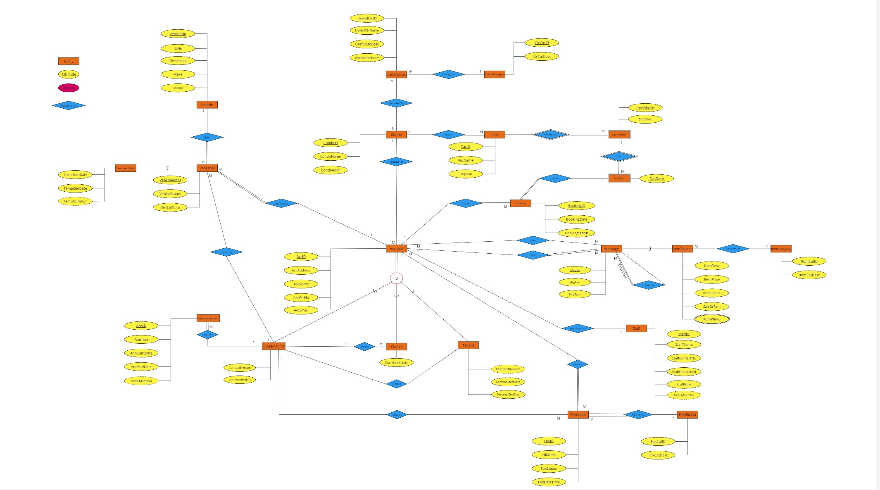

# List of Mapped Relations:

1. Account (AccID, AccName, AccAddress, AccCtcNo, AccEmail, <CondoID>, <ApprovedBy>)
2. Announcement (AnnID, AnnText, AnnStartDate, AnnEndDate, <CondoMgmtID>)
3. Booking (BookingID, BookingDate, BookingStatus, <AccID>, <FacID, TimeSlotSN, SlotDate>)
4. BookSlot(<FacID, TimeSlotSN>, SlotDate, SlotStatus)
5. Condo (CondoID, CondoName, CondoAddress)
6. CondoMgmt (<CondoMgmtID>, ContactPerson, CtcPersonMobile)
7. CondoUsefulContact (<CondoID>, <UsefulCtcID>)
8. ContactCat (CtcCatID, CtcCatDesc)
9. Facility (FacID, FacName, Deposit, <CondoID>)
10. FacTimeSlot (<FacID>, TimeSlotSN, SlotDesc)
11. Feedback (FbkID, FbkDesc, FbkDateTime, FbkStatus, <ByAccID>, <FbkCatID>, <CondoMgmtID>)
12. FeedbkCat (FbkCatID, FbkCatDesc)
13. ItemCategory (ItemCatID, ItemCatDesc)
14. ItemPhoto (<ItemID>, Photo)
15. ItemRelated (<ItemID>, ItemDesc, ItemPrice, ItemStatus, SaleOrRent, <ItemCatID>)
16. Likes ( <AccID>, <MessageID>)
17. Message (MsgID, MsgText, MsgType, <PostedBy>, <ReplyTo>)
18. Owner (<OwnerID>, OwnStartDate, <CheckedBy>)
19. Staff (StaffID, StaffName, StaffContactNo, StaffDateJoined, StaffRole)
20. TempVehLabel (<VehLblAppID>, TempStartDate, TempExpiryDate)
21. Tenant (<TenantID>, ContractStartDate, ContractEndDate, <VerifiedBy>)
22. UsefulContact (UsefulCtcID, UsefulCtcName, UsefulCtcDesc, UsefulCtcPhone, <CtcCatID>)
23. Vehicle (VehicleNo, IUNo, Ownership, Make, Model)
24. VehicleLabel (VehLblAppID, VehLblStatus, VehLblNum, <VehicleNo>,<AppliedBy>, <IssuedBy>)

# Data Dictionary:

Table 1: **Account**

Description: Stores the details of an account holder.

|  |  |  |  |  |
| --- | --- | --- | --- | --- |
| **Attribute** | **Description** | **Data Type** | **Constraint** | **Null Value** |
| AccID | Unique account ID | char(7) | Primary Key  ID must follow format of AC[0-9][0-9][0-9][0-9][A-Z], an example will be “AC0001A” | No |
| AccName | The name of the account holder | varchar(30) |  | No |
| AccAddress | The home address of the account holder | varchar(100) |  | No |
| AccCtcNo | The contact number of  the account holder | char(10) | Unique  Starts with 65 followed by 8 numerical numbers | Yes |
| AccEmail | The email address of the account holder | varchar(50) | Unique | Yes |
| CondoID | The condo that the account is related to | char(7) | Foreign Key -> Condo (CondoID)  CD[0-9][0-9][0-9][0-9][A-Z], an example will be “CD0001A” | No |
| ApprovedBy | The staff ID of MyCondo  staff who approves the account | varchar(30) | Foreign Key > Staff (StaffID)  ST[0-9][0-9][0-9][0-9][A-Z], an example will be “ST0001A” | Yes |

Table 2: **Announcement**

Description: Stores the details of an announcement.

|  |  |  |  |  |
| --- | --- | --- | --- | --- |
| **Attribute** | **Description** | **Data Type** | **Constraint** | **Null Value** |
| AnnID | Unique announcement ID | char(7) | Primary Key  ID must follow format of AN[0-9][0-9][0-9][0-9][A-Z], an example will be “AN0001A” | No |
| AnnText | The text message of the announcement | varchar(1000) |  | No |
| AnnStartDate | The date when the announcement starts | smalldatetime |  | No |
| AnnEndDate | The date when the announcement ends | smalldatetime | Date must be later than AnnStartDate | No |
| CondoMgmtID | The account ID of the condo management who put the announcement | char(7) | Foreign Key -> CondoMgmt (CondoMgmtID)  ID must follow format of AC[0-9][0-9][0-9][0-9][A-Z], an example will be “AC0001A” | No |

Table 3: **Booking**

Description: Stores the details of a booking.

|  |  |  |  |  |
| --- | --- | --- | --- | --- |
| **Attribute** | **Description** | **Data Type** | **Constraint** | **Null Value** |
| BookingID | Unique booking ID | char(7) | Primary Key  ID must follow format of BK[0-9][0-9][0-9][0-9][A-Z], an example will be “BK0001A” | No |
| BookingDate | The date when the booking is made | varchar(20) |  | No |
| BookingStatus | The status of the booking (eg. Pending Payment, Confirmed, Cancelled) | varchar(100) | Values available:  'Pending Payment', 'Confirmed', 'Cancelled' | No |
| AccID | The account ID of the person who makes the  booking | char(7) | Foreign Key -> Account (AccID)  AC[0-9][0-9][0-9][0-9][A-Z], an example will be “AC0001A” | No |
| FacID | The facility ID that is being booked | char(7) | Foreign Key -> BookSlot(FacID, TimeSlotSN, SlotDate)  FC[0-9][0-9][0-9][0-9][A-Z], an example will be “FC0001A” | Yes |
| TimeSlotSN | The facility's time slot number that is being booked | integer | Foreign Key -> BookSlot(FacID, TimeSlotSN, SlotDate) | Yes |
| SlotDate | The date when the facility time slot is being booked | smalldatetime | Foreign Key -> BookSlot (FacID, TimeSlotSN, SlotDate) | Yes |

Table 4: **BookSlot**

Description: Stores the details of dates that facility time slots can be booked.

|  |  |  |  |  |
| --- | --- | --- | --- | --- |
| **Attribute** | **Description** | **Data Type** | **Constraint** | **Null Value** |
| FacID | Unique facility ID that has the time slot | char(7) | Primary Key  Foreign Key ->  FacTimeSlot (FacID, TimeSlotSN)  ID must follow format of FA[0-9][0-9][0-9][0-9][A-Z], an example will be “FA0001A” | No |
| TimeSlotSN | The sequence number of a time slot (eg. 1, 2, …) | integer | Primary Key  Foreign Key -> FacTimeSlot (FacID, TimeSlotSN) | No |
| SlotDate | The date when the  facility time slot can be booked | smalldatetime | Primary Key | No |
| SlotStatus | The status of the slot (Eg. Available, Booked, Maintenance or Reserved) | char(1) | Values available: 'A', 'B', 'M' and ‘R’ | No |

Table 5: **Condo**

Description: Stores the details of a condominium project.

|  |  |  |  |  |
| --- | --- | --- | --- | --- |
| **Attribute** | **Description** | **Data Type** | **Constraint** | **Null Value** |
| CondoID | Unique condo ID | char(7) | Primary Key  ID must follow format of CD[0-9][0-9][0-9][0-9][A-Z], an example will be “CD0001A” | No |
| CondoName | The name of the condo | varchar(50) |  | Yes |
| CondoAddress | The address of the condo | varchar(100) |  | Yes |

Table 6: **CondoMgmt**

Description: A subtype of Account: stores the additional account details for a condo management company.

|  |  |  |  |  |
| --- | --- | --- | --- | --- |
| **Attribute** | **Description** | **Data Type** | **Constraint** | **Null Value** |
| CondoMgmtID | The account ID of the company (or its staff)  that manages a condo | char(7) | Primary Key  Foreign Key -> Account (AccID)  ID must follow format of AC[0-9][0-9][0-9][0-9][A-Z], an example will be “AC0001A” | No |
| ContactPerson | The contact person of the condo management company | varchar(20) |  | Yes |
| CtcPersonMobile | The mobile number of the contact person | char(10) | Unique  Starts with 65 followed by 8 numerical numbers | No |

Table 7: **CondoUsefulContact**

Description: Stores the details of a condo's useful contact, Useful contacts usually are businesses near the condo.

|  |  |  |  |  |
| --- | --- | --- | --- | --- |
| **Attribute** | **Description** | **Data Type** | **Constraint** | **Null Value** |
| CondoID | Unique ID of a condo | char(7) | Primary Key  Foreign Key -> Condo (CondoID)  ID must follow format of CD[0-9][0-9][0-9][0-9][A-Z], an example will be “CD0001A” | No |
| UsefulCtcID | Unique ID of a condo's useful contact | char(7) | Primary Key  Foreign key -> UsefulContact (UsefulCtcID)  ID must follow format of UC[0-9][0-9][0-9][0-9][A-Z], an example will be “UC0001A” | No |

Table 8: **ContactCategory**  
Description: Stores the details of a category that a useful contact can belong to.

|  |  |  |  |  |
| --- | --- | --- | --- | --- |
| **Attribute** | **Description** | **Data Type** | **Constraint** | **Null Value** |
| CtcCatID | Unique category ID of a useful contact | char(7) | Primary Key  ID must follow format of CC[0-9][0-9][0-9][0-9][A-Z], an example will be “CC0001A” | No |
| CtcCatDesc | The description of a useful contact category | varchar(100) |  | No |

Table 9: **Facility**

Description: Entity Stores the details of a condo facility.

|  |  |  |  |  |
| --- | --- | --- | --- | --- |
| **Attribute** | **Description** | **Data Type** | **Constraint** | **Null Value** |
| FacID | Unique category ID of a useful contact | char(7) | Primary Key  ID must follow format of FA[0-9][0-9][0-9][0-9][A-Z], an example will be “FA0001A” | No |
| FacName | The name or description of the facility (Eg. Tennis Court, BBQ Pit, Function Room) | varchar(100) |  | No |
| Deposit | The amount of deposit required to book the facility, if any | smallmoney |  | No |
| CondoID | The condo where the facility is located in | char(7) | Foreign Key -> Condo (CondoID)  ID must follow format of CD[0-9][0-9][0-9][0-9][A-Z], an example will be “CD0001A” | No |

Table 10: **FacTimeSlot**

Description: Stores the details of a time slot that is scheduled by a facility for booking purpose

|  |  |  |  |  |
| --- | --- | --- | --- | --- |
| **Attribute** | **Description** | **Data Type** | **Constraint** | **Null Value** |
| FacID | Unique category ID of a useful contact | char(7) | Primary Key  Foreign Key -> Facility (FacID)  ID must follow format of FA[0-9][0-9][0-9][0-9][A-Z], an example will be “FA0001A” | No |
| TimeSlotSN | The sequence number of a time slot (eg. 1, 2, ...) | integer | Primary Key | No |
| SlotDesc | The time slot's description, eg. Morning, Afternoon, 9am - 10am, 2pm – 4pm | varchar(100) |  | No |

Table 11: **Feedback**

Description: Stores the details of a feedback from an account holder

|  |  |  |  |  |
| --- | --- | --- | --- | --- |
| **Attribute** | **Description** | **Data Type** | **Constraint** | **Null Value** |
| FbkID | Unique feedback ID | char(7) | Primary Key  ID must follow format of FB[0-9][0-9][0-9][0-9][A-Z], an example will be “FB0001A” | No |
| FbkDesc | The description/text of the feedback | varchar(2000) |  | No |
| FbkDateTime | The date and time when the feedback is sent | smalldatetime |  | No |
| FbkStatus | The status of the feedback (eg. Sent, In Progress, Attended) | varchar(15) | Values available:  'Sent', 'In Progress', 'Attended' | No |
| ByAccID | The account ID of the person who sends the feedback | char(7) | Foreign Key -> Account (AccID)  ID must follow format of AC[0-9][0-9][0-9][0-9][A-Z], an example will be “AC0001A” | No |
| FbkCatID | The category ID that the feedback is grouped under | char(7) | Foreign Key -> FbkCat (FbkCatID)  ID must follow format of FC[0-9][0-9][0-9][0-9][A-Z], an example will be “FC0001A” | No |
| CondoMgmtID | The account ID of the condo management staff who handles the feedback | char(7) | Foreign Key -> CondoMgmt (CondoMgmtID)  ID must follow format of AC[0-9][0-9][0-9][0-9][A-Z], an example will be “AC0001A” | Yes |

Table 12: **FeedbkCat**

Description: Stores the details of a feedback category

|  |  |  |  |  |
| --- | --- | --- | --- | --- |
| **Attribute** | **Description** | **Data Type** | **Constraint** | **Null Value** |
| FbkCatID | Unique feedback category ID | char(7) | Primary Key  ID must follow format of FC[0-9][0-9][0-9][0-9][A-Z], an example will be “FC0001A” | No |
| FbkCatDesc | The description of a feedback category (eg. Cleanliness, Security, Plumbing, Building defects, etc) | varchar(20) | Values available: 'Cleanliness', 'Security', 'Plumbing', 'Building Defects', 'Others' | No |

Table 13: **ItemCategory**

Description: Stores the details of a category of item posted by an account holder

|  |  |  |  |  |
| --- | --- | --- | --- | --- |
| **Attribute** | **Description** | **Data Type** | **Constraint** | **Null Value** |
| ItemCatID | Unique item category ID | char(7) | Primary Key  ID must follow format of IC[0-9][0-9][0-9][0-9][A-Z], an example will be “IC0001A” | No |
| ItemCatDesc | The description of an  item category (eg. Homeware, Fashion, Furniture, Electronics, etc) | varchar(20) | Values available:  'Homeware', 'Fashion', 'Furniture', 'Electronics', 'Others' | No |

Table 14: **ItemPhoto**

Description: Stores the photos of an item

|  |  |  |  |  |
| --- | --- | --- | --- | --- |
| **Attribute** | **Description** | **Data Type** | **Constraint** | **Null Value** |
| ItemID | Unique item ID | char(7) | Primary Key  Foreign Key -> ItemRelated (ItemID)  ID must follow format of MI[0-9][0-9][0-9][0-9][A-Z], an example will be “MI0001A” | No |
| Photo | A photo of the item (note: don't need to include actual photo, but just put  text "photo 1", "photo 2", etc) | varchar(100) | Primary Key | No |

Table 15: **ItemRelated**

Description: A subtype of Message: stores the additional details which are related to an item

|  |  |  |  |  |
| --- | --- | --- | --- | --- |
| **Attribute** | **Description** | **Data Type** | **Constraint** | **Null Value** |
| ItemID | Unique message ID that is item related | char(7) | Primary Key  Foreign Key -> Message (MsgID)  MI must follow format of IT[0-9][0-9][0-9][0-9][A-Z], an example will be “MI0001A” | No |
| ItemDesc | The description of the item | varchar(100) |  | No |
| ItemPrice | The price of the item | smallmoney |  | No |
| ItemStatus | The status of the item (eg. Available, Sold) | varchar(15) | Values available will be 'Available', 'Sold' | No |
| SaleOrRent | Is the item for sale or for rent? (eg. For Sale, For Rent) | varchar(10) | Values available will be 'For Sale' or 'For Rent' | No |
| ItemCatID | The category ID that the item belongs to | char(7) | Foreign Key -> ItemCategory (ItemCatID)  ID must follow format of IC[0-9][0-9][0-9][0-9][A-Z], an example will be “IC0001A” | Yes |

Table 16: **Likes**

Description: Stores the details of who likes which message posted by others

|  |  |  |  |  |
| --- | --- | --- | --- | --- |
| **Attribute** | **Description** | **Data Type** | **Constraint** | **Null Value** |
| AccID | Unique account ID | char(7) | Primary Key  Foreign Key - > Account (AccID)  ID must follow format of AC[0-9][0-9][0-9][0-9][A-Z], an example will be “AC0001A” | No |
| MessageID | The message ID that is liked by this account holder | char(7) | Primary Key  Foreign Key -> Message (MsgID)  ID must follow format of MI[0-9][0-9][0-9][0-9][A-Z], an example will be “MI0001A” | No |

Table 17: **Message**

Description: Stores the details of a message posted by an account holder

|  |  |  |  |  |
| --- | --- | --- | --- | --- |
| **Attribute** | **Description** | **Data Type** | **Constraint** | **Null Value** |
| MsgID | Unique message ID | char(7) | Primary Key  ID must follow format of MI[0-9][0-9][0-9][0-9][A-Z], an example will be “MI0001A” | No |
| MsgText | The message text | varchar(100) |  | No |
| MsgType | The type of a message (eg. Chatterbox, Garage Sale, Find a Buddy). Item related message is Garage Sale | varchar(20) | Values available will be 'CB', 'GS', 'FB' | No |
| PostedBy | The account ID of the person who posts this message | char(7) | Foreign Key -> Account (AccID)  ID must follow format of AC[0-9][0-9][0-9][0-9][A-Z], an example will be “ACI0001A” | No |
| ReplyTo | The message ID that is being replied to by this message (it is NULL if this message is not a reply/response) | char(7) | Foreign Key -> Account (AccID)  ID must follow format of AC[0-9][0-9][0-9][0-9][A-Z], an example will be “AC0001A” | Yes |

Table 18: **Owner**

Description: A subtype of Account: stores the additional account details of a condo unit owner.

|  |  |  |  |  |
| --- | --- | --- | --- | --- |
| **Attribute** | **Description** | **Data Type** | **Constraint** | **Null Value** |
| OwnerID | Unique account ID of a condo unit owner | char(7) | Primary Key  Foreign Key -> Account (AccID)  ID must follow format of AC[0-9][0-9][0-9][0-9][A-Z], an example will be “AC0001A” | No |
| OwnStartDate | The date when this owner starts owning the condo unit | smalldatetime | OwnStartDate must not be past current date | No |
| CheckedBy | The account ID of the condo management staff who verifies the validity of ownership | char(7) | Foreign Key -> CondoMgmt (CondoMgmtID)  ID must follow format of AC[0-9][0-9][0-9][0-9][A-Z], an example will be “AC0001A” | Yes |

Table 19: **Staff**

Description: Staff Stores the details of a staff who manages the MyCondo system

|  |  |  |  |  |
| --- | --- | --- | --- | --- |
| **Attribute** | **Description** | **Data Type** | **Constraint** | **Null Value** |
| StaffID | Unique staff ID | char(7) | Primary Key  ID must follow format of ST[0-9][0-9][0-9][0-9][A-Z], an example will be “ST0001A” | No |
| StaffName | The name of this MyCondo staff | varchar(30) |  | No |
| StaffContactNo | The contact number of the MyCondo staff | char(10) | Unique  Starts with 65 followed by 8 numerical numbers | No |
| StaffDateJoined | The start date when this staff joined MyCondo | smalldatetime | StaffDateJoined must not be past current date | No |
| StaffRole | The role of this MyCondo staff (eg. Admin, Customer Service, Tech Support) | varchar(20) | Values available will be 'Admin', 'Customer Service', 'Tech Support' | No |

Table 20: **TempVehLabel**

Description: A subtype of VehicleLabel: stores the additional details for a temporary vehicle label application

|  |  |  |  |  |
| --- | --- | --- | --- | --- |
| **Attribute** | **Description** | **Data Type** | **Constraint** | **Null Value** |
| VehLblAppID | Unique application ID for a temporary vehicle label | char(7) | Primary Key  Foreign Key -> VehicleLabel (VehLblAppID)  ID must follow format of VL[0-9][0-9][0-9][0-9][A-Z], an example will be “VL0001A” | No |
| TempStartDate | The start date of the parking permit | smalldatetime |  | No |
| TempEndDate | The expiry date of the parking permit | smalldatetime | Date must be later than TempStartDate | No |

Table 21: **Tenant**

Description: A subtype of Account: stores the additional details of a tenant

|  |  |  |  |  |
| --- | --- | --- | --- | --- |
| **Attribute** | **Description** | **Data Type** | **Constraint** | **Null Value** |
| TenantID | Unique account ID of a tenant | char(7) | Primary Key  Foreign Key -> Account (AccID)  ID must follow format of AC[0-9][0-9][0-9][0-9][A-Z], an example will be “AC0001A” | No |
| ContractStartDate | The start date of the tenancy contract | smalldatetime |  | No |
| ContractEndDate | The end date of the tenancy contract | smalldatetime | Date must be later than ContractEndDate | No |
| VerifiedBy | The account ID of the condo management staff who verifies the validity of tenancy | char(7) | Foreign Key -> CondoMgmt (CondoMgmtID)  ID must follow format of AC[0-9][0-9][0-9][0-9][A-Z], an example will be “AC0001A” | Yes |

Table 22: **UsefulContact**

Description: Stores the details of a useful contact of a condo. Useful contacts usually are businesses near the condo.

|  |  |  |  |  |
| --- | --- | --- | --- | --- |
| **Attribute** | **Description** | **Data Type** | **Constraint** | **Null Value** |
| UsefulCtcID | Unique useful contact ID | char(7) | Primary Key  ID must follow format of UC[0-9][0-9][0-9][0-9][A-Z], an example will be “UC0001A” | No |
| UsefulCtcName | The name of a useful contact | varchar(50) |  | No |
| UsefulCtcDesc | The description of a useful contact | varchar(100) |  | Yes |
| UsefulCtcPhone | The phone number of a useful contact | char(10) | Unique  Starts with 65 followed by 8 numerical numbers | No |
| CtcCatID | The contact category ID that this useful contact belongs to | char(7) | Foreign Key -> ContactCat (CtcCatID)  ID must follow format of CC[0-9][0-9][0-9][0-9][A-Z], an example will be “CC0001A” | Yes |

Table 23: **Vehicle**

Description: Stores the details of a vehicle

|  |  |  |  |  |
| --- | --- | --- | --- | --- |
| **Attribute** | **Description** | **Data Type** | **Constraint** | **Null Value** |
| VehicleNo | Unique vehicle number | char(8) | Primary Key  S[A-Z][A-Z][0-9][0-9][0-9][0-9][A-Z], an example will be “SAB1234C” | No |
| IUNo | The IU number of the vehicle | char(10) | 10-Digit Number | Yes |
| Ownership | The ownership of the vehicle (eg. Own, Rented, Company Car, Others) | varchar(30) | Values available 'Own', 'Rent', 'Company', 'Others' | No |
| Make | The make of the vehicle (eg. Toyota, Honda, Proton) | varchar(30) |  | No |
| Model | The model of the vehicle (eg. Crown, Altis, Saga) | varchar(30) |  | No |

Table 24: **VehLabel**

Description: Stores the details of a vehicle label

|  |  |  |  |  |
| --- | --- | --- | --- | --- |
| **Attribute** | **Description** | **Data Type** | **Constraint** | **Null Value** |
| VehLblAppID | Unique application ID | char(7) | Primary Key  VL[0-9][0-9][0-9][0-9][A-Z], an example will be “VL0001A” | No |
| VehLblStatus | The status of the vehicle label (eg. Pending, Approved, Rejected) | varchar(30) | Values available:  'Pending', 'Approved', 'Rejected | No |
| VehLblNum | The vehicle label number assigned by the condo management | varchar(10) | Has only digits | Yes |
| VehicleNo | The vehicle number which the label is applied for | char(8) | Foreign Key ->  Vehicle(VehicleNo)  S[A-Z][A-Z][0-9][0-9][0-9][0-9][A-Z], an example will be “SAB1234C” | No |
| AppliedBy | The account ID of the person who makes the application | char(7) | Foreign Key ->  Account (AccID)  AC[0-9][0-9][0-9][0-9][A-Z], an example will be “AC0001A” | No |
| IssuedBy | The account ID of the condo management staff who issues the vehicle label | char(7) | Foreign Key -> CondoMgmt(CondoMgmtID)  AC[0-9][0-9][0-9][0-9][A-Z], an example will be “AC0001A” | Yes |

# Listing of SQL Commands for Table Creation:

Kindly refer to Appendix B and C for respective DDL/DML Queries in their text format.

## Data Definition Language:

1. **SQL Query to Create Table (Account):**

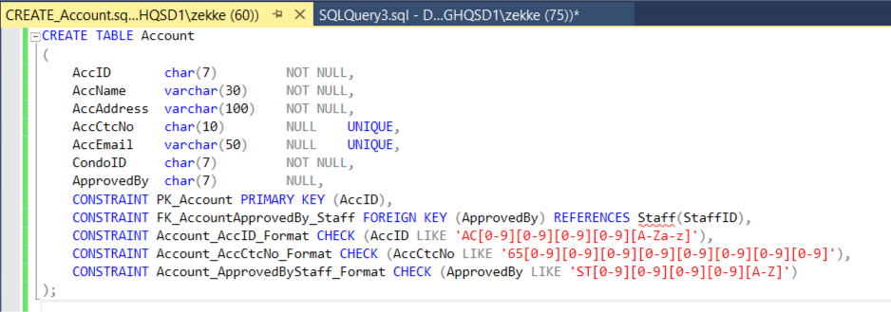

1. **SQL Query to Create Table (Announcement):**

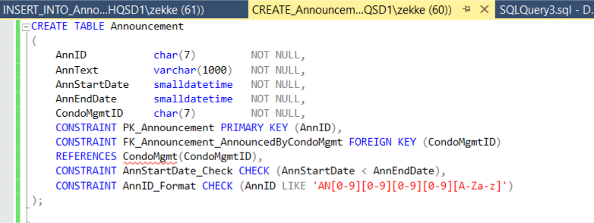

1. **SQL Query to Create Table (Booking):**

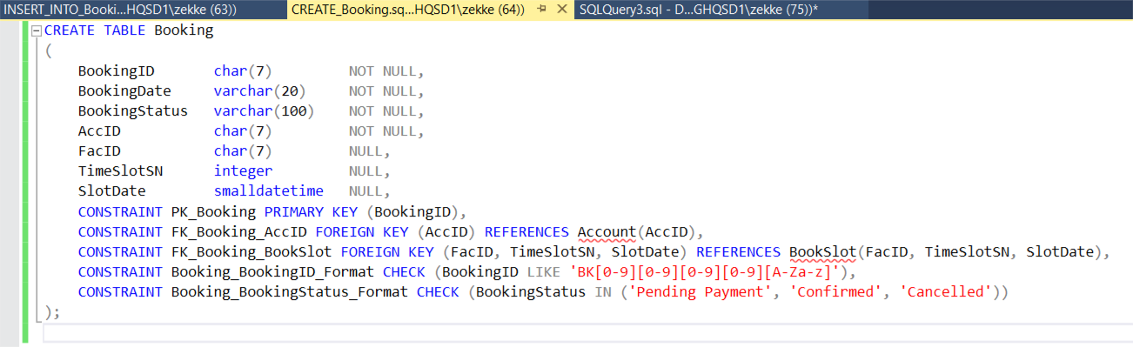

1. **SQL Query to Create Table (BookSlot):**

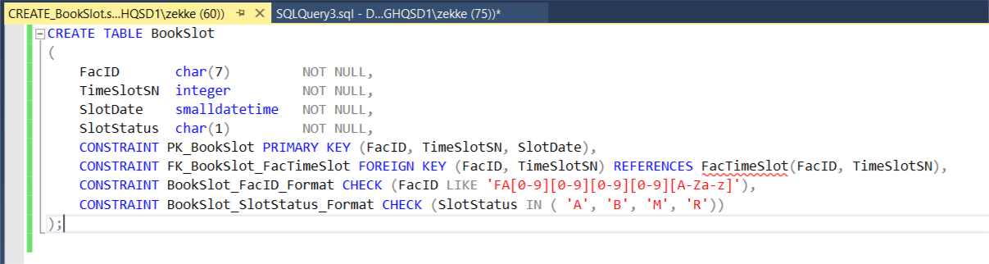

1. **SQL Query to Create Table (Condo):**

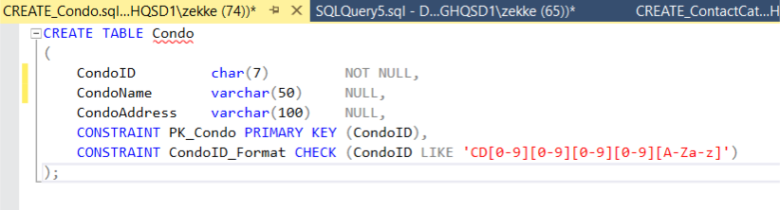

1. **SQL Query to Create Table (CondoMgmt):**

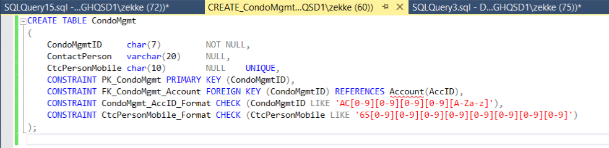

1. **SQL Query to Create Table (CondoUsefulContact):**

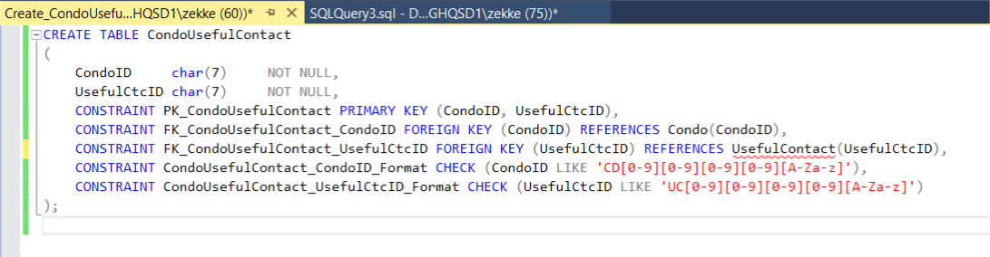

1. **SQL Query to Create Table (ContactCategory):**

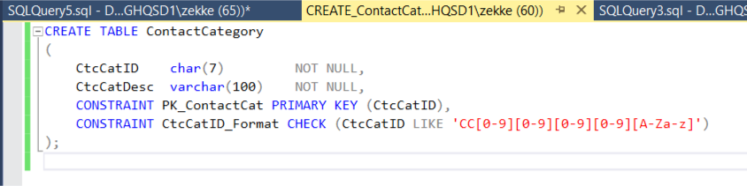

1. **SQL Query to Create Table (Facility):**

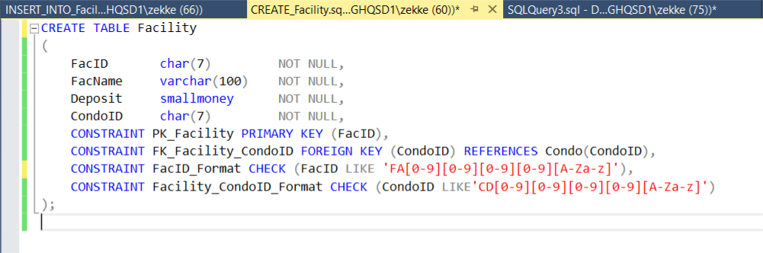

1. **SQL Query to Create Table (FacTimeSlot):**

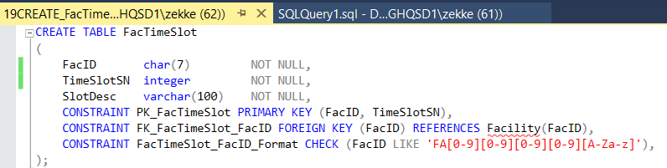

1. **SQL Query to Create Table (Feedback):**

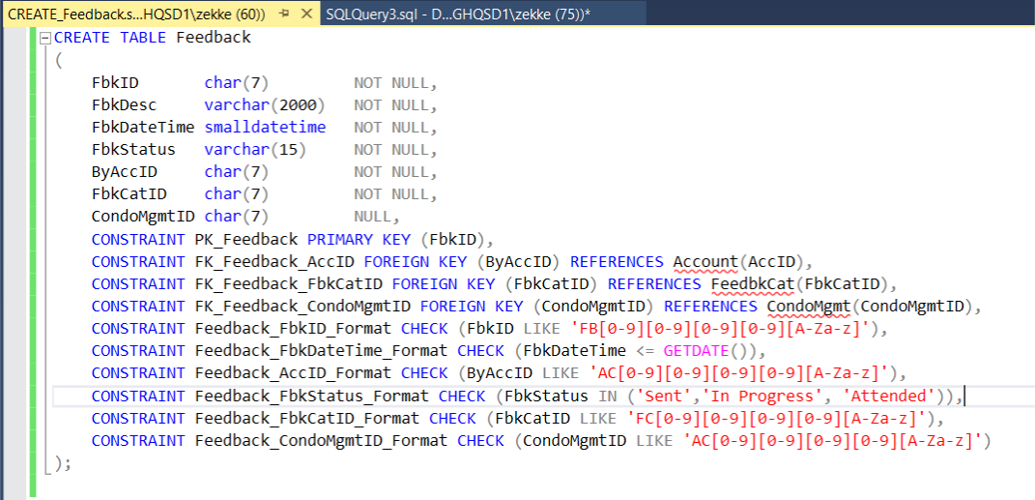

1. **SQL Query to Create Table (FeedbkCat):**

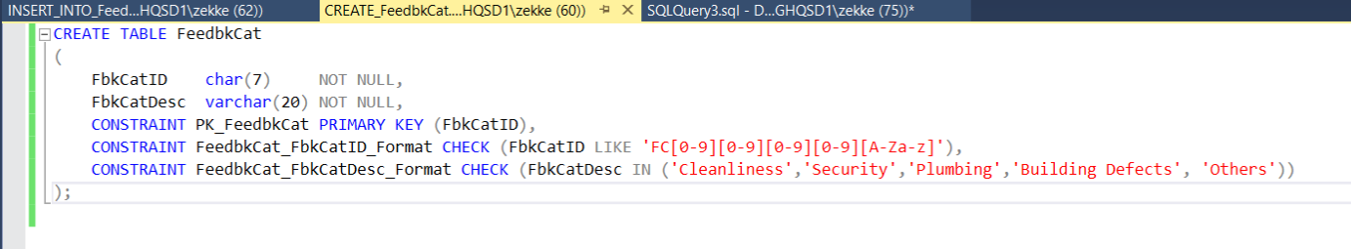

1. **SQL Query to Create Table (ItemCategory):**

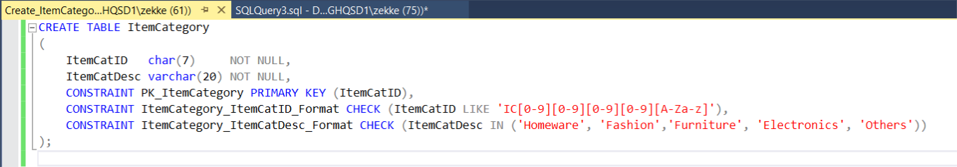

1. **SQL Query to Create Table (ItemPhoto):**

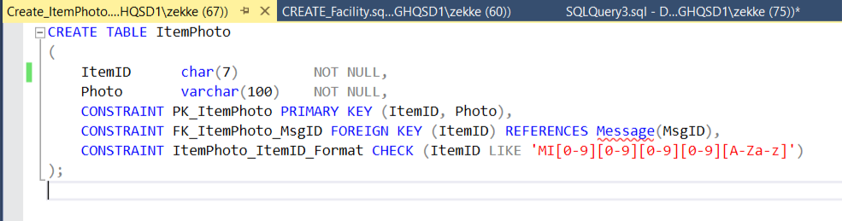

1. **SQL Query to Create Table (ItemRelated):**

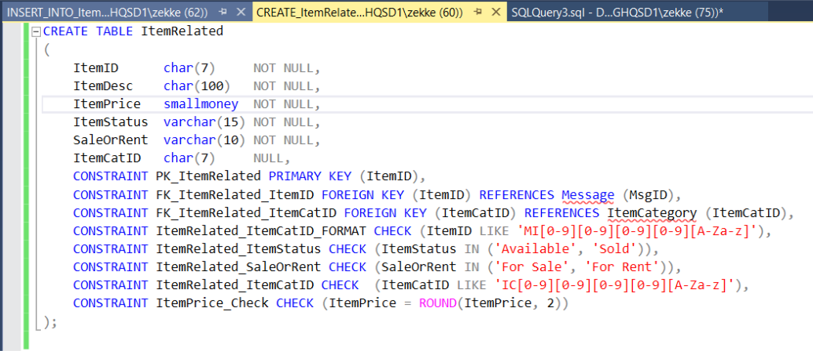

1. **SQL Query to Create Table (Likes):**

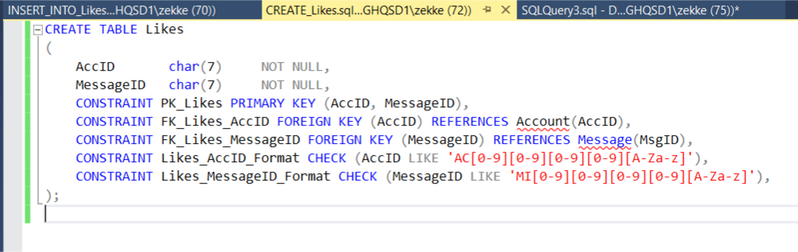

1. **SQL Query to Create Table (Message):**

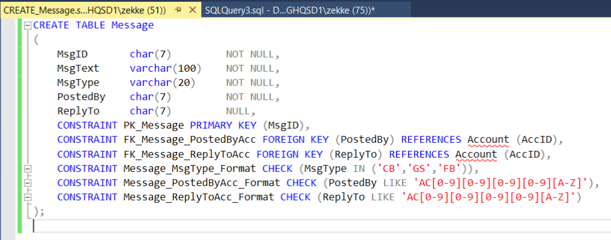

1. **SQL Query to Create Table (Owner):**

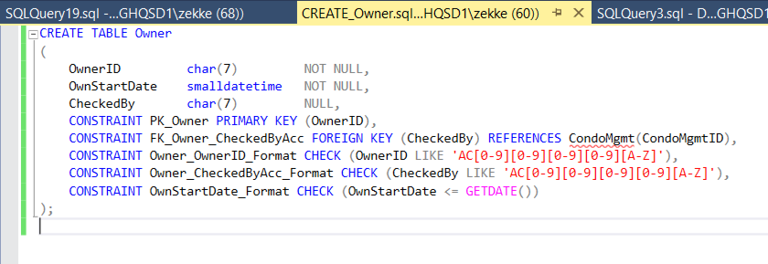

1. **SQL Query to Create Table (Staff):**

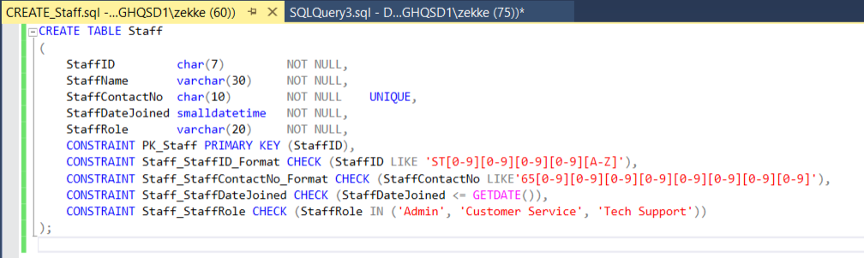

1. **SQL Query to Create Table (TempVehLabel):**

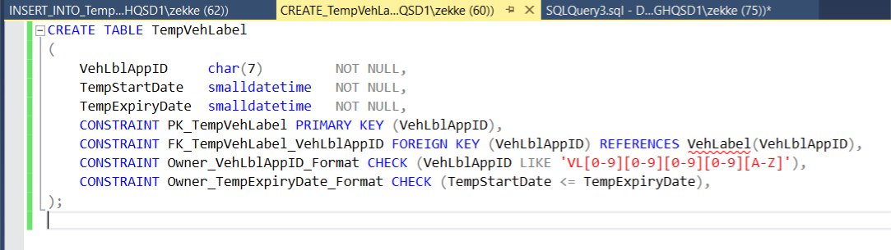

1. **SQL Query to Create Table (Tenant):**

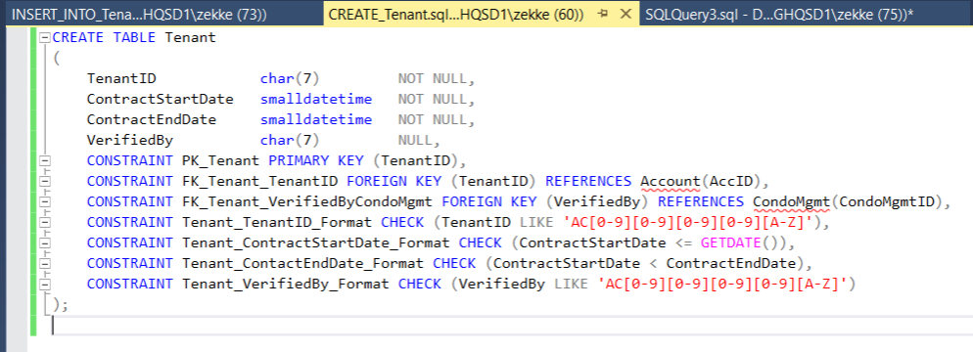

1. **SQL Query to Create Table (UsefulContact):**

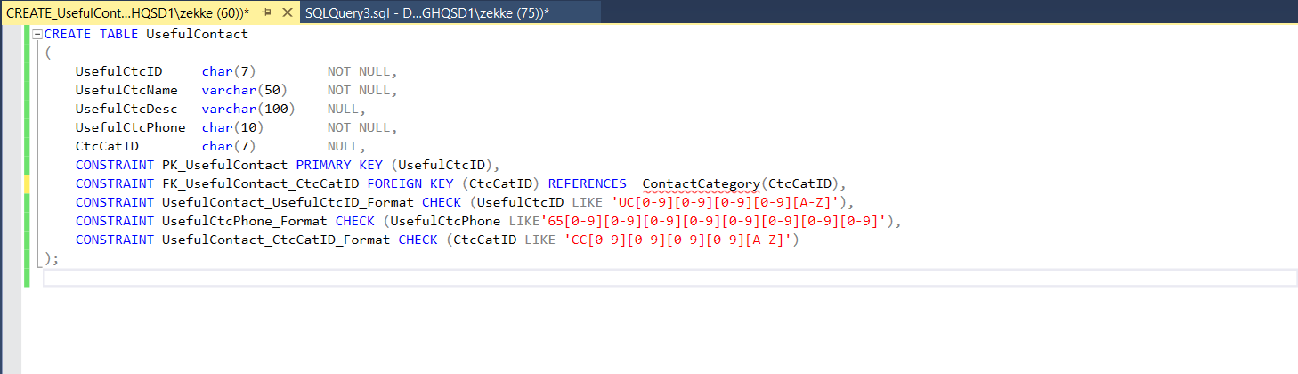

1. **SQL Query to Create Table (Vehicle):**

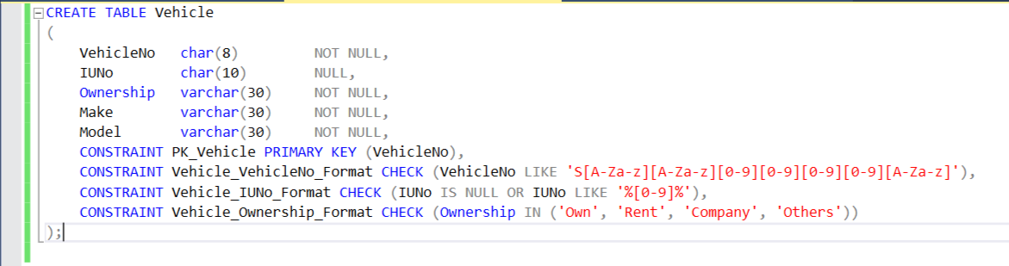

1. **SQL Query to Create Table (VehLabel):**

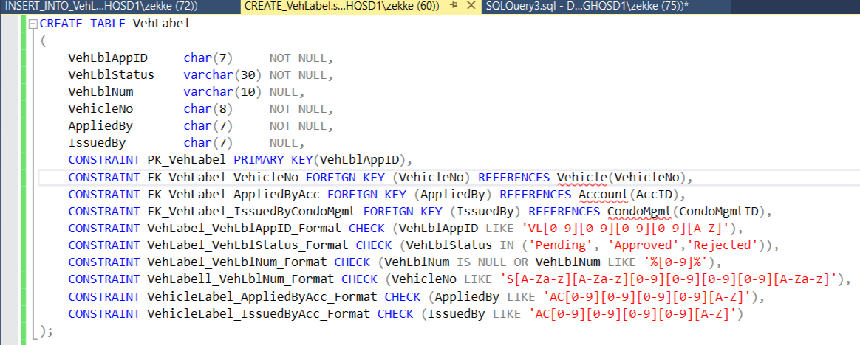

## Data Manipulation Language:

1. **SQL Insert Data for Table (Account):**

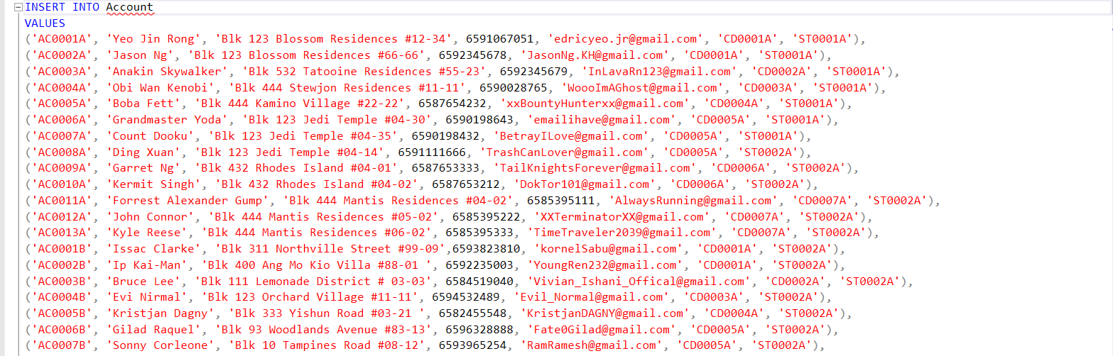

1. **SQL Insert Data for Table (Announcement):**

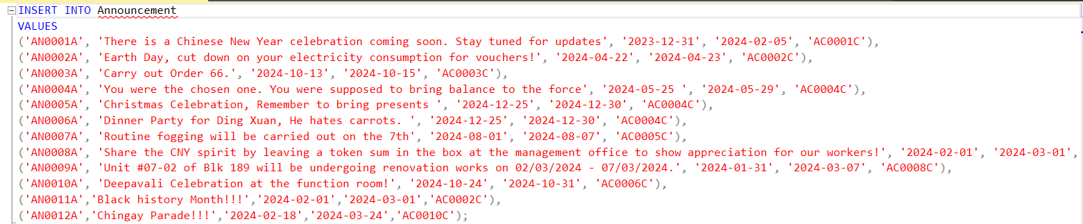

1. **SQL Insert Data for Table (Booking):**

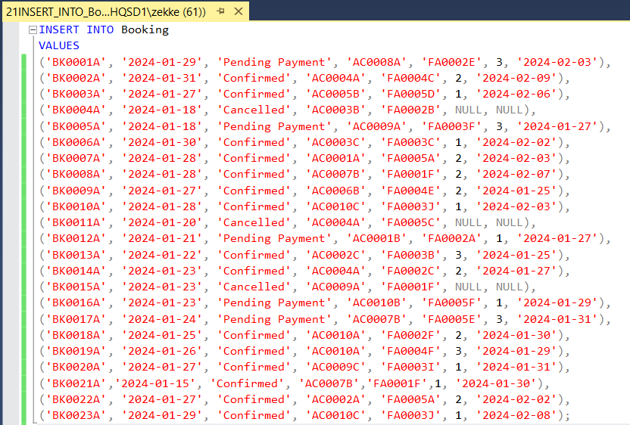

1. **SQL Insert Data for Table (BookSlot):**

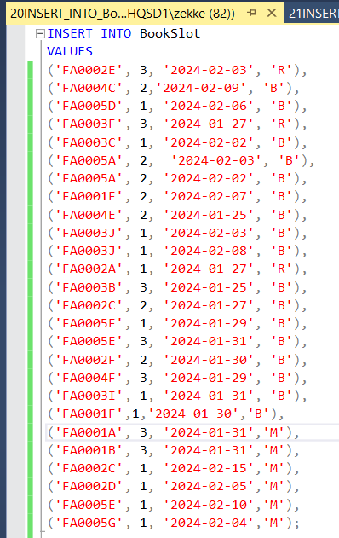

1. **SQL Insert Data for Table (Condo):**

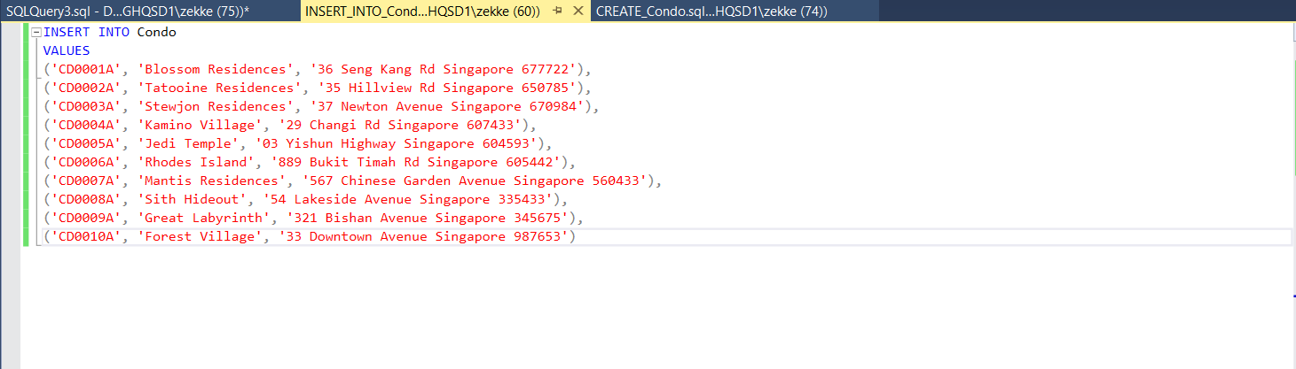

1. **SQL Insert Data for Table (CondoMgmt)**

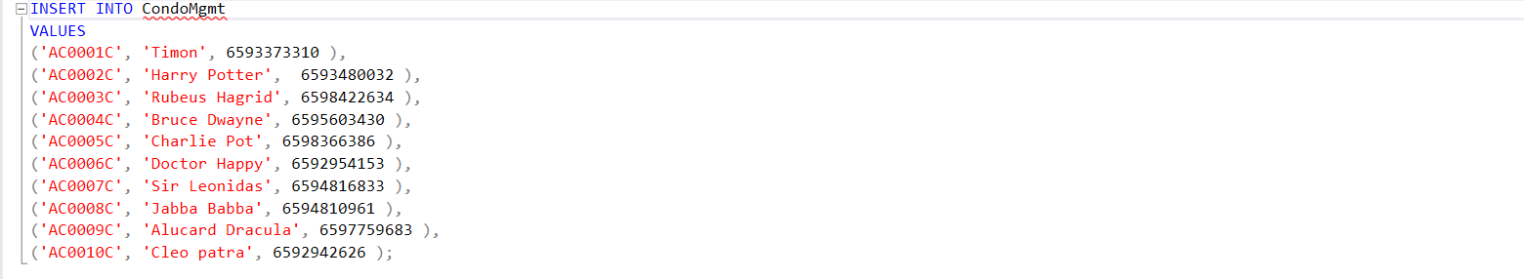

1. **SQL Insert Data for Table (CondoUsefulContact):**

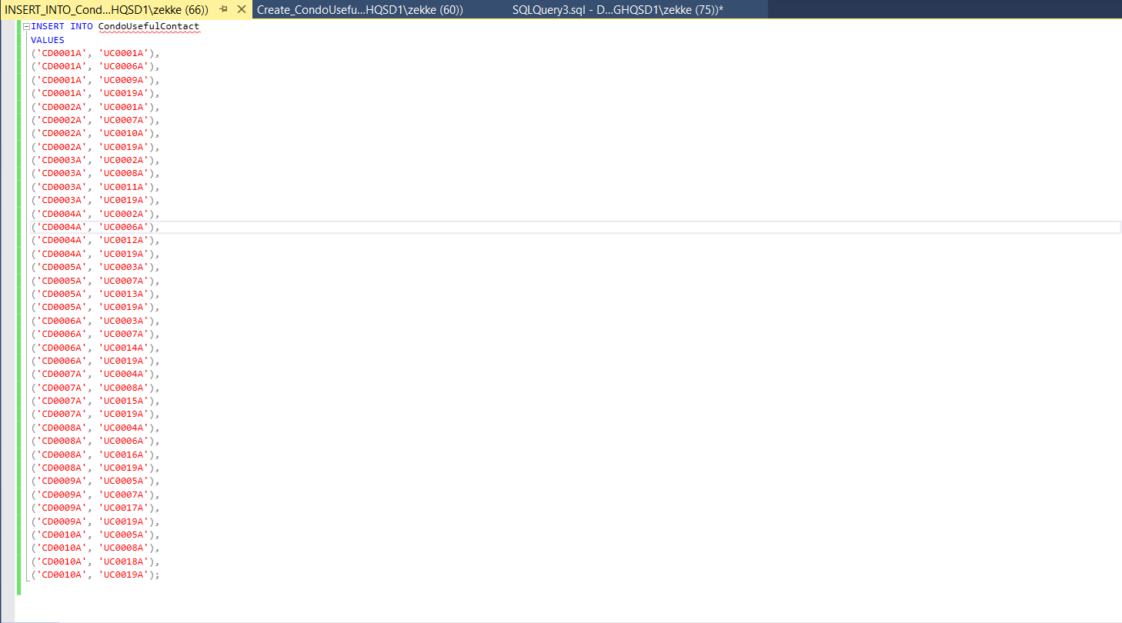

1. **SQL Insert Data for Table (ContactCat):**

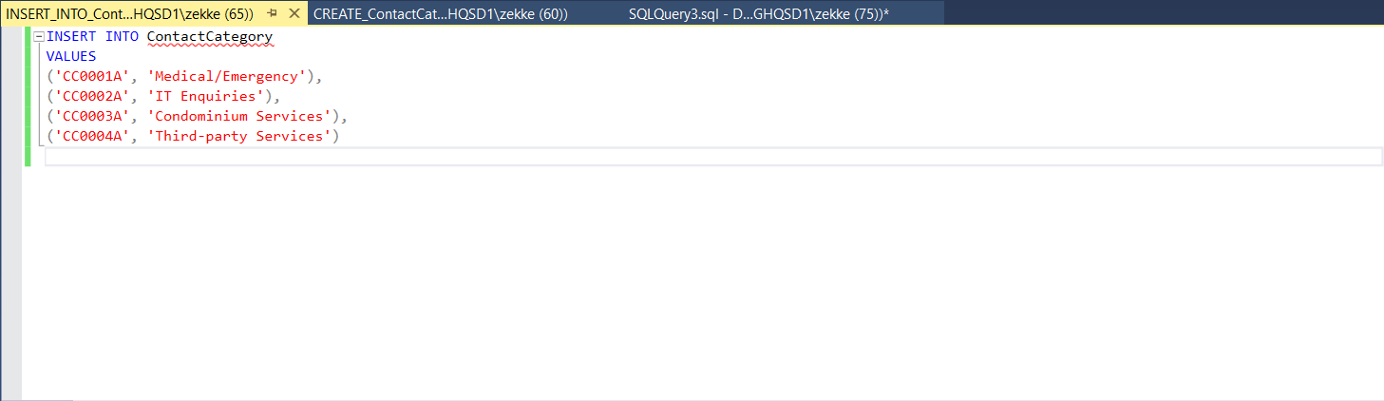

1. **SQL Insert Data for Table (Facility):**

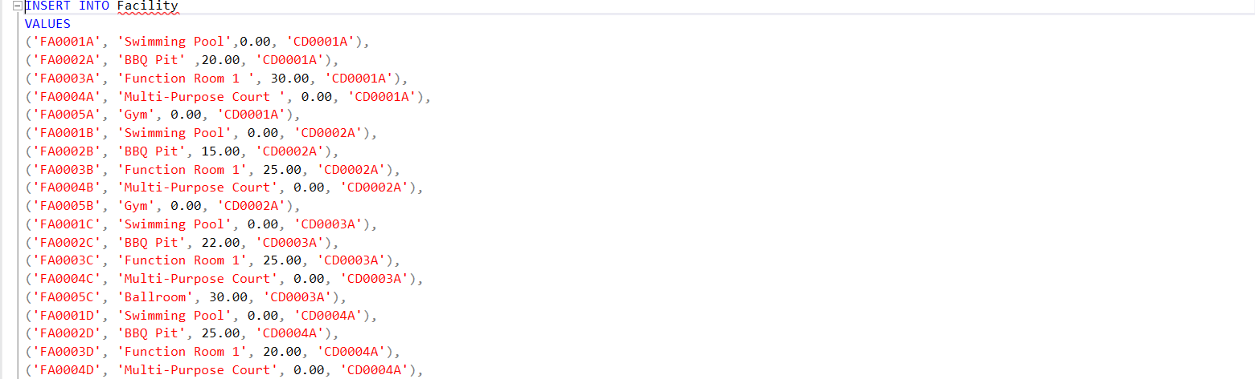

1. **SQL Insert Data for Table (FacTimeSlot):**

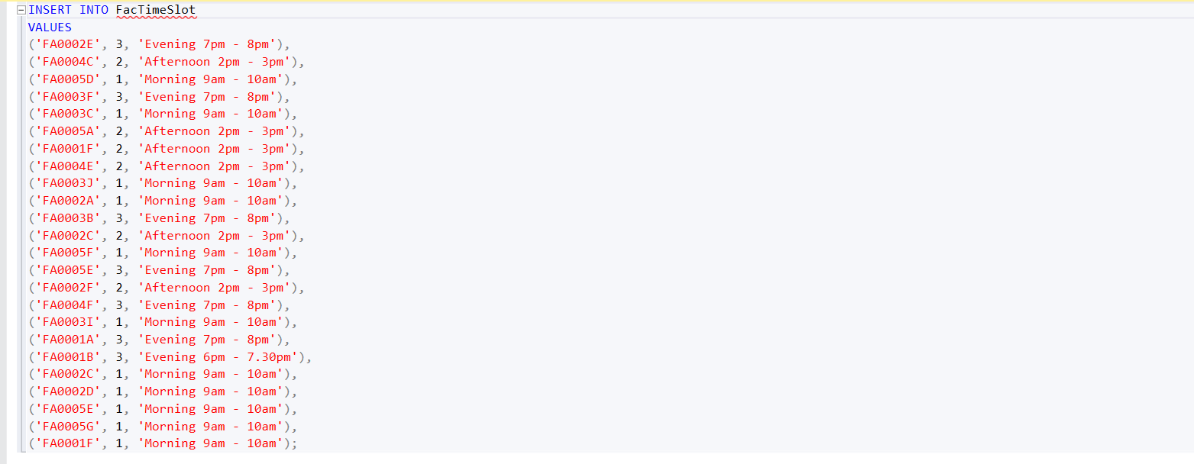

1. **SQL Insert Data for Table (Feedback):**

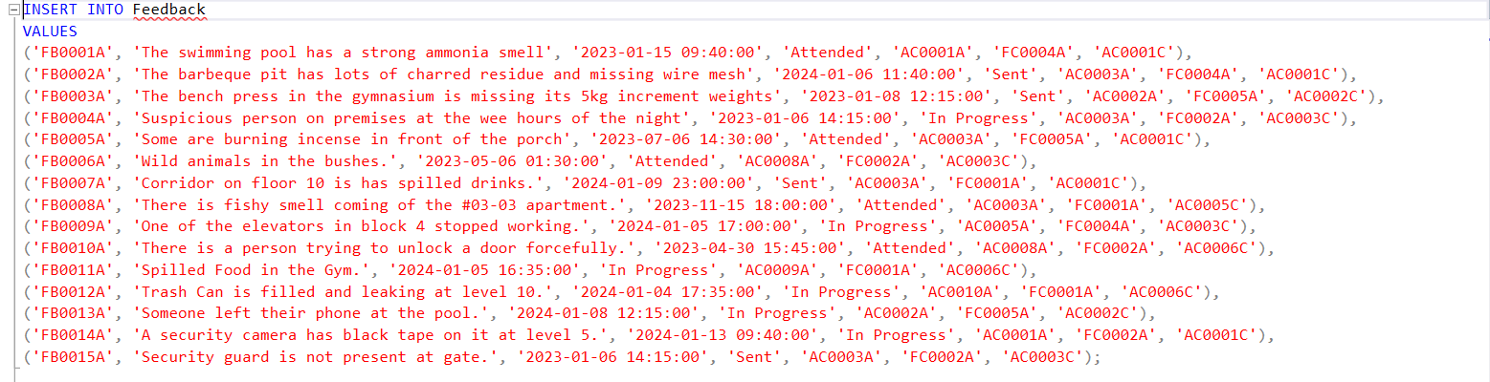

1. **SQL Insert Data for Table (FeedbkCat):**

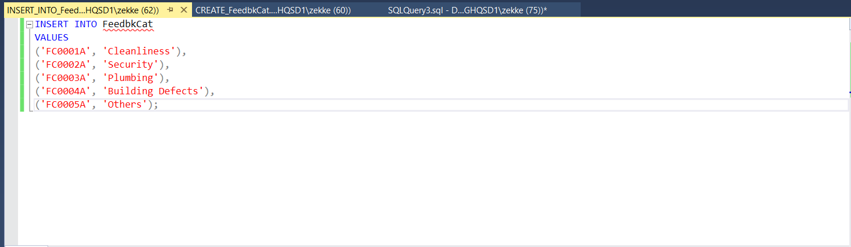

1. **SQL Insert Data for Table (ItemCategory):**

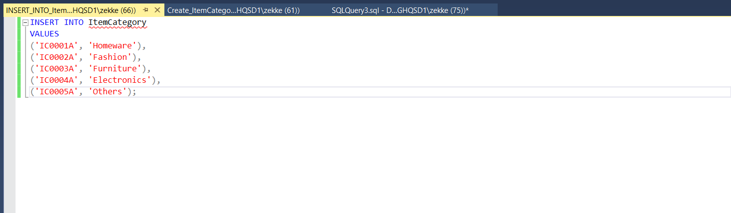

1. **SQL Insert Data for Table (ItemPhoto):**

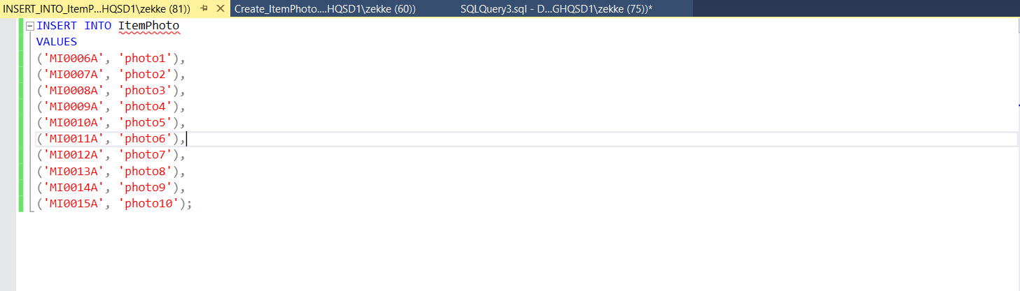

1. **SQL Insert Data for Table (ItemRelated):**

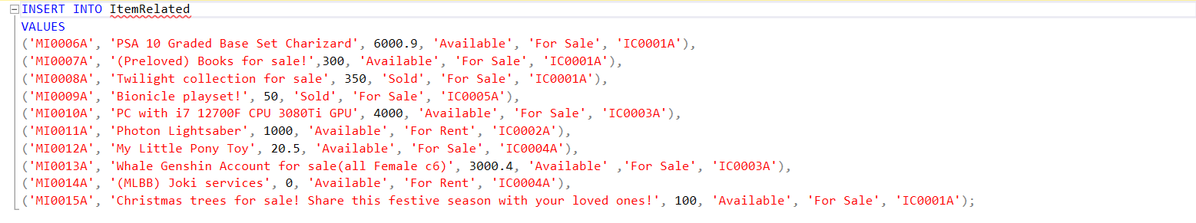

1. **SQL Insert Data for Table (Likes):**

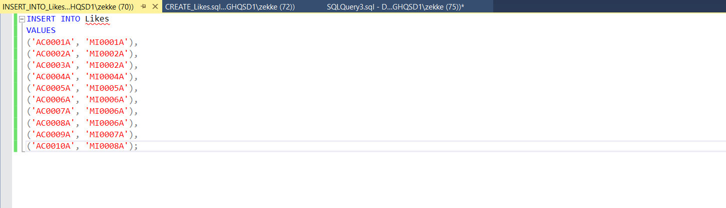

1. **SQL Insert Data for Table (Message):**

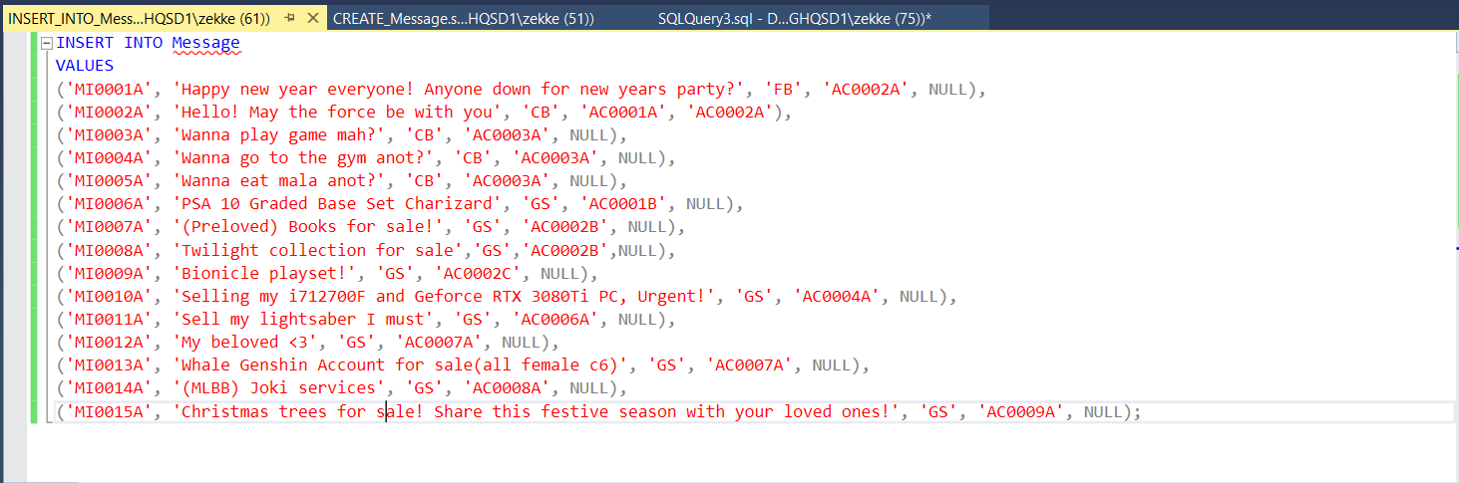

1. **SQL Insert Data for Table (Owner):**

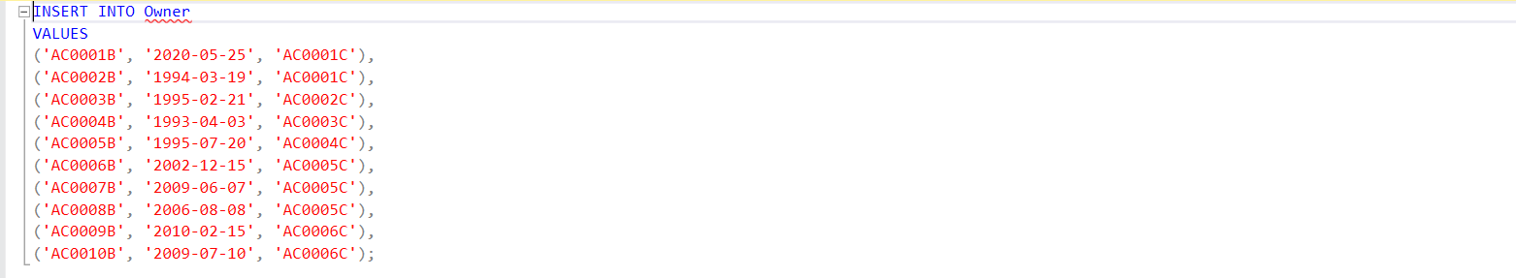

1. **SQL Insert Data for Table (Staff):**

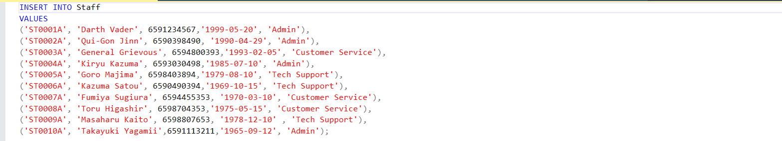

1. **SQL Insert Data for Table (TempVehLabel):**

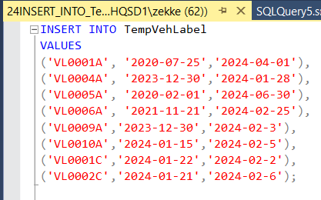

1. **SQL Insert Data for Table (Tenant):**

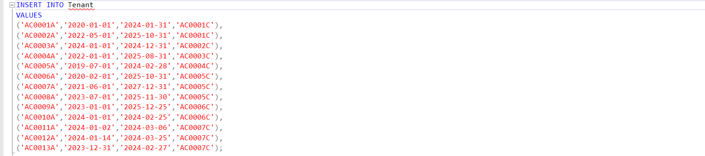

1. **SQL Insert Data for Table (UsefulContact):**

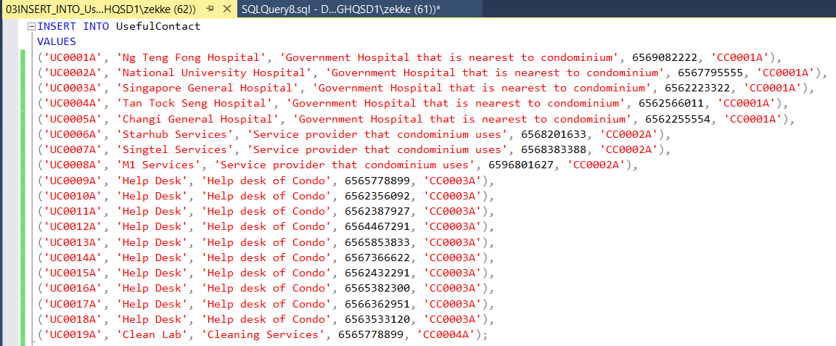

1. **SQL Insert Data for Table (Vehicle):**

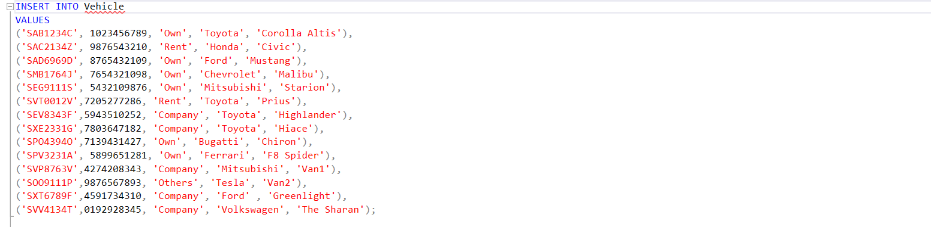

1. **SQL Insert Data for Table (VehicleLabel):**

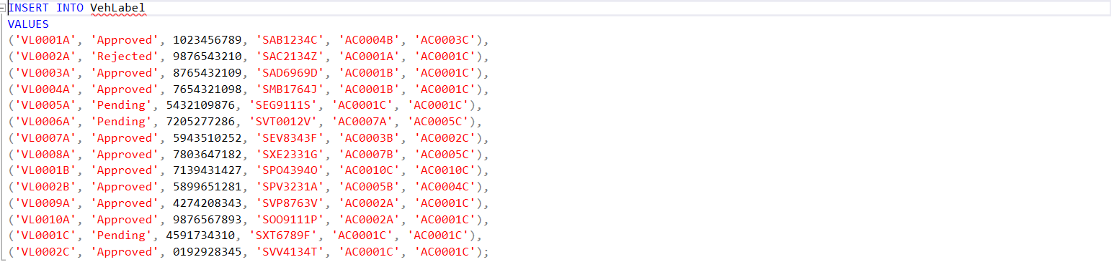

# Content of all the Tables:

1. **SQL Table content (Account):**

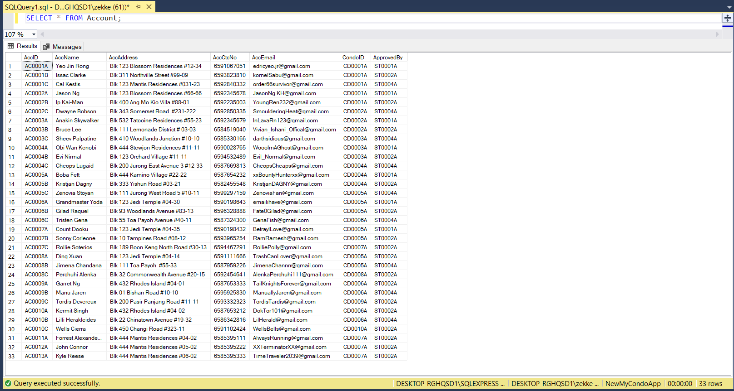

1. **SQL Table content (Announcement):**

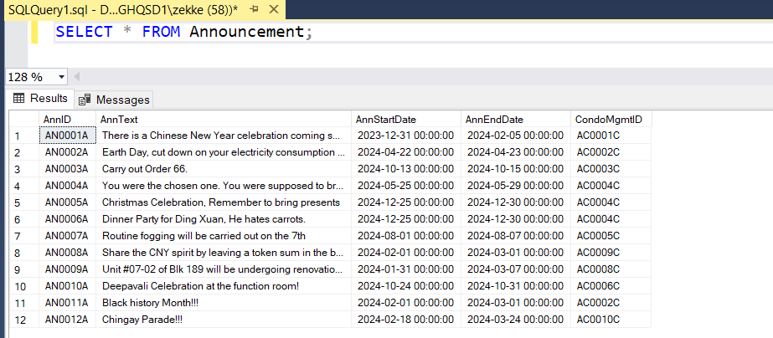

1. **SQL Table content (Booking)**

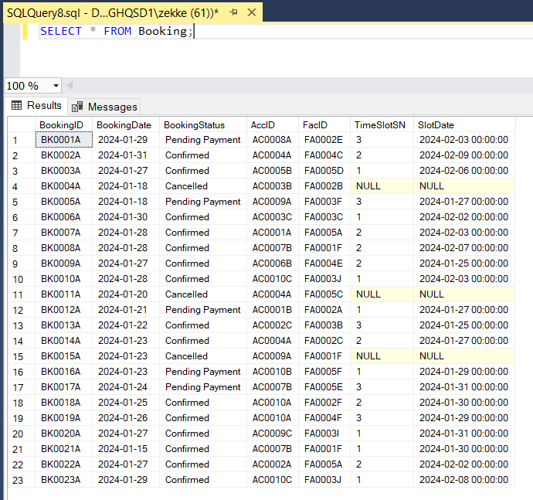

1. **SQL Table content (Bookslot)**

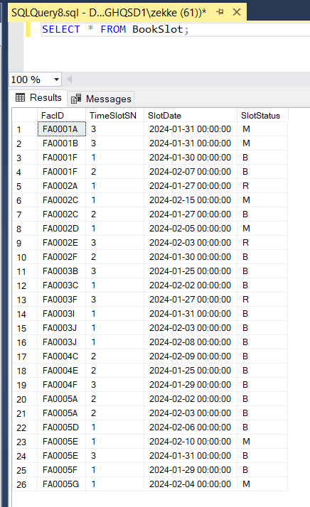

1. **SQL Table content (Condo)**

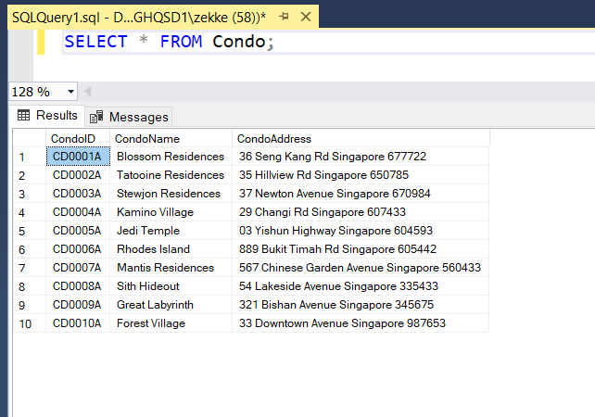

1. **SQL Table content (CondoMgmt)**

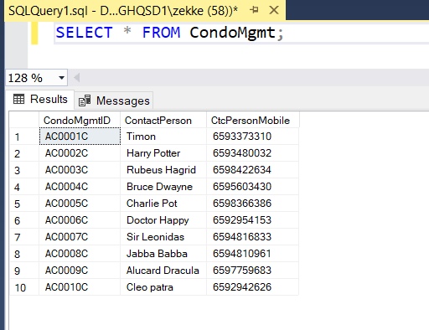

1. **SQL Table content (CondoUsefulContact):**

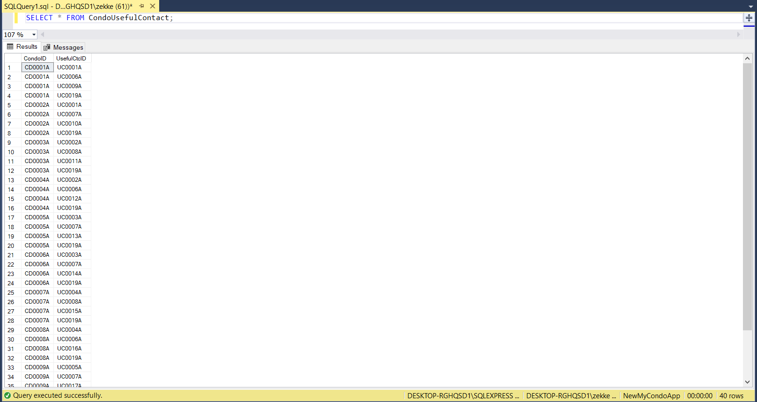

1. **SQL Table content (ContactCategory):**

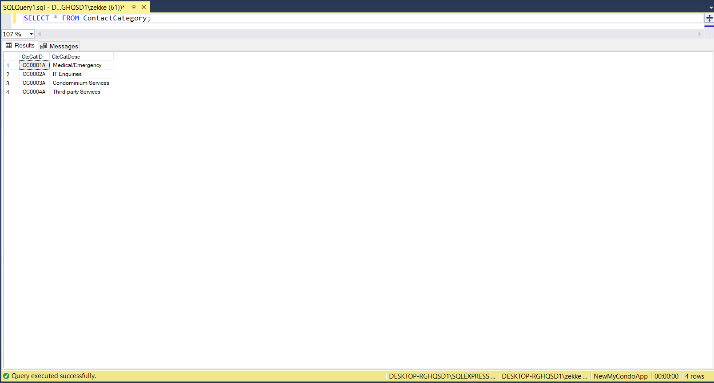

1. **SQL Table content (Facility):**

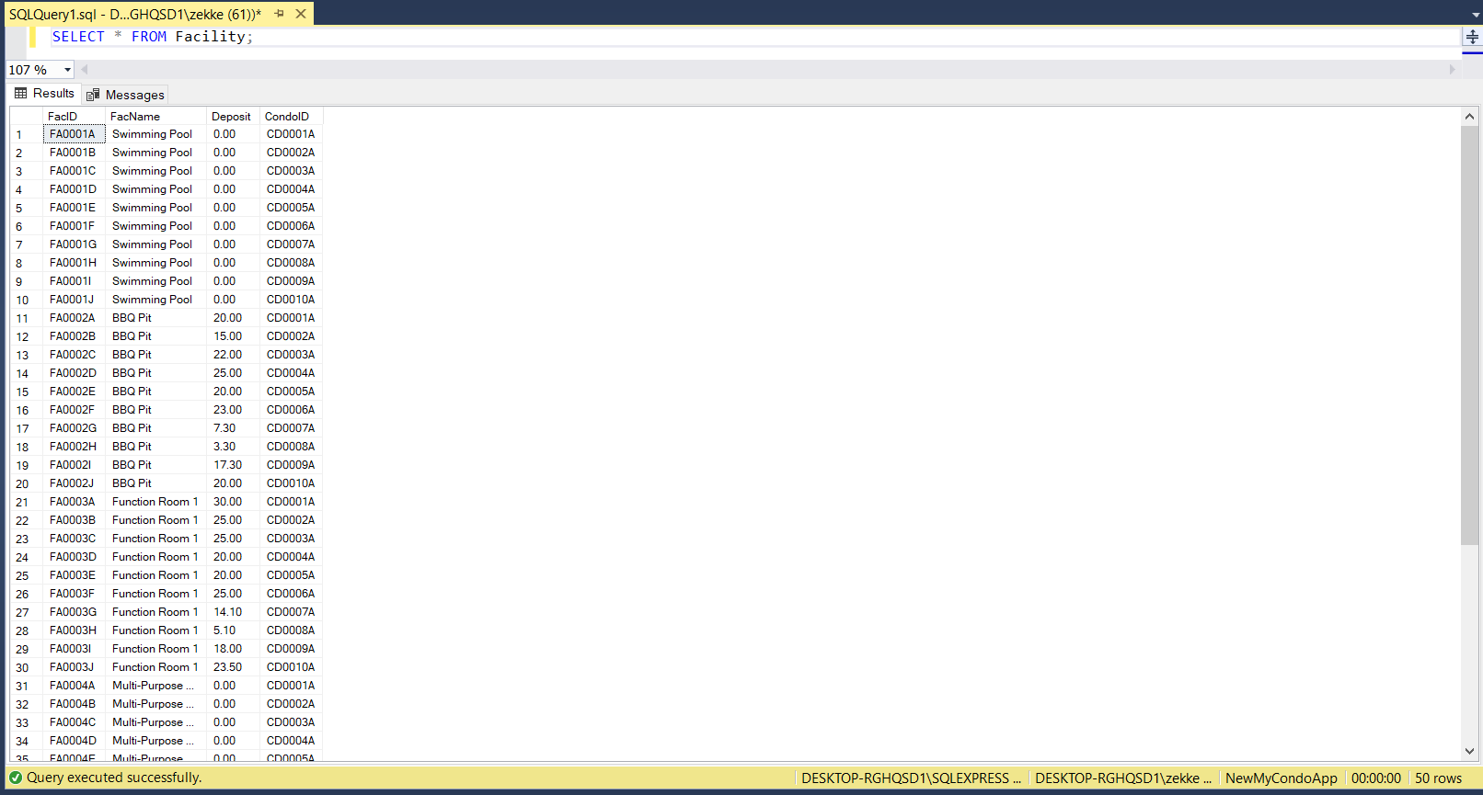

1. **SQL Table content (FacTimeSlot):**

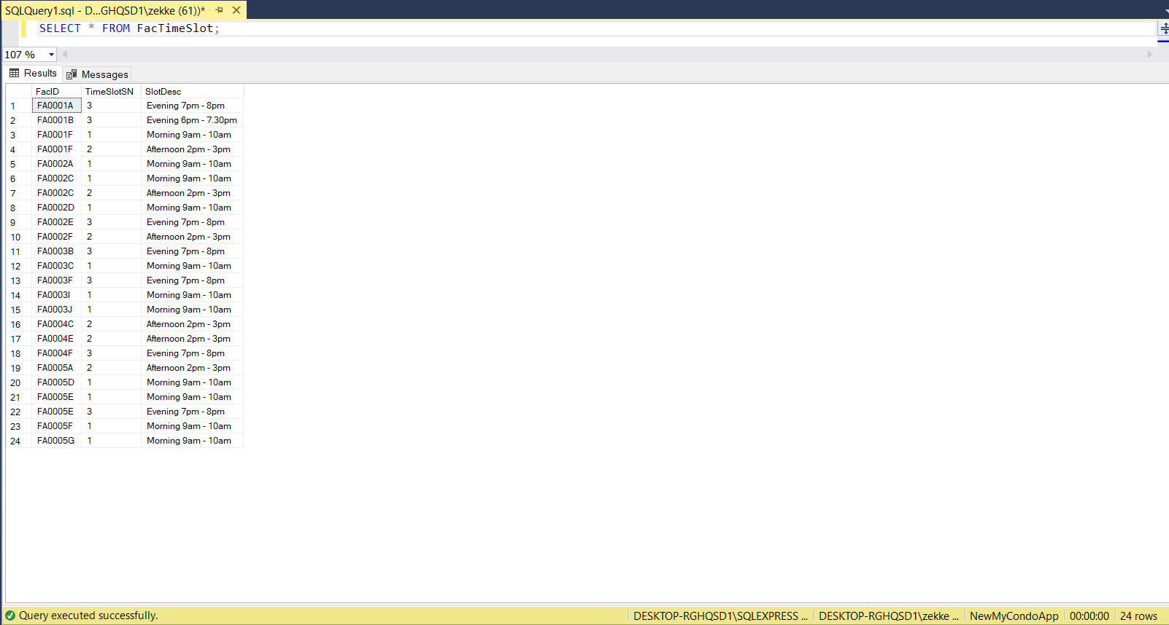

1. **SQL Table content (Feedback):**

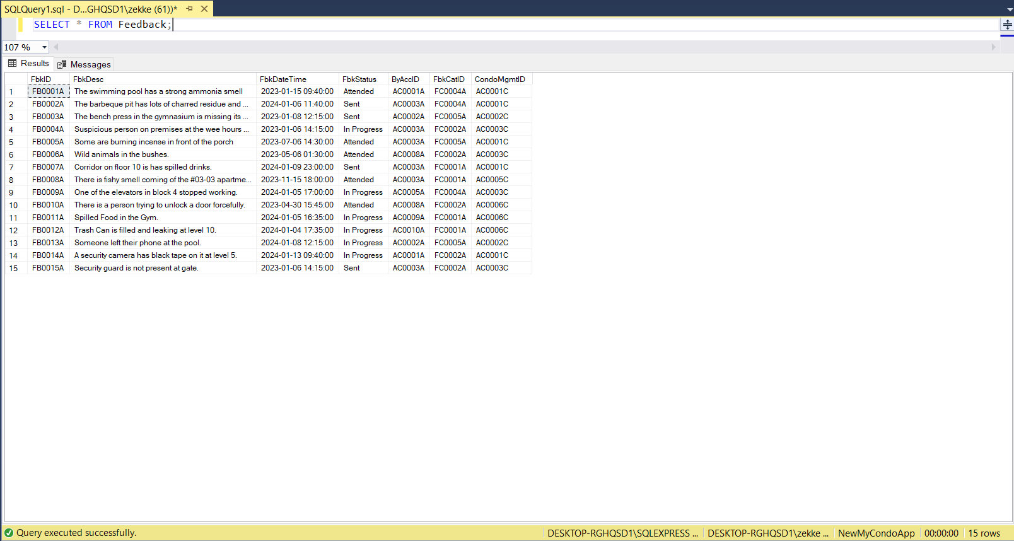

1. **SQL Table content (FeedbackCat):**

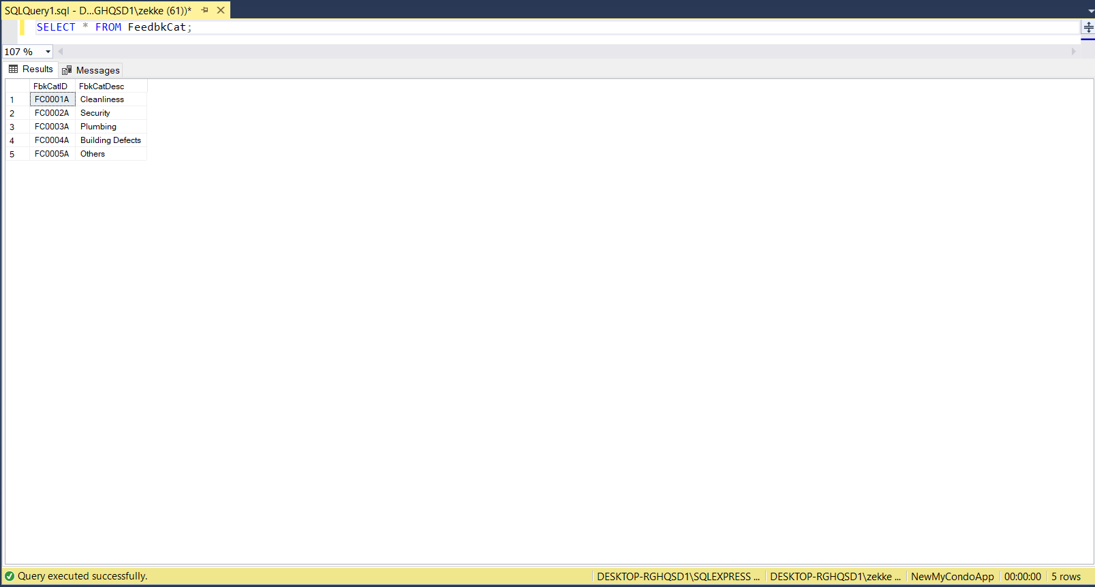

1. **SQL Table content (ItemCategory):**

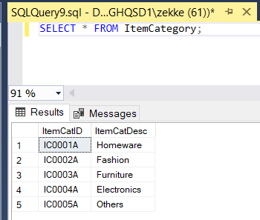

1. **SQL Table content (ItemPhoto):**

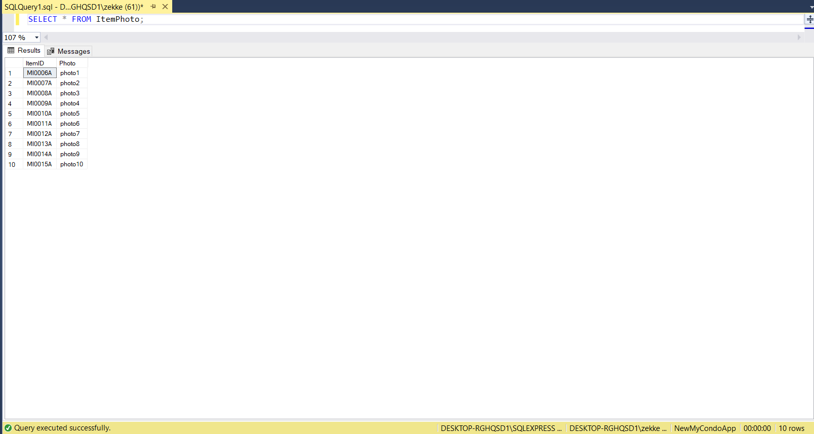

1. **SQL Table content (ItemRelated):**

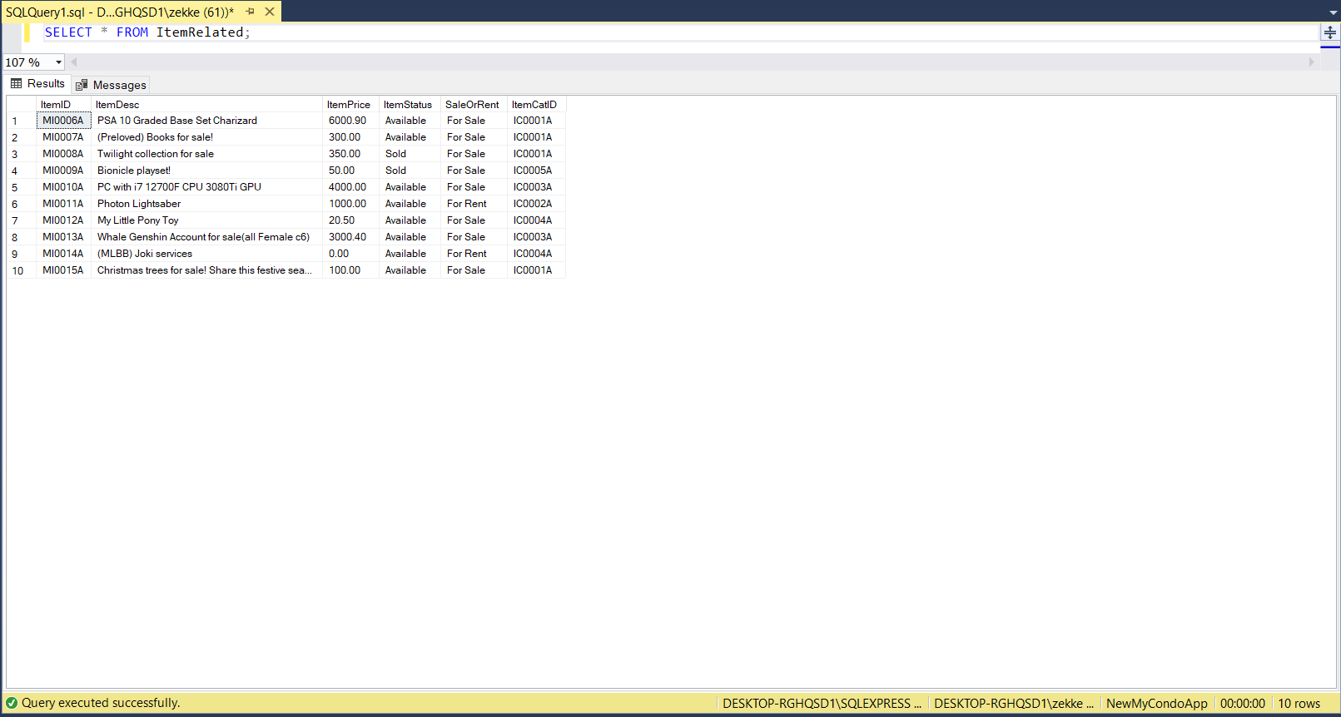

1. **SQL Table content (Likes):**

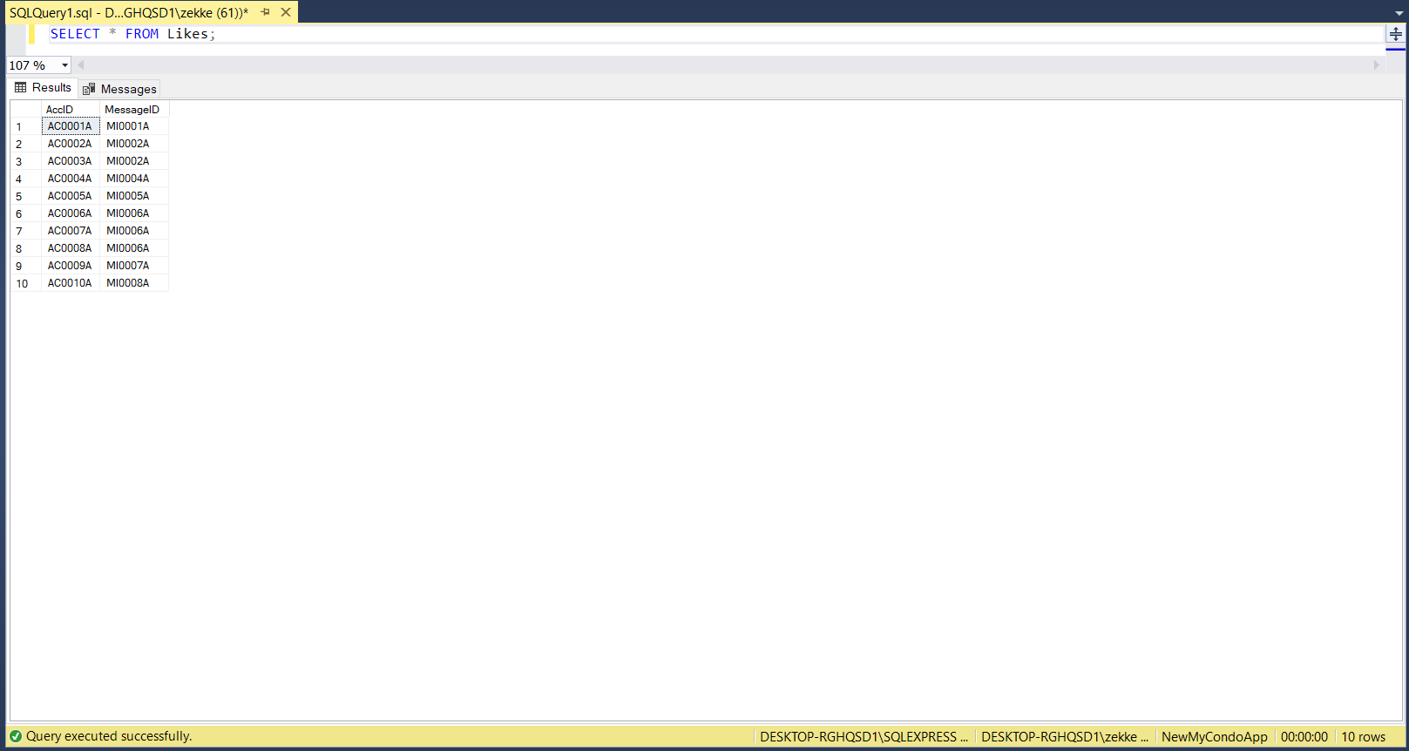

1. **SQL Table content (Message):**

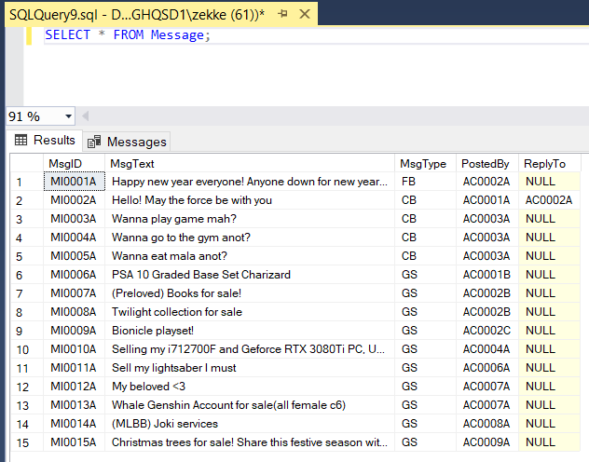

1. **SQL Table content (Owner):**

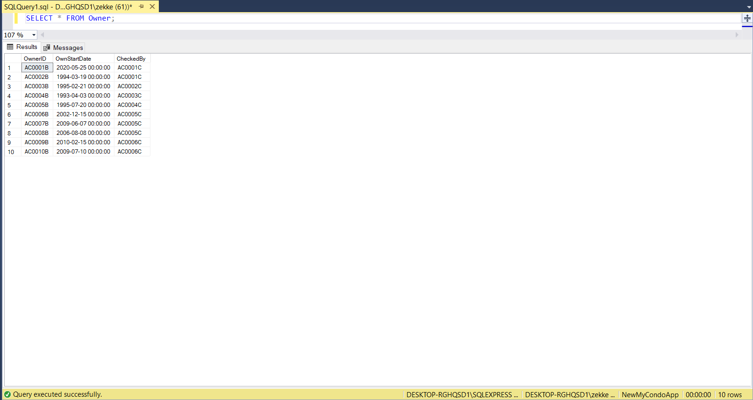

1. **SQL Table content (Staff):**

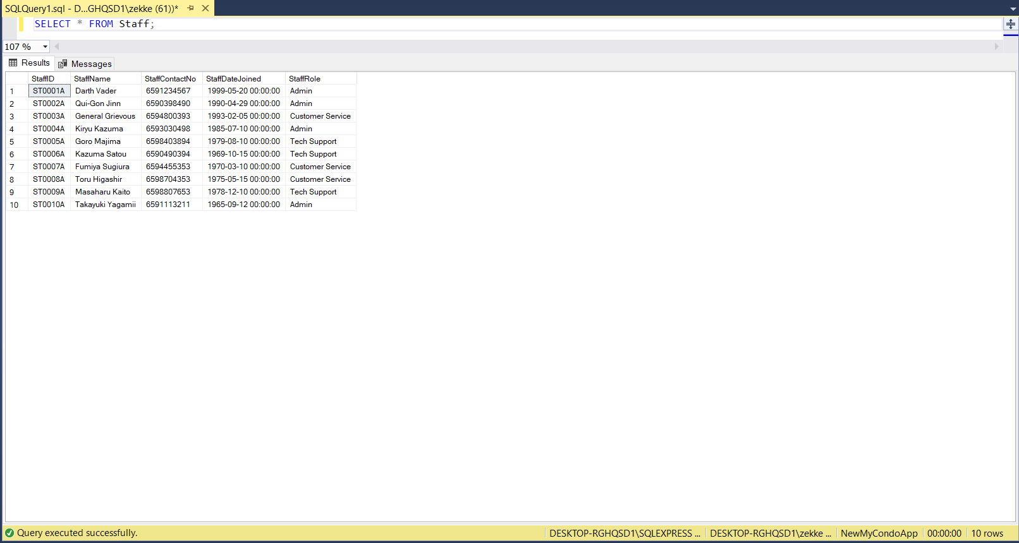

1. **SQL Table content (TempVehLabel):**

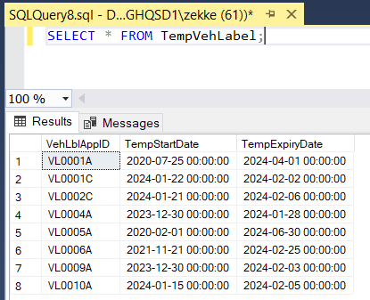

1. **SQL Table content (Tenant):**

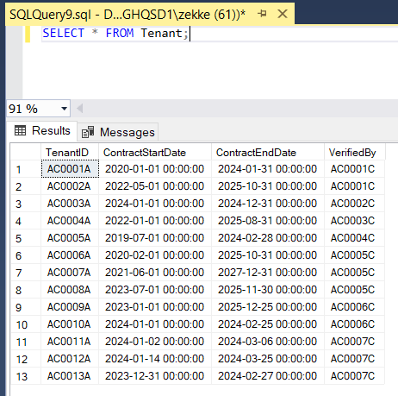

1. **SQL Table content (UsefulContact):**

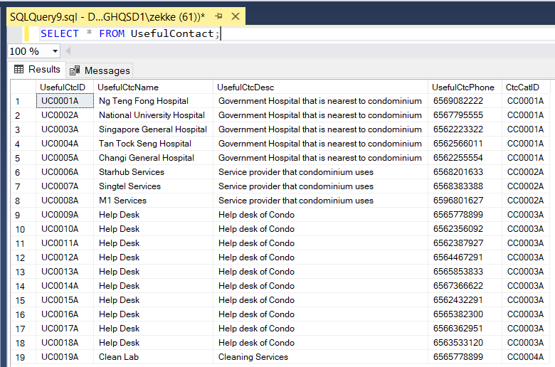

1. **SQL Table content (Vehicle):**

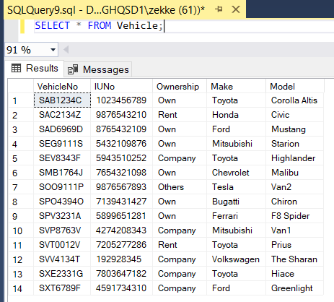

1. **SQL Table content (VehLabel):**

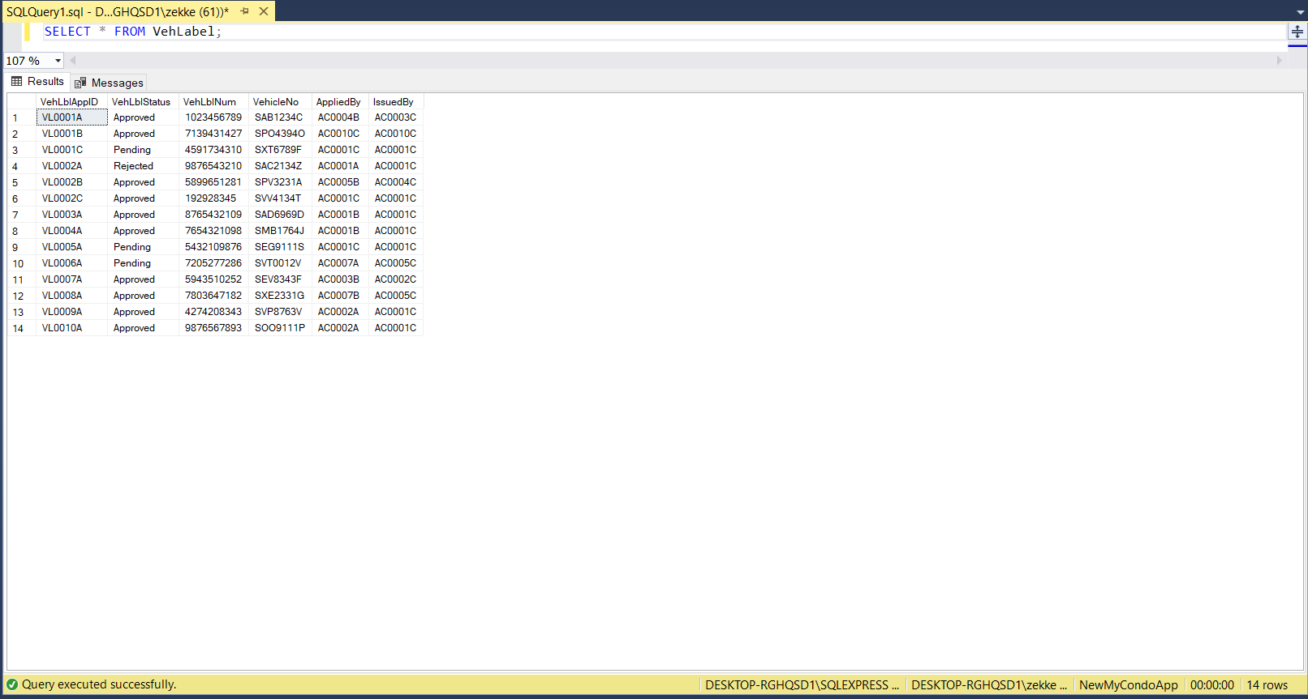

# List of SQL Queries and Result Sets:

For full text versions of SQL queries, please refer to Appendix D

For all queries with more than one image, all images are ordered.

* **Jin Rong’s Queries**

**Jin Rong Query 1:**

Retrieve the latest upcoming facility booking that are confirmed for an associated Condo Name, providing condo name, facility id, facility name and total count of total bookings, while providing information related to the latest booking available.

This query thus is able to provide the user with information on the latest booking for each facility at a glance, easily identifying which facilities are to be prioritized for maintenance or upkeep, as they have an upcoming booking. The query is also able to be tweaked by changing SlotStatus or Booking Status to fit the user’s queries (such as SlotStatus being ‘M’ or Booking Status to be ‘Pending’). Furthermore, this query can be scrutinized even further by adjusting the “WHERE” statement to be more specific, such as specifying Facility Name or ID to be more precise.

**The query utilizes:**

1. **INNER JOIN** to join table from **Booking** to **BookSlot** > **FacTimeSlot** > **Facility**
2. **WHERE** to filter tuples in subquery BaseQuery where:
   1. SlotDate in table **Booking** is greater than current date
   2. SlotStatus in table **BookSlot** is “B” for Booked
   3. BookingStatus in table **Booking** is “Confirmed”
3. **ROW_NUMBER** to assign a number to tuples by FacID in table **Facility** and ordered by ascending order of SlotDatein table BookSlot
4. **INNER JOIN** to join table from **Booking** to **Bookslot** > **FaccTimeSlot** > **Facility**, then join to table **Accoun**t > **Condo**
5. **WHERE** to filter tuples in subquery LatestBooking where:
   1. SlotDate in table **Booking** is greater than current date
   2. SlotStatus in table **BookSlot** is “B” for Booked
   3. BookingStatus in table **Booking** is “Confirmed”
6. **SELECT** statements to select tuples for result
7. **LEFT JOIN** result from subquery **Latest Booking** where ROWNUM = 1 (i.e the row with earliest slot date) ON FacID from **base_query** and **latest_booking**
8. **GROUP BY** statement to group by order of select statements
9. **HAVING** statement to filter and only show results with TotalBookings >= 1 (i.e COUNT(BookingID) from table **Booking**
10. **ORDER BY** statements to order results in ascending order of TotalBookings (i.e COUNT(BookingID) from table **Booking**

**Jin Rong Query 1:**

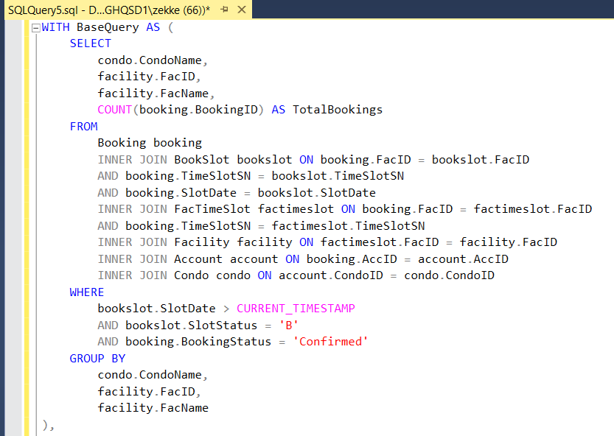

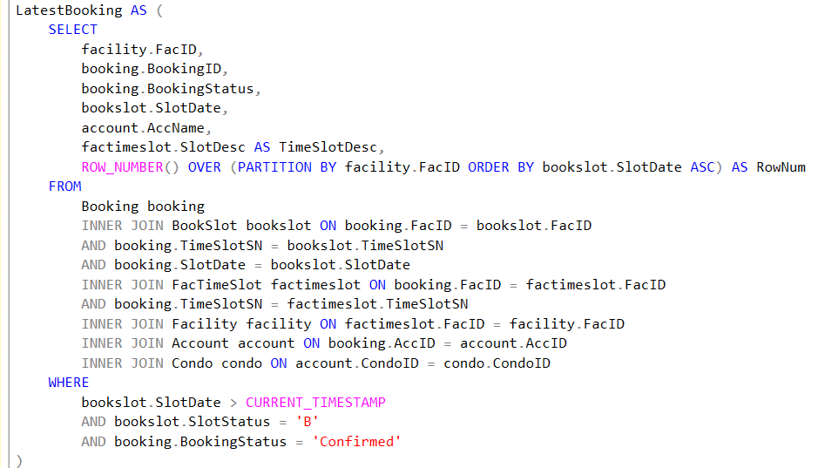

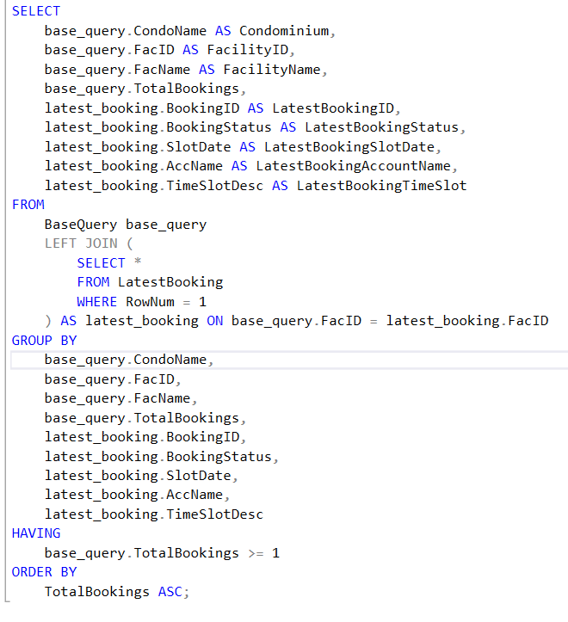

**Jin Rong Query 1 Result:**

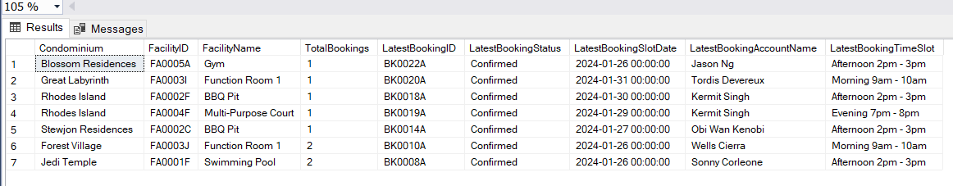

**Jin Rong Query 2:**

Retrieve Name, Contact Number, Email, Vehicle No, IUNo, Expiry Date of TempVehLabel and Days left to expiry date and CondoMgmt Staff that approved the label of Temporary Vehicle Labels expiring within a month, with a subquery for a specific condominium name

This query provides information in relevance to TempVehLabels expiring in a month as well as the Condo Management Personnel who is responsible for the approval of the Temp Vehicle Label.

This provides businesses operating the carpark in the Condominium to have reliable tracking of temporary vehicle labels close to expiry, improving their customer service potential by providing them the necessary information to remind their users to resolve the expiring TempVehLabel.

**The query utilizes:**

1. **DATEDIFF** to calculate difference between CurrentDate & TempExpiryDate in **TempVehLabel**
2. **INNER JOIN** to join tables from **VehLabel t**o **Account** & **VehLabe**l to **Vehicle** & **VehLabe**l to **CondoMgmt** & **VehLabel** to **TempVehLabel**
3. **SubQuery** result to return CondoMgmtID, **INNER JOIN** **Account** & **CondoMgmt** where CondoName in table **Condo** is ‘Blossom Residences’
4. **GROUP BY** statements following order of SELECT statements
5. **HAVING** statement to filter that difference between TempExpiryDate in table TempVehLabel and CurrentDate is more than zero
6. **ORDER BY** statement to order by “Days Left” which is difference between CurrentDate and TempExpiryDate in table **TempVehLabel**

**Jin Rong Query 2:**

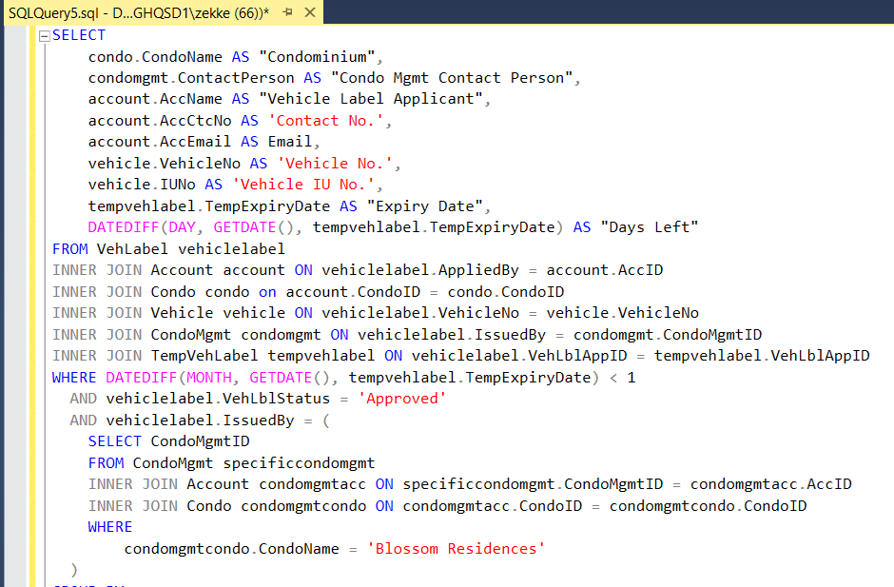

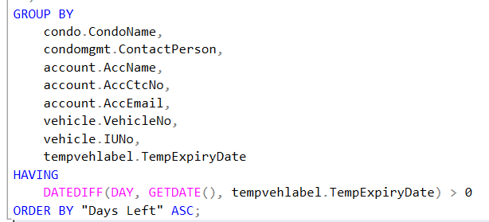

**Jin Rong Query 2 Result:**



**Jin Rong Query 3:**

Retrieve information such as feedback status, days feedback is overdue, name of feedback provider, contact number of feedback provider, category of feedback, contact person for condo management company, contact number for condo management person and count of feedback provided.

This query allows user to obtain information on Feedback that is overdue by more than 1 month, which will provide users with the relevant information to priorities these feedback and act upon them, either by executing corrective measures or resolving the issue.

This is valuable for businesses within the Condominium to maintain user satisfaction, maintaining the hygiene, safety and functionality of the facilities and premises in the Condominium, upholding the reputation of the Condominium, which directly influences the property price. Hence, this information is valuable to businesses, especially those managing the Condominiums.

**This query utilizes:**

1. **ABS()** to modulus the result, **DATEDIFF()** to get Days Overdue (i.e difference between FbkDateTime and GETDATE())
2. **COUNT()** and **DISTINCT** to get number of distinct feedbacks
3. **INNER JOIN** to join tables from **FeedbackCat** > **Account** > **CondoMgmt**
4. **WHERE** to filter tuples where:
   1. FbkCatDesc is ‘Security’ in table **FeedBackCat**
   2. FbkStatus is either ‘Sent’ or ‘In Progress’ in table **Feedback**
   3. FbkDateTime is less than current date in table **Feedback**
   4. FbkDateTime and GETDATE() difference is more than 1 month in table **Feedback**
5. **GROUP BY** statements following order of SELECT statements
6. **HAVING** statement to filter and validate the difference between FeedbackDateTime and Current Date is > 0, after modulus
7. **ORDER BY** statement to order by feedback status, feedback category and “days overdue”

**Jin Rong Query 3:**

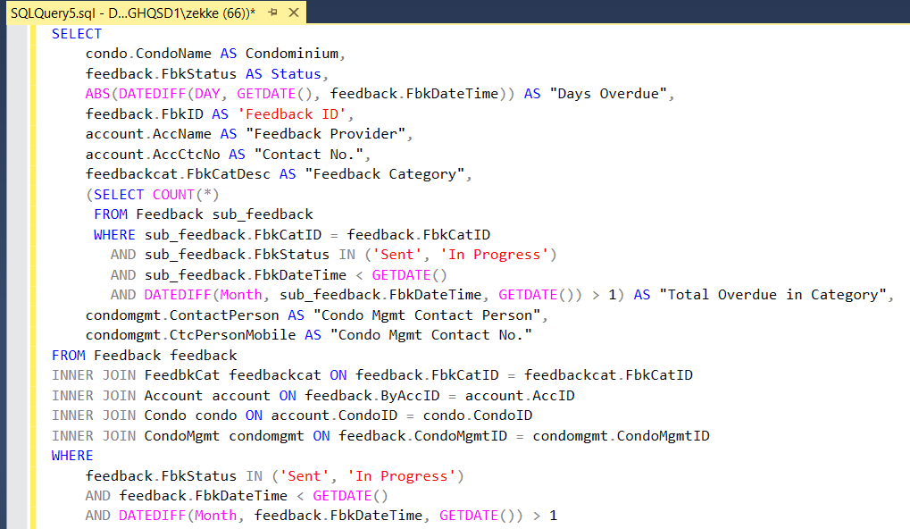

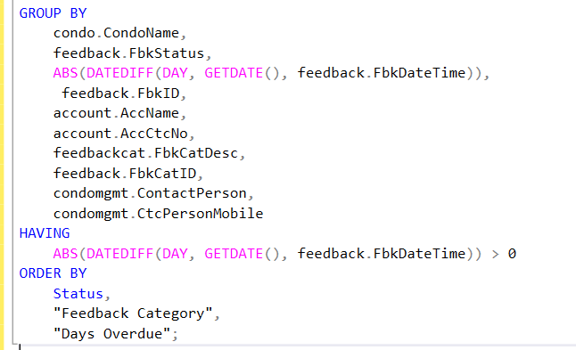

**Jin Rong Query 3 Result:**



* **Jason’s Queries**

**Jason Query 1:**

Obtain the average revenue generated by Condominium and Facility Name

This query provides Condominiums the ability to spot any discrepancies or outliers in revenue generation for Facilities, being able highlight them for corrective or ameliorative measures.

For example, if two Condominiums have gymnasiums, one is able to compare the average revenue provided by both and compare, implementing some changes from the more profitable swimming pool to the less profitable one, such as what type of equipment is popular or what amenities it could provide to boost profits.

**This query utilizes:**

1. **INNER JOIN** to join table **Booking** > **BookSlot** > **FacTimeSlot** > **Facility** > **Condo**  
   Additionally, join table **Booking** > **Account**
2. **WHERE** statement to check if BookingStatus is ‘Confirmed’ in table **Booking**, whether SlotStatus is ‘B’ for ‘Booked’ in table **BookSlot** and that Deposit is more than 0 in table **Facility**
3. **GROUP BY** statement to group by CondoName in table **Condo** followed by FacName in table **Facility**
4. **ORDER BY** statement to order by **SUM(Facility.Deposit)** in descending order.

**Jason Query 1:**

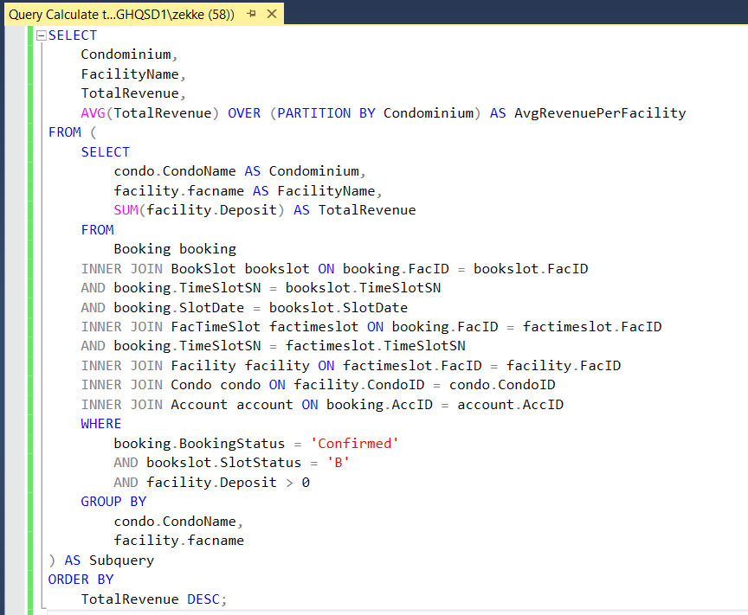

**Jason Query 1 Result:**

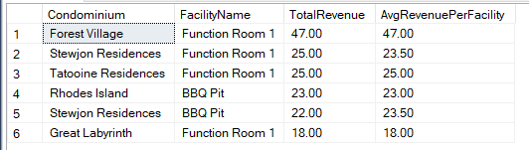

**Jason Query 2:**

List tenants who provided feedback with confirmed bookings.

This query provides users with feedback that is created by accounts that have confirmed bookings, therefore an inference can be made that this feedback is pertaining to the booked facility or something of relevance. As such, feedback that would be valuable is highlighted in this query, being brought to attention.

**This query utilizes:**

1. **INNER JOIN** statements to join tables from **Feedback** > **Account** > **Condo** > **Booking** > **BookSlot** > **FacTimeSlot** > **Facility**
2. **WHERE** statements to filter tuples with:
   1. SlotStatus = ‘B’ for ‘Booked’ in table **BookSlot**
   2. BookingID in table **Booking** is not null

**Jason Query 2:**

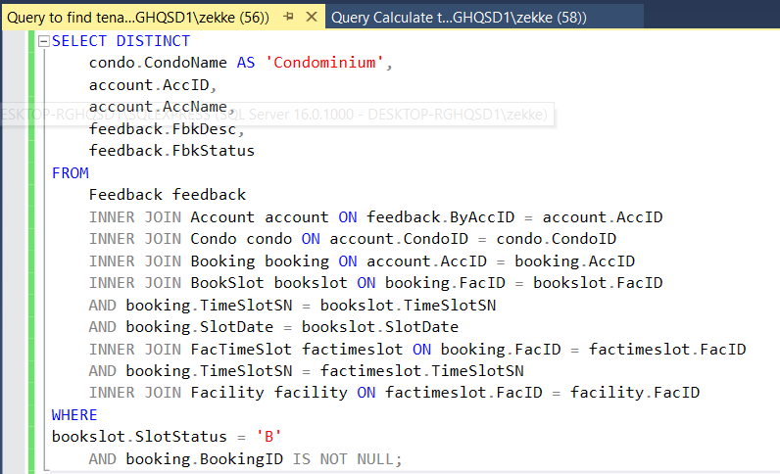

**Jason Query 2 Result:**

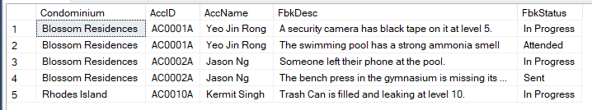

**Jason Query 3:**

Query to find tenants with contract lasting less than 3 months (i.e. Illegal Tenants)

This query provides the user tenants that are not legal in Singapore, where tenancy is below 3 months duration, or their Tenancy has exceeded their Contract End Date. This allows the Condominium Management to verify that the Condominium does not house any illegal tenants, which could result in legal issues.

**This query utilizes:**

1. **SELECT** statements with COUNT() and MAX() to get the count of TenantID(s) (AccID) for a particular condominium, and the information of Condo Manager and his/her respective Condo Management Company
2. **WHERE** statements to filter tuples with
   1. SlotStatus = ‘B’ for ‘Booked’ in table **BookSlot**
   2. BookingID in table **Booking** is not null
3. **INNER JOIN** statements to join table **Account** > **Condo** > **Tenant** > **CondoMgmt** > **Account** (Using CondoMgmtID = AccID)
4. **WHERE** statements to filter tuples with difference in month between ContractStartDate and ContractEndDate is less than 3, in table **Tenant**
5. **GROUP BY** statement to filter tuples by CondoName from table **Condo**
6. **ORDER BY** statement to order tuples by **COUNT(TenantID)** by descending order

**Jason Query 3:**

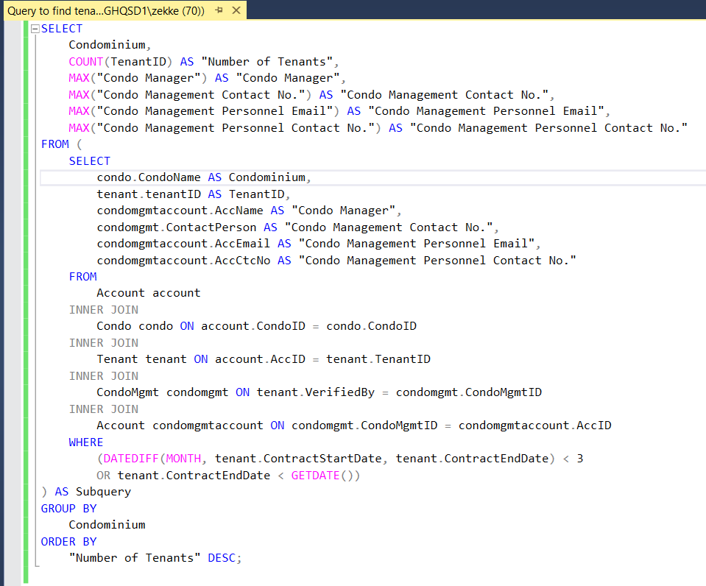

**Jason Query 3 Result:**



* **Ding Xuan’s Queries**

**Ding Xuan Query 1:**

Retrieve announcements in February and its relevant information

This provides users, such as Condo Managers, the ability to sort announcements and retrieve information pertaining to it. This allows Condominium staff or users to view announcements upcoming in the month of February in the app. The query can be altered by Year and Month in the WHERE statement, thus this can be used as a filter or a calendar functionality in MyCondoApp

**This query utilizes:**

1. **INNER JOIN** to join table from **Announcement** > **CondoMgmt** > **Accoun**t
2. **WHERE** filter tuples that AnnStartDate in table **Announcement:**
   1. Year = ‘2024’
   2. Month = ‘2’ for February
3. **GROUP BY** statement to group by order of SELECT statements

**Ding Xuan Query 1:**

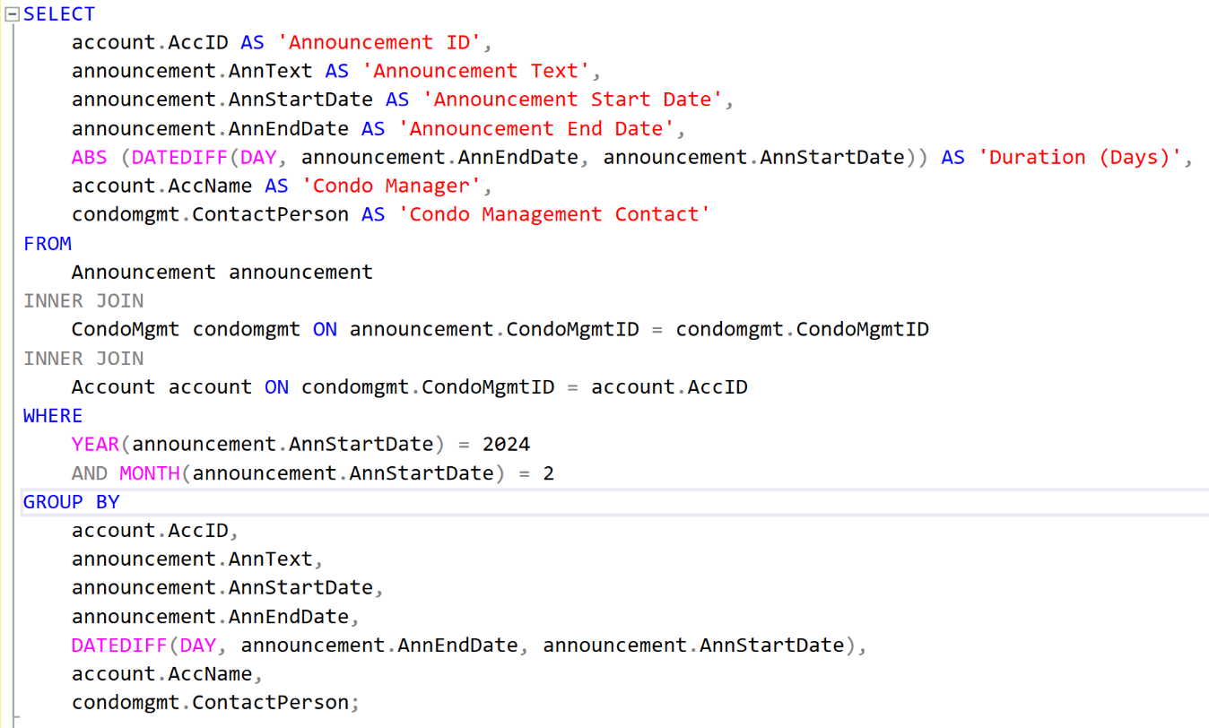

**Ding Xuan Query 1 Result:**



**Ding Xuan Query 2:**

Retrieve vehicle labels that have approved status, and thus information such as the vehicle number, whomever approved it (CondoMgmt) as well as the account that applied for it (Account).

This allows for the user to track all approved Vehicle Labels, thus assuming that once they are Approved, they are also Issued, this also serves to track all active vehicle labels. Hence, the account associated with the Vehicle Label and accountable Condo Management personnel is tracked. Thus, this information can be used to track all approved vehicles in the condominium, and any vehicle not present (by Vehicle No.) in this query can easily be identified as unapproved. Thus, investigative procedures or corrective measures can commence if an unapproved vehicle is detected.

**This query utilizes:**

1. **INNER JOIN** to join table **VehLabel** to **Vehicle** > **Account** > **CondoMgmt** > **CondoManagerAccount**
2. **WHERE** statement to filter tuples that
   1. VehLblStatus is ‘Approved’ in table
   2. IssuedBy (CondoMgmtID) is NOT NULL (i.e. is issued by a Condo Manager) in table **VehLabel**
3. **GROUP BY** statement to group by order of SELECT statements
4. **ORDER BY** statement to order by AccName in table **Account** for a respective CondoMgmt tuple

**Ding Xuan Query 2:**

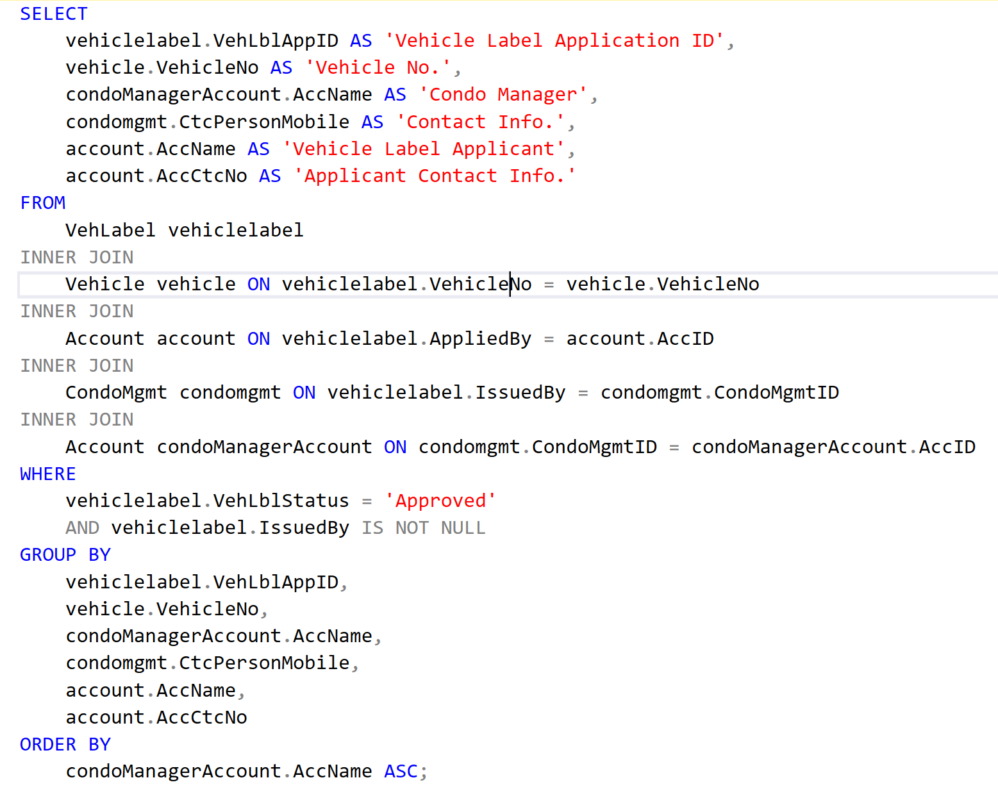

**Ding Xuan Query 2 Result:**

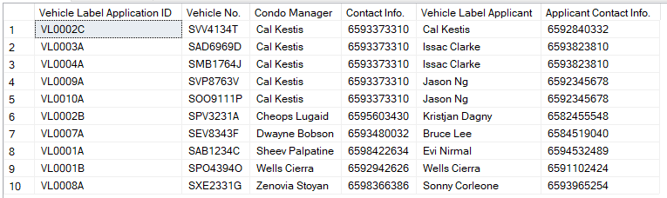

**Ding Xuan Query 3:**

Retrieve all item related information where item category is 'Electronics' and grouped by whether for sale or for purchase

This query serves to filter messages in the MyCondoApp by “Garage Sale” and Item Category of Electronics, this can be used as a category filter in the app. The ItemCatDesc statement in the WHERE statement can be tweaked to another category.

**This query utilises:**

1. **INNER JOIN** to join table from **Message** > **Account** > **ItemRelated** > **ItemCategory** > **ItemPhoto**
2. **WHERE** statement to filter tuples that
   1. MsgType is ‘GS’ in table **Message**
   2. ItemCatDesc is ‘Electronics’ in table **ItemCategory**
3. **GROUP BY** statement to group by order of SELECT statements
4. **ORDER BY** statement to order by AccID in table **Account** in Ascending Order

**Ding Xuan Query 3:**

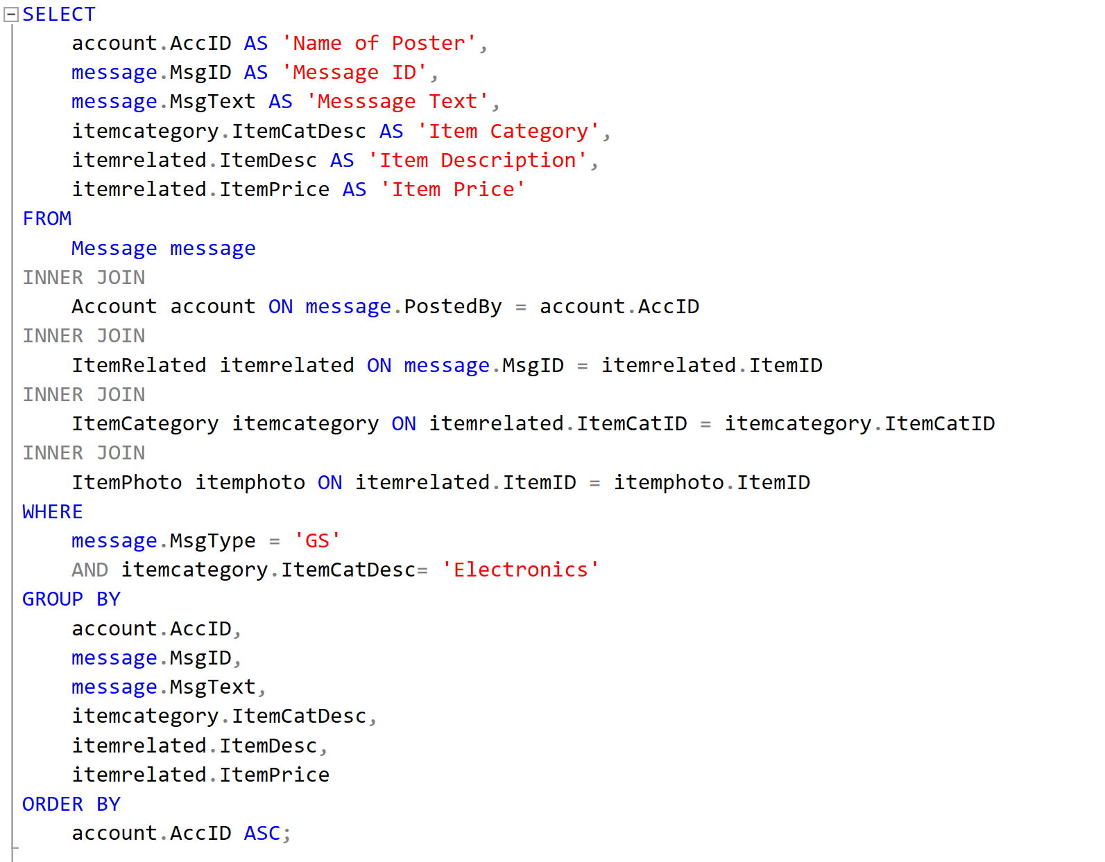

**Ding Xuan Query 3 Result:**  
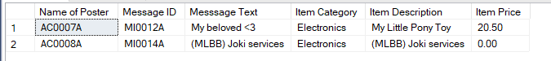

* **Garrett’s Queries**

**Garrett Query 1:**

Retrieve list and information of emergency services that are near to each condominium development grouped by condominium development.

This allows users, particularly Condominium Managers, to visualize whether there are an appropriate and adequate amount of contactable medical facilities located in the vicinity of the Condominium.

In the event that there are insufficient medical/emergency contacts, the condominium has to provide sufficient medical response amenities such as AEDs (automated external defibrillator) or First Aid Kits to ensure the safety of residents.

**This query utilizes:**

1. **INNER JOIN** to join table from **Condo** > **CondoUsefulContact** > **UsefulContact** > **ContactCategory**
2. **WHERE** filters tuples that:
   1. CtcCatDesc is ‘Medical/Emergency’ in table **ContactCategory**
3. **GROUP BY** statement to group by order of SELECT statements.
4. **ORDER BY** statement to order by CondoID from table **Condo** in ascending order

**Garrett Query 1:**

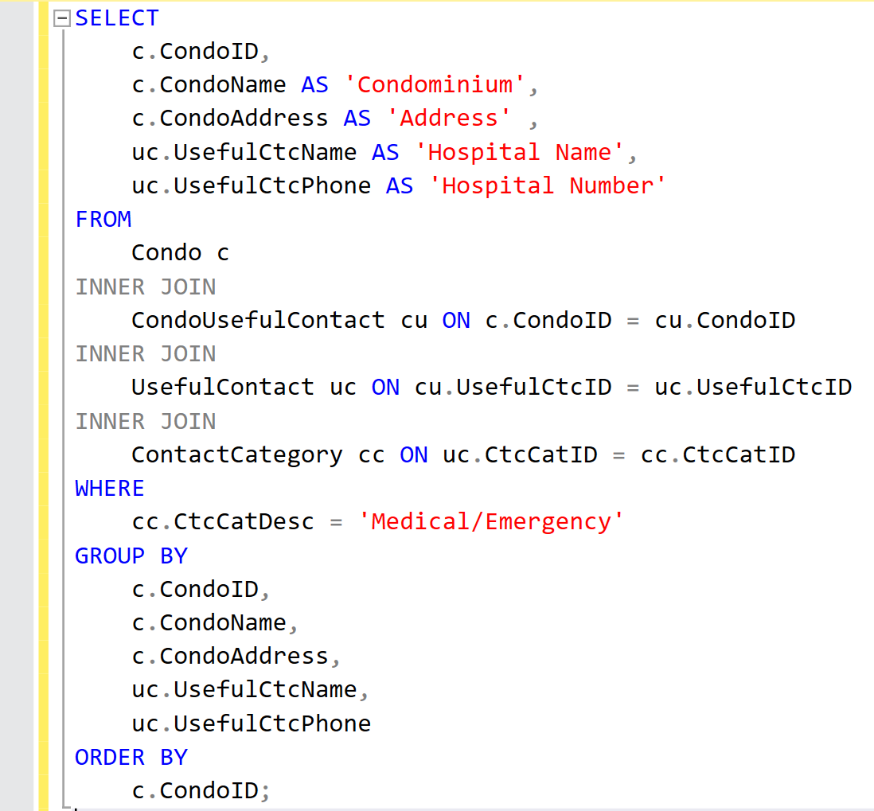

**Garrett Query 1 Result:**

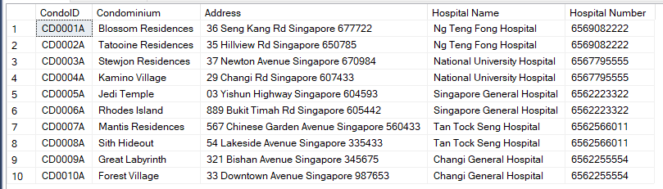

**Garret Query 2:**

Retrieve the list of facilities that will be undergoing maintenance from 24th to 31st Jan, grouped by condominium development.

This query allows Condominium Managers to identify which Condominium and Facilities are under maintenance, which can provide succinct information for Condo Managers to post announcements based on this information.

**This query utilizes:**

1. **INNER JOIN** to join table from **Condo** > **Facility** > **FacTimeSlot** > **BookSlot**
2. **WHERE** filters tuples that In Table **BookSlot:**
   1. SlotStatus = ‘M’
   2. SlotDate between 31 Jan and 17 Feb
3. **GROUP BY** statement to group by order of **SELECT** statements
4. **ORDER BY** statement to order by CondoID from table **Condo** in ascending order

**Garrett Query 2:**

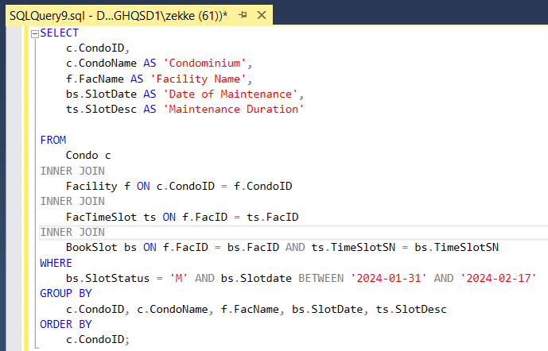

**Garrett Query 2 Result:**

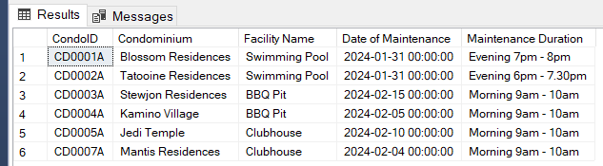

**Garrett Query 3:**

Calculate average tenancy duration by condominium development.

This query allows Condominium Managers to identify Condominium developments with anomalous tenancy durations (i.e. too long or too short). This allows the Condominium Managers to pinpoint specific Condominiums that require investigation or law enforcement involvement. For example, there could be illegal tenants resulting in shorter-than-average tenancy durations. Conversely, if average tenancy duration is absurdly long, it could be due to falsified tenancy contracts

**This query utilizes:**

1. **INNER JOIN** to join table from **Condo** > **Account** > **Tenant**
2. **COUNT** allows to find the number of tenants per condominium
3. **AVG** allows to find average tenancy duration per condominium (i.e Difference between ContractStartDate and ContractEndDate in table **Tenant**)
4. **GROUP BY** statement to group by order of SELECT statements

**Garrett Query 3:**

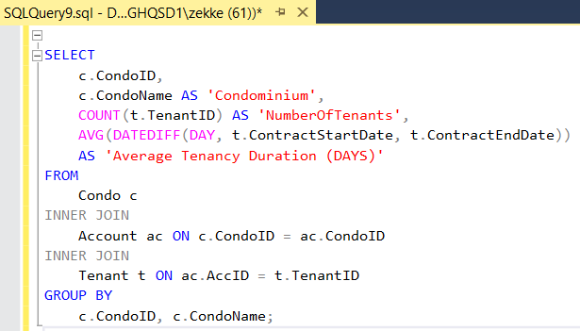

**Garrett Query 3 Result:**

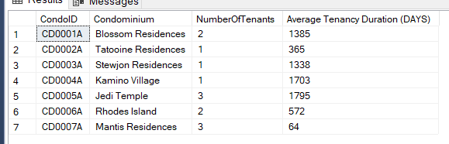

# Assumptions:

## Generalised Assumptions:

* These are assumptions that cannot be categorized or associated with a specific entity, hence are considered generalized and applicable to most of the Entity-Relationship Diagram.

1. Assume that all inputs into the MyCondoApp are true and not falsified (such as legitimate vehicle numbers, legitimate VU numbers)
2. Assume that the system performs validations on user-inputted data to ensure accuracy and consistency
3. Assume that for all attributes that do not accept null values, this is due to the MyCondoApp not allowing users to input null values for the associated field (i.e Vehicle No. cannot be blank when applying for a vehicle label)

## Entity-Related Assumptions:

1. Account
   * AccName and AccAddress are required fields when constructing a new account on the MyCondoApp
   * AccName consists of both the user’s first name and last name
   * AccCtcNo only accepts Singaporean phone numbers, the AccCtcNo will be format of 65xxxxxxxx
   * AccEmail is not a mandatory field, hence accepts null value but must be unique.
   * CondoID does not accept NULL values as it has total participation from relationship Account -> Condo, hence all Accounts consist of a Condo
   * ApprovedBy accepts NULL values as it is only partial participation from relationship Account -> Staff, as only some Accounts are approved by Staff
   * Assume that individuals only utilise one account, therefore assigned only one MyCondoApp account (possibly linked to NRIC or Singpass)
   * Owner, Tenant and CondoMgmt cannot overlap, hence CondoMgmt, Owner and Tenant being disjoint types of Account.
   * Assume that only when ApprovedBy is not a null value, that the Account is valid and able to function (i.e can log in, can message, can book). ApprovedBy will be done by a Staff whose StaffRole is “Admin”.
2. Announcement
   * Condo Managers can post announcements in advance, with a stipulated time and date
   * Expired Announcement(s) are automatically deleted and removed from database
   * Announcements can only be posted if they have a valid AnnText, hence does not accept NULL values
   * CondoMgmtID cannot have NULL values, due to total participation from Announcement > CondoMgmtID, hence all announcements must be put by CondoMgmt
3. Booking

* When a Booking is made by an Account, it will have its BookingStatus be set to “Pending Payment'' and it’s corresponding BookSlot tuple will have it’s BookSlotStatus be “R”(i.e Reserved). However, once a Booking's payment is made successfully, it will update BookingStatus to “Confirmed” and update it’s corresponding BookSlot Tuple, changing it’s BookSlotStatus to “Booked”
* BookingStatus can only have three states of “Pending Payment”, “Confirmed” or “Cancelled”
* BookingDate must be equal or earlier than SlotDate, however this cannot be set as an SQL constraint due to SlotDate accepting null values
* Once a Booking is cancelled by an Account, it’s BookingStatus will be set to “Cancelled” and it’s ForeignKey referencing BookSlot(FacID, TimeSlotSN, SlotDate) will be set to NULL values, this is to avoid conflicts in the 1-1 relationship between Booking and BookSlot (i.e allow someone else to book the same BookSlot)

1. BookSlot
   * FacID and TimeSlotSN cannot have NULL values, due to total participation from BookSlot -> FacTimeSlot. hence there are many BookSlots for a particular FacTimeSlot and all BookSlots are for a FacTimeSlot
2. Condo
   * All Condos are Singapore-Based hence will have a postal code of 6 digits and Singapore within the address.
3. CondoMgmt
   * ContactPerson specifically refers to the contact person of the condo management company who handles queries and customer service (such as Human Resources or Customer Service personnel), Consequently, CtcPersonMobile will be the contact number of this contact person. (i.e, ContactPerson and CtcPersonMobile are distinct from AccName and AccCtcNo)
   * Elaborating on the previous assumption, therefore for a specific CondoMgmt account, to find the details of a specific Condo Manager, an INNER JOIN between Account and CondoMgmt has to be executed, in reference to the data dictionary where CondoMgmtID is a foreign key of AccID in Account. The inner joined Account tuple will therefore reference the Condo Manager’s personal details.
   * As CtcPersonMobile is UNIQUE, it does not accept NULL values such that there are no duplicate NULL values
4. CondoUsefulContact
   * CondoUsefulContact represents the many to many relationship between Condo and UsefulContact, with partial participation from both sides.. However, this cannot be reflected in SQL tables as they only accept one value for a given attribute, hence the entity CondoUsefulContact exists to reflect this relationship properly in the database
5. ContactCat
   * All tuples must have distinct and meaningful CtcCatDesc values, one tuple will have the CtcCatDesc “Not Applicable” to accommodate UsefulContact with no applicable categories
6. Facility
   * Facility Name must not be null, must contain a value that corresponds accordingly to FacID, this is in line with the App Mock-Up shown in Appendix
   * Deposit if unknown, default value will be entered as $0, hence deposit will not be nullable and that the Deposit required for facility booking is a fixed amount or a percentage of the total booking cost
   * Deposit in this context is assumed to be effectively the revenue generated by the facility, as deposits are not returned to the user
   * CondoID must not be null, due to total participation of Facility in the relationship of Facility>Condo. Hence, one condo can own many Facility, and all Facility must belong to it’s respective Condo
7. FacTimeSlot
   * SlotDesc must not be null, so that the database has appropriate values to represent the FacTimeSlot in the mobile application interface, such as shown in mobile interface
8. Feedback
   * When providing Feedback, the FbkDesc is a required field, hence will not accept NULL values
   * FbkDateTime is automatically input as GETDATE() when the user provides feedback on myCondoApp
   * FbkStatus is a required field, in order to track and maintain accountability for FbkStatus, by default, it will always be “Sent” upon tuple insertion
   * ByAccID is not null due to Total Participation between the relationship of Feedback to Account. This means that all Feedback must be reported by an Account. However, not all accounts report feedback
   * FbkCatID is not null due to Total Participation between the relationship of Feedback to FeedbkCat, resulting in all Feedback being able to be filtered by FeedbkCat, and many Feedback(s) being filtered by one Feedback Category
9. FeedbkCat
   * All tuples must have distinct and meaningful FbkCatDesc values, one tuple will have the FbkCatDesc “Others” to accommodate Feedback with no corresponding categories. This is due to Appendix C [an example of a user providing feedback on MyCondoApp] where Feedback Category is a dropdown menu, thus having finite options
10. ItemCategory
    * All tuples must have distinct and meaningful ItemCatDesc values, one tuple will have the ItemCatDesc “Others” to accommodate ItemRelated with no corresponding categories
11. ItemPhoto
    * An ItemRelated (which is a sub-type of Message) can contain multiple ItemPhoto(s), hence there is a many to many relationship between ItemRelated and ItemPhoto, with total participation from ItemPhoto and partial participation from ItemRelated. However, this cannot be reflected in SQL tables as they only accept one value for a given attribute, hence ItemPhoto entity exists to reflect the relationship properly in the database
12. ItemRelated
    * ItemDesc cannot be empty/null, as in the App, when prompted for ItemRelated Information, ItemDesc text area cannot be left empty
    * ItemPrice smallmoney has to have a value, even if the item is free, as NULL is not 0, it is not acceptable as an input. If price is negotiable, an estimate still must be provided
    * ItemStatus must have a status of the item as it is a required field and binary choice in the app (i.e Available/Sold button), hence it does not accept NULL values.
    * SaleOrRent must have a status of the item as it is a required field and binary choice in the app (i.e for sale/ for rent button), hence it does not accept NULL values
    * ItemCatID is nullable as ItemRelated message is not necessary to have a ItemCategory. This is due to the ItemRelated having partial participation in the relationship with ItemCategory, thus not all ItemRelated entities have an ItemCategory associated with it. If ItemCategory is not known or is uncategorized, it will be left as NULL
13. Likes
    * N/A
14. Message
    * MsgText does not accept NULL values. This is due to the App not allowing the user to post a message unless there is an input in the MsgText input text area
    * MsgType does not accept NULL values. This is due to the message type being a drop down select menu and a required field for message posting
    * PostedBy is not null due to Total Participation between the relationship of Message to Account. This means that all Message must be posted by an Account
    * ReplyTo can be a null value, if it is the first message in a specific message thread
15. Owner
    * When an owner creates an account, they must key in OwnStartDate in order to be eligible to create the disjoint account type owner
    * OwnStartDate cannot be later than the current date when entering tuple into database. This is due to the assumption that only once full ownership of the Condominium Property is acquired, will they be able to create an Owner Account Type
    * CheckedBy can be null due to the partial participation between both Owner and CondoMgmt, where many owners can be checked by one CondoMgmt. Hence, not all Owner(s) will be checked by a CondoMgmt
16. Staff
    * Staff Name is not null, this is so that Staff Name can be displayed in the mobile app interface
    * Staff are all Singaporeans, hence StaffContactNo utilise singapore-based phone numbers. It is required so that staff are contactable in the event of an emergency as well as to ensure unique tuple of StaffContactNo
    * StaffDateJoined cannot be past the current date of constructing the Staff Tuple as it is only entered on the Staff’s commencement of employment. It is a mandatory field
    * StaffRole currently only has “Admin”, “Customer Service” and “Tech Support” roles; constraints have to be altered to accommodate more roles. Only “Admin” are able to approve Accounts, hence the partial participation for the relationship between Staff and Account.
17. TempVehLabel
    * TempStartDate and TempExpiryDate must not be null as TempVehLabel must have a valid derived duration
18. Tenant
    * Tenancy Contract Duration, should fall under a minimum of 3 months. This is to fall in line with Singapore Tenancy Agreement Law, under CONTROLLED PREMISES (SPECIAL PROVISIONS) ACT; Hence ContractStartDate and ContractEndDate cannot be NULL
    * VerifiedBy can be null as there is partial participation between Tenant and CondoMgmt where 1 CondoMgmt verified many Tenant(s). Hence, it can be a NULL value
19. UsefulContact
    * UsefulCtcName is NOT NULL as it provides more information, so that when displayed in the MyCondoApp, there is a UsefulCtcName associated with it.
    * UsefulContacts are all Singapore-based, hence UsefulCtcPhone will be a singapore phone number, following the format of 65xxxxxxxx
    * CtcCatID is nullable due to Partial Participation between the relationship of UsefulContact to ContactCategory. This means that only some UsefulContact(s) will have a ContactCategory.
20. Vehicle
    * IUNo can be nullable due to it being an optional input field as seen in Appendix A
    * Ownership is not nullable as it is a dropdown menu selection, hence cannot accommodate NULL values as seen in Appendix A
    * In Appendix A, vehicle make and model are required in the field, thus are not able to accommodate NULL values. Hence, they do not accept NULL values.
21. VehLabel
    * VehLblStatus does not accommodate null values, hence is not nullable. By default, all tuples will be inserted with “Pending” and changed to “Approved” or “Rejected” after being checked by CondoMgmt.
    * VehLblNum is nullable as it is only provided once VehicleLabel is Approved.
    * VehicleNo is not nullable due to Total Participation between the relationship of Vehicle to Vehicle Label. This means that all VehicleLabel applications must be given by a Vehicle. Many VehicleLabel applications (whether temporary or permanent) may be given to one vehicle
    * AppliedBy is not nullable due to TotalParticipation between the relationship of VehicleLabel to Account. This means that all VehicleLabel applications must be applied by an Account. Many VehicleLabel applications (whether temporary or permanent) may be applied by one Account.
    * IssuedBy is nullable due to Partial Participation between the relationship of VehicleLabel to CondoMgmt. This means that not all VehicleLabel(s) must be issued by CondoMgmt. One CondoMgmt can issue many VehicleLabel(s) but not necessarily.

# Conclusion:

In summary, the condominium database design stands out for its effective management of diverse community aspects. Through distinct account types (Condo Management, Owner, and Tenant), the system accurately represents various roles within the community.

The incorporation of foreign key relationships ensures referential integrity, while entities such as Feedback, Useful Contacts, Facilities, Booking, and Announcements facilitate streamlined processes. The data comprehensively captures the relationships and attributes essential for managing accounts, facilities, bookings, announcements, label applications, vehicle labels, parking lots, feedback, messages, and useful contacts within a condominium environment.

Furthermore, the system accommodates a versatile messaging feature, allowing users to post messages, including a sub-type for selling items. This holistic approach to data organization and functionality positions the condominium database as an efficient and comprehensive solution for community management

# Appendix A:

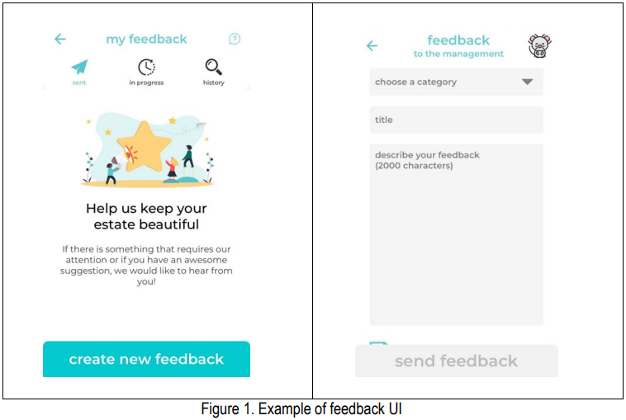

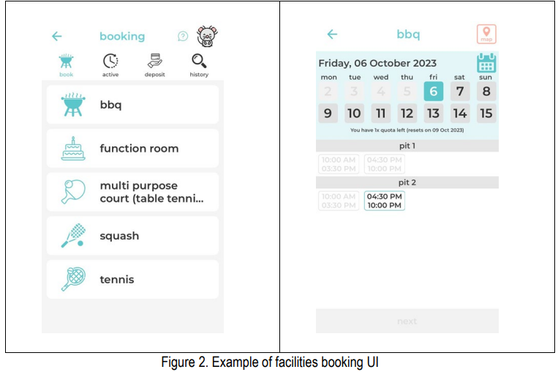

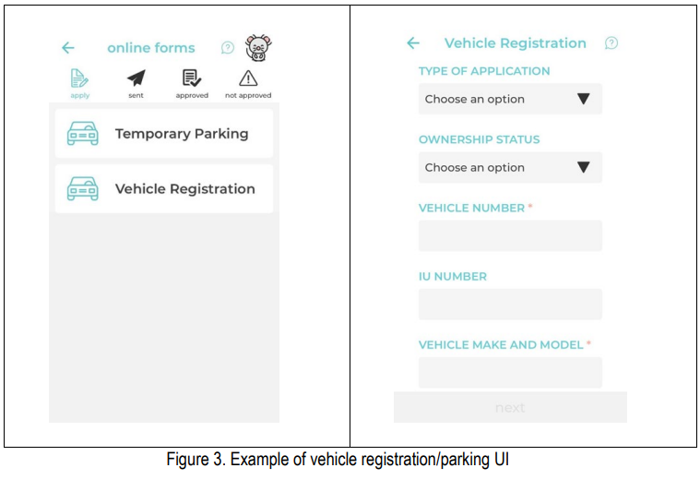

# Appendix B:

1. **SQL Create Query for Table (Account)**

CREATE TABLE Account

(

AccID char(7) NOT NULL,

AccName varchar(30) NOT NULL,

AccAddress varchar(100) NOT NULL,

AccCtcNo char(10) NULL UNIQUE,

AccEmail varchar(50) NULL UNIQUE,

CondoID char(7) NOT NULL,

ApprovedBy char(7) NULL,

CONSTRAINT PK_Account PRIMARY KEY (AccID),

CONSTRAINT FK_AccountApprovedBy_Staff FOREIGN KEY (ApprovedBy) REFERENCES Staff(StaffID),

CONSTRAINT Account_AccID_Format CHECK (AccID LIKE 'AC[0-9][0-9][0-9][0-9][A-Za-z]'),

CONSTRAINT Account_AccCtcNo_Format CHECK (AccCtcNo LIKE '65[0-9][0-9][0-9][0-9][0-9][0-9][0-9][0-9]'),

CONSTRAINT Account_ApprovedByStaff_Format CHECK (ApprovedBy LIKE 'ST[0-9][0-9][0-9][0-9][A-Z]')

);

1. **SQL Query to Create Table (Announcement)**

CREATE TABLE Announcement

(

AnnID char(7) NOT NULL,

AnnText varchar(1000) NOT NULL,

AnnStartDate smalldatetime NOT NULL,

AnnEndDate smalldatetime NOT NULL,

CondoMgmtID char(7) NOT NULL,

CONSTRAINT PK_Announcement PRIMARY KEY (AnnID),

CONSTRAINT FK_Announcement_AnnouncedByCondoMgmt FOREIGN KEY (CondoMgmtID) REFERENCES CondoMgmt(CondoMgmtID),

CONSTRAINT AnnStartDate_Check CHECK (AnnStartDate < AnnEndDate),

CONSTRAINT AnnID_Format CHECK (AnnID LIKE 'AN[0-9][0-9][0-9][0-9][A-Za-z]')

);

1. **SQL Query to Create Table (Booking)**

CREATE TABLE Booking

(

BookingID char(7) NOT NULL,

BookingDate varchar(20) NOT NULL,

BookingStatus varchar(100) NOT NULL,

AccID char(7) NOT NULL,

FacID char(7) NULL,

TimeSlotSN integer NULL,

SlotDate smalldatetime NULL,

CONSTRAINT PK_Booking PRIMARY KEY (BookingID),

CONSTRAINT FK_Booking_AccID FOREIGN KEY (AccID) REFERENCES Account(AccID),

CONSTRAINT FK_Booking_BookSlot FOREIGN KEY (FacID, TimeSlotSN, SlotDate) REFERENCES BookSlot(FacID, TimeSlotSN, SlotDate),

CONSTRAINT Booking_BookingID_Format CHECK (BookingID LIKE 'BK[0-9][0-9][0-9][0-9][A-Za-z]'),

CONSTRAINT Booking_BookingStatus_Format CHECK (BookingStatus IN ('Pending Payment', 'Confirmed', 'Cancelled'))

);

1. **SQL Query to Create Table (BookSlot)**

CREATE TABLE BookSlot

(

FacID char(7) NOT NULL,

TimeSlotSN integer NOT NULL,

SlotDate smalldatetime NOT NULL,

SlotStatus char(1) NOT NULL,

CONSTRAINT PK_BookSlot PRIMARY KEY (FacID, TimeSlotSN, SlotDate),

CONSTRAINT FK_BookSlot_FacTimeSlot FOREIGN KEY (FacID, TimeSlotSN) REFERENCES FacTimeSlot(FacID, TimeSlotSN),

CONSTRAINT BookSlot_FacID_Format CHECK (FacID LIKE 'FA[0-9][0-9][0-9][0-9][A-Za-z]'),

CONSTRAINT BookSlot_SlotStatus_Format CHECK (SlotStatus IN ( 'A', 'B', 'M', 'R'))

);

1. **SQL Query to Create Table (Condo)**

CREATE TABLE Condo

(

CondoID char(7) NOT NULL,

CondoName varchar(50) NULL,

CondoAddress varchar(100) NULL,

CONSTRAINT PK_Condo PRIMARY KEY (CondoID),

CONSTRAINT CondoID_Format CHECK (CondoID LIKE 'CD[0-9][0-9][0-9][0-9][A-Za-z]')

);

1. **SQL Query to Create Table (CondoMgmt)**

CREATE TABLE CondoMgmt

(

CondoMgmtID char(7) NOT NULL,

ContactPerson varchar(20) NULL,

CtcPersonMobile char(10) NULL UNIQUE,

CONSTRAINT PK_CondoMgmt PRIMARY KEY (CondoMgmtID),

CONSTRAINT FK_CondoMgmt_Account FOREIGN KEY (CondoMgmtID) REFERENCES Account(AccID),

CONSTRAINT CondoMgmt_AccID_Format CHECK (CondoMgmtID LIKE 'AC[0-9][0-9][0-9][0-9 [A-Za-z]'),

CONSTRAINT CtcPersonMobile_Format CHECK (CtcPersonMobile LIKE '65[0-9][0-9][0-9][0-9][0-9][0-9][0-9][0-9]')

);

1. **SQL Query to Create Table (CondoUsefulContact)**

CREATE TABLE CondoUsefulContact

(

CondoID char(7) NOT NULL,

UsefulCtcID char(7) NOT NULL,

CONSTRAINT PK_CondoUsefulContact PRIMARY KEY (CondoID, UsefulCtcID),

CONSTRAINT FK_CondoUsefulContact_CondoID FOREIGN KEY (CondoID) REFERENCES Condo(CondoID),

CONSTRAINT FK_CondoUsefulContact_UsefulCtcID FOREIGN KEY (UsefulCtcID) REFERENCES UsefulContact(UsefulCtcID)

CONSTRAINT CondoUsefulContact_CondoID_Format CHECK (CondoID LIKE 'CD[0-9][0-9][0-9][0-9][A-Za-z]'),

CONSTRAINT CondoUsefulContact_UsefulCtcID_Format CHECK (UsefulCtcID LIKE

'UC[0-9][0-9][0-9][0-9][A-Za-z]')

);

1. **SQL Query to Create Table (ContactCategory)**

CREATE TABLE ContactCategory

(

CtcCatID char(7) NOT NULL,

CtcCatDesc varchar(100) NOT NULL,

CONSTRAINT PK_ContactCat PRIMARY KEY (CtcCatID),

CONSTRAINT CtcCatID_Format CHECK (CtcCatID LIKE 'CC[0-9][0-9][0-9][0-9][A-Za-z]')

);

1. **SQL Query to Create Table (Facility)**

CREATE Table Facility

(

FacID char(7) NOT NULL,

FacName varchar(100) NOT NULL,

Deposit smallmoney NOT NULL,

CondoID char(7) NOT NULL,

CONSTRAINT PK_Facility PRIMARY KEY (FacID),

CONSTRAINT FK_Facility_CondoID FOREIGN KEY (CondoID) REFERENCES Condo(CondoID),

CONSTRAINT FacID_Format CHECK (FacID LIKE 'FA[0-9][0-9][0-9][0-9][A-Za-z]'),

CONSTRAINT Facility_CondoID_Format CHECK (CondoID LIKE 'CD[0-9][0-9][0-9][0-9][A-Za-z]')

);

1. **SQL Query to Create Table (FacTimeSlot)**

CREATE TABLE FacTimeSlot

(

FacID char(7) NOT NULL,

TimeSlotSN integer NOT NULL,

SlotDesc varchar(100) NOT NULL,

CONSTRAINT PK_FacTimeSlot PRIMARY KEY (FacID, TimeSlotSN),

CONSTRAINT FK_FacTimeSlot_FacID FOREIGN KEY (FacID) REFERENCES Facility(FacID),

CONSTRAINT FacTimeSlot_FacID_Format CHECK (FacID LIKE 'FA[0-9][0-9][0-9][0-9][A-Za-z]'),

);

1. **SQL Query to Create Table (Feedback)**

CREATE TABLE Feedback

(

FbkID char(7) NOT NULL,

FbkDesc varchar(2000) NOT NULL,

FbkDateTime smalldatetime NOT NULL,

FbkStatus varchar(15) NOT NULL,

ByAccID char(7) NOT NULL,

FbkCatID char(7) NOT NULL,

CondoMgmtID char(7) NULL,

CONSTRAINT PK_Feedback PRIMARY KEY (FbkID),

CONSTRAINT FK_Feedback_AccID FOREIGN KEY (ByAccID) REFERENCES Account(AccID),

CONSTRAINT FK_Feedback_FbkCatID FOREIGN KEY (FbkCatID) REFERENCES FeedbkCat(FbkCatID),

CONSTRAINT FK_Feedback_CondoMgmtID FOREIGN KEY (CondoMgmtID) REFERENCES CondoMgmt(CondoMgmtID),

CONSTRAINT Feedback_FbkID_Format CHECK (FbkID LIKE 'FB[0-9][0-9][0-9][0-9][A-Za-z]'),

CONSTRAINT Feedback_FbkDateTime_Format CHECK (FbkDateTime <= GETDATE()),

CONSTRAINT Feedback_AccID_Format CHECK (ByAccID LIKE 'AC[0-9][0-9][0-9][0-9][A-Za-z]'),

CONSTRAINT Feedback_FbkStatus_Format CHECK (FbkStatus IN ('Sent', 'In Progress', 'Attended'),

CONSTRAINT Feedback_FbkCatID_Format CHECK (FbkCatID LIKE 'FC[0-9][0-9][0-9][0-9][A-Za-z]'),

CONSTRAINT Feedback_CondoMgmtID_Format CHECK (CondoMgmtID LIKE 'AC[0-9][0-9][0-9][0-9][A-Za-z]')

);

1. **SQL Query to Create Table (FeedbkCat)**

CREATE TABLE FeedbkCat

(

FbkCatID char(7) NOT NULL,

FbkCatDesc varchar(20) NOT NULL,

CONSTRAINT PK_FeedbkCat PRIMARY KEY (FbkCatID),

CONSTRAINT FeedbkCat_FbkCatID_Format CHECK (FbkCatID LIKE 'FC[0-9][0-9][0-9][0-9][A-Za-z]'),

CONSTRAINT FeedbkCat_FbkCatDesc_Format CHECK (FbkCatDesc IN ('Cleanliness', 'Security', 'Plumbing', 'Building Defects', 'Others'))

);

1. **SQL Query to Create Table (ItemCategory)**

CREATE TABLE ItemCategory

(

ItemCatID char(7) NOT NULL,

ItemCatDesc varchar(20) NOT NULL,

CONSTRAINT PK_ItemCategory PRIMARY KEY (ItemCatID),

CONSTRAINT ItemCategory_ItemCatID_Format CHECK (ItemCatID LIKE 'IC[0-9][0-9][0-9][0-9][A-Za-z]'),

CONSTRAINT ItemCategory_ItemCatDesc_Format CHECK (ItemCatDesc IN ('Homeware', 'Fashion', 'Furniture', 'Electronics', 'Others')

);

1. **SQL Query to Create Table (ItemPhoto)**

CREATE TABLE ItemPhoto

(

ItemID char(7) NOT NULL,

Photo varchar(100) NOT NULL,

CONSTRAINT PK_ItemPhoto PRIMARY KEY (ItemID, Photo),

CONSTRAINT FK_ItemPhoto_MsgID FOREIGN KEY (ItemID) REFERENCES Message(MsgID),

CONSTRAINT ItemPhoto_ItemID_Format CHECK (ItemID LIKE 'MI[0-9][0-9][0-9][0-9][A-Za-z]')

);

1. **SQL Query to Create Table (ItemRelated)**

CREATE TABLE ItemRelated

(

ItemID char(7) NOT NULL,

ItemDesc char(100) NOT NULL,

ItemPrice smallmoney NOT NULL,

ItemStatus varchar(15) NOT NULL,

SaleOrRent varchar(10) NOT NULL,

ItemCatID char(7) NULL,

CONSTRAINT PK_ItemRelated PRIMARY KEY (ItemID),

CONSTRAINT FK_ItemRelated_ItemID FOREIGN KEY (ItemID) REFERENCES Message (MsgID),

CONSTRAINT FK_ItemRelated_ItemCatID FOREIGN KEY (ItemCatID) REFERENCES ItemCategory (ItemCatID),

CONSTRAINT ItemRelated_ItemCatID_FORMAT CHECK (ItemID LIKE 'MI[0-9][0-9][0-9][0-9][A-Za-z]'),

CONSTRAINT ItemRelated_ItemStatus CHECK (ItemStatus IN ('Available', 'Sold')),

CONSTRAINT ItemRelated_SaleOrRent CHECK (SaleOrRent IN ('For Sale', 'For Rent')),

CONSTRAINT ItemRelated_ItemCatID CHECK (ItemCatID LIKE 'IC[0-9][0-9][0-9][0-9][A-Za-z]'),

CONSTRAINT ItemPrice_Check CHECK (ItemPrice = ROUND(ItemPrice, 2))

);

1. **SQL Query to Create Table (Likes)**

CREATE TABLE Likes

(

AccID char(7) NOT NULL,

MessageID char(7) NOT NULL,

CONSTRAINT PK_Likes PRIMARY KEY (AccID, MessageID),

CONSTRAINT FK_Likes_AccID FOREIGN KEY (AccID) REFERENCES Account(AccID),

CONSTRAINT FK_Likes_MessageID FOREIGN KEY (MessageID) REFERENCES Message(MsgID),

CONSTRAINT Likes_AccID_Format CHECK (AccID LIKE 'AC[0-9][0-9][0-9][0-9][A-Za-z]'),

CONSTRAINT Likes_MessageID_Format CHECK (MessageID LIKE 'MI[0-9][0-9][0-9][0-9][A-Za-z]'),

);

1. **SQL Query to Create Table (Message)**

CREATE TABLE Message

(

MsgID char(7) NOT NULL,

MsgText varchar(100) NOT NULL,

MsgType varchar(20) NOT NULL,

PostedBy char(7) NOT NULL,

ReplyTo char(7) NULL,

CONSTRAINT PK_Message PRIMARY KEY (MsgID),

CONSTRAINT FK_Message_PostedByAcc FOREIGN KEY (PostedBy) REFERENCES Account(AccID),

CONSTRAINT FK_Message_ReplyToAcc FOREIGN KEY (ReplyTo) REFERENCES Account(AccID),

CONSTRAINT Message_MsgType_Format CHECK (MsgType IN ('CB', 'GS', 'FB')),

CONSTRAINT Message_PostedByAcc_Format CHECK (PostedBy LIKE 'AC[0-9][0-9][0-9][0-9][A-Z]'),

CONSTRAINT Message_ReplyToAcc_Format CHECK (ReplyTo LIKE 'AC[0-9][0-9][0-9][0-9][A-Z]'),

);

1. **SQL Query to Create Table (Owner)**

CREATE TABLE Owner

(

OwnerID char(7) NOT NULL,

OwnStartDate smalldatetime NOT NULL,

CheckedBy char(7) NULL,

CONSTRAINT PK_Owner PRIMARY KEY (OwnerID),

CONSTRAINT FK_Owner_CheckedByAcc FOREIGN KEY (CheckedBy) REFERENCES CondoMgmt(CondoMgmtID),

CONSTRAINT Owner_OwnerID_Format CHECK (OwnerID LIKE 'AC[0-9][0-9][0-9][0-9][A-Z]'),

CONSTRAINT Owner_CheckedByAcc_Format CHECK (CheckedBy LIKE 'AC[0-9][0-9][0-9][0-9][A-Z]'),

CONSTRAINT OwnStartDate_Format CHECK (OwnStartDate <= GETDATE())

);

1. **SQL Query to Create Table (Staff)**

CREATE TABLE Staff

(

StaffID char(7) NOT NULL,

StaffName varchar(30) NOT NULL,

StaffContactNo char(10) NOT NULL UNIQUE,

StaffDateJoined smalldatetime NOT NULL,

StaffRole varchar(20) NOT NULL,

CONSTRAINT PK_Staff PRIMARY KEY (StaffID),

CONSTRAINT Staff_StaffID_Format CHECK (StaffID LIKE 'ST[0-9][0-9][0-9][0-9][A-Z]'),

CONSTRAINT Staff_StaffContactNo_Format CHECK (StaffContactNo LIKE '65[0-9][0-9][0-9][0-9][0-9][0-9][0-9][0-9]'),

CONSTRAINT Staff_StaffDateJoined CHECK (StaffDateJoined <= GETDATE()),

CONSTRAINT Staff_StaffRole CHECK (StaffRole IN ('Admin', 'Customer Service', 'Tech Support'))

);

1. **SQL Query to Create Table (TempVehLabel)**

CREATE TABLE TempVehLabel

(

VehLblAppID char(7) NOT NULL,

TempStartDate smalldatetime NOT NULL,

TempExpiryDate smalldatetime NOT NULL,

CONSTRAINT PK_TempVehLabel PRIMARY KEY (VehLblAppID),

CONSTRAINT FK_TempVehLabel_VehLblAppID FOREIGN KEY (VehLblAppID) REFERENCES VehLabel(VehLblAppID),

CONSTRAINT Owner_VehLblAppID_Format CHECK (VehLblAppID LIKE 'VL[0-9][0-9][0-9][0-9][A-Z]'),

CONSTRAINT Owner_TempExpiryDate_Format CHECK (TempStartDate <= TempExpiryDate),

);

1. **SQL Query to Create Table (Tenant)**

CREATE TABLE Tenant

(

TenantID char(7) NOT NULL,

ContractStartDate smalldatetime NOT NULL,

ContractEndDate smalldatetime NOT NULL,

VerifiedBy char(7) NULL,

CONSTRAINT PK_Tenant PRIMARY KEY (TenantID),

CONSTRAINT FK_Tenant_TenantID FOREIGN KEY (TenantID) REFERENCES

Account(AccID),

CONSTRAINT FK_Tenant_VerifiedByCondoMgmt FOREIGN KEY (VerifiedBy) REFERENCES

CondoMgmt(CondoMgmtID),

CONSTRAINT Tenant_TenantID_Format CHECK (TenantID LIKE 'AC[0-9][0-9][0-9][0-9][A-Z]'),

CONSTRAINT Tenant_ContractStartDate_Format CHECK (ContractStartDate <= GETDATE()),

CONSTRAINT Tenant_ContactEndDate_Format CHECK (ContractStartDate < ContractEndDate),

CONSTRAINT Tenant_VerifiedBy_Format CHECK (VerifiedBy LIKE 'AC[0-9][0-9][0-9][0-9][A-Z]')

);

1. **SQL Query to Create Table (UsefulContact)**

CREATE TABLE UsefulContact

(

UsefulCtcID char(7) NOT NULL,

UsefulCtcName varchar(50) NOT NULL,

UsefulCtcDesc varchar(100) NULL,

UsefulCtcPhone char(10) NOT NULL,

CtcCatID char(7) NULL,

CONSTRAINT PK_UsefulContact PRIMARY KEY (UsefulCtcID),

CONSTRAINT FK_UsefulContact_CtcCatID FOREIGN KEY (CtcCatID) REFERENCES ContactCategory(CtcCatID),

CONSTRAINT UsefulContact_UsefulCtcID_Format CHECK (UsefulCtcID LIKE 'UC[0-9][0-9][0-9][0-9][A-Z]'),

CONSTRAINT UsefulCtcPhone_Format CHECK (UsefulCtcPhone LIKE '65[0-9][0-9][0-9][0-9][0-9][0-9][0-9][0-9]'),

CONSTRAINT UsefulContact_CtcCatID_Format CHECK (CtcCatID LIKE 'CC[0-9][0-9][0-9][0-9][A-Z]')

);

1. **SQL Query to Create Table (Vehicle)**

CREATE TABLE Vehicle

(

VehicleNo char(8) NOT NULL,

IUNo char(10) NULL,

Ownership varchar(30) NOT NULL,

Make varchar(30) NOT NULL,

Model varchar(30) NOT NULL,

CONSTRAINT PK_Vehicle PRIMARY KEY (VehicleNo),

CONSTRAINT Vehicle_VehicleNo_Format CHECK (VehicleNo LIKE 'S[A-Za-z][A-Za-z][0-9][0-9][0-9][0-9][A-Za-z]'),

CONSTRAINT Vehicle_IUNo_Format CHECK (IUNo IS NULL OR IUNo LIKE '%[0-9]%'),

CONSTRAINT Vehicle_Ownership_Format CHECK (Ownership IN ('Own', 'Rent', 'Company', 'Others'))

);

1. **SQL Query to Create Table (VehLabel)**

CREATE TABLE VehLabel

(

VehLblAppID char(7) NOT NULL,

VehLblStatus varchar(30) NOT NULL,

VehLblNum varchar(10) NULL,

VehicleNo char(8) NOT NULL,

AppliedBy char(7) NOT NULL,

IssuedBy char(7) NULL,

CONSTRAINT PK_VehLabel PRIMARY KEY(VehLblAppID),

CONSTRAINT FK_VehLabel_VehicleNo FOREIGN KEY (VehicleNo) REFERENCES Vehicle(VehicleNo),

CONSTRAINT FK_VehLabell_AppliedByAcc FOREIGN KEY (AppliedBy) REFERENCES Account(AccID),

CONSTRAINT FK_VehLabel_IssuedByCondoMgmt FOREIGN KEY (IssuedBy) REFERENCES

CondoMgmt(CondoMgmtID),

CONSTRAINT VehLabel_VehLblAppID_Format CHECK (VehLblAppID LIKE 'VL[0-9][0-9][0-9][0-9][A-Z]'),

CONSTRAINT VehLabel_VehLblStatus_Format CHECK (VehLblStatus IN ('Pending', 'Approved', 'Rejected'),

CONSTRAINT VehLabel_VehLblNum_Format CHECK (VehLblNum IS NULL OR VehLblNum LIKE '%[0-9]%'),

CONSTRAINT VehLabell_VehLblNum_Format CHECK (VehicleNo LIKE 'S[A-Za-z][A-Za-z][0-9][0-9][0-9][0-9][A-Za-z]'),

CONSTRAINT VehicleLabel_AppliedByAcc_Format CHECK (AppliedBy LIKE 'AC[0-9][0-9][0-9][0-9][A-Z]'),

CONSTRAINT VehicleLabel_IssuedByAcc_Format CHECK (IssuedBy LIKE 'AC[0-9][0-9][0-9][0-9][A-Z]')

);

# Appendix C:

1. **SQL Insert Query for Table (Account)**

INSERT INTO Account

VALUES

('AC0001A', 'Yeo Jin Rong', 'Blk 123 Blossom Residences #12-34', 6591067051, 'edricyeo.jr@gmail.com', 'CD0001A', 'ST0001A'),

('AC0002A', 'Jason Ng', 'Blk 123 Blossom Residences #66-66', 6592345678, 'JasonNg.KH@gmail.com', 'CD0001A', 'ST0001A'),

('AC0003A', 'Anakin Skywalker', 'Blk 532 Tatooine Residences #55-23', 6592345679, 'InLavaRn123@gmail.com', 'CD0002A', 'ST0001A'),

('AC0004A', 'Obi Wan Kenobi', 'Blk 444 Stewjon Residences #11-11', 6590028765, 'WoooImAGhost@gmail.com', 'CD0003A', 'ST0001A'),

('AC0005A', 'Boba Fett', 'Blk 444 Kamino Village #22-22', 6587654232, 'xxBountyHunterxx@gmail.com', 'CD0004A', 'ST0001A'),

('AC0006A', 'Grandmaster Yoda', 'Blk 123 Jedi Temple #04-30', 6590198643, 'emailihave@gmail.com', 'CD0005A', 'ST0001A'),

('AC0007A', 'Count Dooku', 'Blk 123 Jedi Temple #04-35', 6590198432, 'BetrayILove@gmail.com', 'CD0005A', 'ST0001A'),

('AC0008A', 'Ding Xuan', 'Blk 123 Jedi Temple #04-14', 6591111666, 'TrashCanLover@gmail.com', 'CD0005A', 'ST0002A'),

('AC0009A', 'Garret Ng', 'Blk 432 Rhodes Island #04-01', 6587653333, 'TailKnightsForever@gmail.com', 'CD0006A', 'ST0002A'),

('AC0010A', 'Kermit Singh', 'Blk 432 Rhodes Island #04-02', 6587653212, 'DokTor101@gmail.com', 'CD0006A', 'ST0002A'),

('AC0011A', 'Forrest Alexander Gump', 'Blk 444 Mantis Residences #04-02', 6585395111, 'AlwaysRunning@gmail.com', 'CD0007A', 'ST0002A'),

('AC0012A', 'John Connor', 'Blk 444 Mantis Residences #05-02', 6585395222, 'XXTerminatorXX@gmail.com', 'CD0007A', 'ST0002A'),

('AC0013A', 'Kyle Reese', 'Blk 444 Mantis Residences #06-02', 6585395333, 'TimeTraveler2039@gmail.com', 'CD0007A', 'ST0002A'),

('AC0001B', 'Issac Clarke', 'Blk 311 Northville Street #99-09',6593823810, 'kornelSabu@gmail.com', 'CD0001A', 'ST0002A'),

('AC0002B', 'Ip Kai-Man', 'Blk 400 Ang Mo Kio Villa #88-01 ', 6592235003, 'YoungRen232@gmail.com', 'CD0001A', 'ST0002A'),

('AC0003B', 'Bruce Lee', 'Blk 111 Lemonade District # 03-03', 6584519040, 'Vivian_Ishani_Offical@gmail.com', 'CD0002A', 'ST0002A'),

('AC0004B', 'Evi Nirmal', 'Blk 123 Orchard Village #11-11', 6594532489, 'Evil_Normal@gmail.com', 'CD0003A', 'ST0002A'),

('AC0005B', 'Kristjan Dagny', 'Blk 333 Yishun Road #03-21 ', 6582455548, 'KristjanDAGNY@gmail.com', 'CD0004A', 'ST0002A'),

('AC0006B', 'Gilad Raquel', 'Blk 93 Woodlands Avenue #83-13', 6596328888, 'Fate0Gilad@gmail.com', 'CD0005A', 'ST0002A'),

('AC0007B', 'Sonny Corleone', 'Blk 10 Tampines Road #08-12', 6593965254, 'RamRamesh@gmail.com', 'CD0005A', 'ST0002A'),

('AC0008B', 'Jimena Chandana', 'Blk 111 Toa Payoh #55-33', 6587959226, 'JimenaChannn@gmail.com', 'CD0005A', 'ST0004A'),

('AC0009B', 'Manu Jaren', 'Blk 01 Bishan Road #10-10', 6595925830, 'ManuallyJaren@gmail.com', 'CD0006A', 'ST0004A'),

('AC0010B', 'Lilli Herakleides', 'Blk 22 Chinatown Avenue #19-32', 6586342816, 'LilHerald@gmail.com', 'CD0006A', 'ST0004A'),

('AC0001C', 'Cal Kestis', 'Blk 123 Mantis Residences #031-23', 6592840332, 'order66survivor@gmail.com', 'CD0001A', 'ST0004A'),

('AC0002C', 'Dwayne Bobson', 'Blk 343 Somerset Road #231-222', 6592850335, 'SmoulderingHeat@gmail.com', 'CD0002A', 'ST0004A'),

('AC0003C', 'Sheev Palpatine', 'Blk 410 Woodlands Junction #10-10', 6585330166, 'darthsidious@gmail.com', 'CD0003A', 'ST0004A'),

('AC0004C', 'Cheops Lugaid', 'Blk 200 Jurong East Avenue 3 #12-33', 6587669813, 'CheopsCheaps@gmail.com', 'CD0004A', 'ST0004A'),

('AC0005C', 'Zenovia Stoyan', 'Blk 111 Jurong West Road 5 #10-11', 6599297159, 'ZenoviaFan@gmail.com', 'CD0005A', 'ST0004A'),

('AC0006C', 'Tristen Gena', 'Blk 55 Toa Payoh Avenue #40-11', 6587324300, 'GenaFish@gmail.com', 'CD0006A', 'ST0004A'),

('AC0007C', 'Rollie Soterios', 'Blk 189 Boon Keng North Road #30-13', 6594467291, 'RolliePolly@gmail.com', 'CD0007A', 'ST0002A'),

('AC0008C', 'Perchuhi Alenka', 'Blk 32 Commonwealth Avenue #20-15', 6592454641, 'AlenkaPerchuhi111@gmail.com', 'CD0008A', 'ST0002A'),

('AC0009C', 'Tordis Devereux', 'Blk 200 Pasir Panjang Road #11-11', 6593332323, 'TordisTardis@gmail.com', 'CD0009A', 'ST0002A'),

('AC0010C', 'Wells Cierra', 'Blk 450 Changi Road #323-11', 6591102424, 'WellsBells@gmail.com', 'CD0010A', 'ST0002A');

1. **SQL Insert Query for Table (Announcement)**

INSERT INTO Announcement

VALUES

('AN0001A', 'There is a Chinese New Year celebration coming soon. Stay tuned for updates', '2023-12-31', '2024-02-05', 'AC0001C'),

('AN0002A', 'Earth Day, cut down on your electricity consumption for vouchers!', '2024-04-22', '2024-04-23', 'AC0002C'),

('AN0003A', 'Carry out Order 66.', '2024-10-13', '2024-10-15', 'AC0003C'),

('AN0004A', 'You were the chosen one. You were supposed to bring balance to the force', '2024-05-25 ', '2024-05-29', 'AC0004C'),

('AN0005A', 'Christmas Celebration, Remember to bring presents ', '2024-12-25', '2024-12-30', 'AC0004C'),

('AN0006A', 'Dinner Party for Ding Xuan, He hates carrots. ', '2024-12-25', '2024-12-30', 'AC0004C'),

('AN0007A', 'Routine fogging will be carried out on the 7th', '2024-08-01', '2024-08-07', 'AC0005C'),

('AN0008A', 'Share the CNY spirit by leaving a token sum in the box at the management office to show appreciation for our workers!', '2024-02-01', '2024-03-01', 'AC0009C'),

('AN0009A', 'Unit #07-02 of Blk 189 will be undergoing renovation works on 02/03/2024 - 07/03/2024.', '2024-01-31', '2024-03-07', 'AC0008C'),

('AN0010A', 'Deepavali Celebration at the function room!', '2024-10-24', '2024-10-31', 'AC0006C'),

('AN0011A','Black history Month!!!','2024-02-01','2024-03-01','AC0002C'),

('AN0012A','Chingay Parade!!!','2024-02-18','2024-03-24','AC0010C');

1. **SQL Insert Query for Table (Booking)**

INSERT INTO Booking

VALUES

('BK0001A', '2024-01-29', 'Pending Payment', 'AC0008A', 'FA0002E', 3, '2024-02-03'),

('BK0002A', '2024-01-31', 'Confirmed', 'AC0004A', 'FA0004C', 2, '2024-02-09'),

('BK0003A', '2024-01-27', 'Confirmed', 'AC0005B', 'FA0005D', 1, '2024-02-06'),

('BK0004A', '2024-01-18', 'Cancelled', 'AC0003B', 'FA0002B', NULL, NULL),

('BK0005A', '2024-01-18', 'Pending Payment', 'AC0009A', 'FA0003F', 3, '2024-01-27'),

('BK0006A', '2024-01-30', 'Confirmed', 'AC0003C', 'FA0003C', 1, '2024-02-02'),

('BK0007A', '2024-01-28', 'Confirmed', 'AC0001A', 'FA0005A', 2, '2024-02-03'),

('BK0008A', '2024-01-28', 'Confirmed', 'AC0007B', 'FA0001F', 2, '2024-02-07'),

('BK0009A', '2024-01-27', 'Confirmed', 'AC0006B', 'FA0004E', 2, '2024-01-25'),

('BK0010A', '2024-01-28', 'Confirmed', 'AC0010C', 'FA0003J', 1, '2024-02-03'),

('BK0011A', '2024-01-20', 'Cancelled', 'AC0004A', 'FA0005C', NULL, NULL),

('BK0012A', '2024-01-21', 'Pending Payment', 'AC0001B', 'FA0002A', 1, '2024-01-27'),

('BK0013A', '2024-01-22', 'Confirmed', 'AC0002C', 'FA0003B', 3, '2024-01-25'),

('BK0014A', '2024-01-23', 'Confirmed', 'AC0004A', 'FA0002C', 2, '2024-01-27'),

('BK0015A', '2024-01-23', 'Cancelled', 'AC0009A', 'FA0001F', NULL, NULL),

('BK0016A', '2024-01-23', 'Pending Payment', 'AC0010B', 'FA0005F', 1, '2024-01-29'),

('BK0017A', '2024-01-24', 'Pending Payment', 'AC0007B', 'FA0005E', 3, '2024-01-31'),

('BK0018A', '2024-01-25', 'Confirmed', 'AC0010A', 'FA0002F', 2, '2024-01-30'),

('BK0019A', '2024-01-26', 'Confirmed', 'AC0010A', 'FA0004F', 3, '2024-01-29'),

('BK0020A', '2024-01-27', 'Confirmed', 'AC0009C', 'FA0003I', 1, '2024-01-31'),

('BK0021A','2024-01-15', 'Confirmed', 'AC0007B','FA0001F',1, '2024-01-30'),

('BK0022A', '2024-01-27', 'Confirmed', 'AC0002A', 'FA0005A', 2, '2024-02-02'),

('BK0023A', '2024-01-29', 'Confirmed', 'AC0010C', 'FA0003J', 1, '2024-02-08');

1. **SQL Insert Query for Table (BookSlot)**

INSERT INTO BookSlot

VALUES

('FA0002E', 3, '2024-02-03', 'R'),

('FA0004C', 2,'2024-02-09', 'B'),

('FA0005D', 1, '2024-02-06', 'B'),

('FA0003F', 3, '2024-01-27', 'R'),

('FA0003C', 1, '2024-02-02', 'B'),

('FA0005A', 2, '2024-02-03', 'B'),

('FA0005A', 2, '2024-02-02', 'B'),

('FA0001F', 2, '2024-02-07', 'B'),

('FA0004E', 2, '2024-01-25', 'B'),

('FA0003J', 1, '2024-02-03', 'B'),

('FA0003J', 1, '2024-02-08', 'B'),

('FA0002A', 1, '2024-01-27', 'R'),

('FA0003B', 3, '2024-01-25', 'B'),

('FA0002C', 2, '2024-01-27', 'B'),

('FA0005F', 1, '2024-01-29', 'B'),

('FA0005E', 3, '2024-01-31', 'B'),

('FA0002F', 2, '2024-01-30', 'B'),

('FA0004F', 3, '2024-01-29', 'B'),

('FA0003I', 1, '2024-01-31', 'B'),

('FA0001F', 1, '2024-01-30','B'),

('FA0001A', 3, '2024-01-31','M'),

('FA0001B', 3, '2024-01-31','M'),

('FA0002C', 1, '2024-02-15','M'),

('FA0002D', 1, '2024-02-05','M'),

('FA0005E', 1, '2024-02-10','M'),

('FA0005G', 1, '2024-02-04','M');

1. **SQL Insert Query for Table (Condo)**

INSERT INTO Condo

VALUES

('CD0001A', 'Blossom Residences', '36 Seng Kang Rd Singapore 677722'),

('CD0002A', 'Tatooine Residences', '35 Hillview Rd Singapore 650785'),

('CD0003A', 'Stewjon Residences', '37 Newton Avenue Singapore 670984'),

('CD0004A', 'Kamino Village', '29 Changi Rd Singapore 607433'),

('CD0005A', 'Jedi Temple', '03 Yishun Highway Singapore 604593'),

('CD0006A', 'Rhodes Island', '889 Bukit Timah Rd Singapore 605442'),

('CD0007A', 'Mantis Residences', '567 Chinese Garden Avenue Singapore 560433'),

('CD0008A', 'Sith Hideout', '54 Lakeside Avenue Singapore 335433'),

('CD0009A', 'Great Labyrinth', '321 Bishan Avenue Singapore 345675'),

('CD0010A', 'Forest Village', '33 Downtown Avenue Singapore 987653');

1. **SQL Insert Query for Table (Condomgmt)**

INSERT INTO CondoMgmt

VALUES

('AC0001C', 'Timon', 6593373310 ),

('AC0002C', 'Harry Potter', 6593480032 ),

('AC0003C', 'Rubeus Hagrid', 6598422634 ),

('AC0004C', 'Bruce Dwayne', 6595603430 ),

('AC0005C', 'Charlie Pot', 6598366386 ),

('AC0006C', 'Doctor Happy', 6592954153 ),

('AC0007C', 'Sir Leonidas', 6594816833 ),

('AC0008C', 'Jabba Babba', 6594810961 ),

('AC0009C', 'Alucard Dracula', 6597759683 ),

('AC0010C', 'Cleo patra', 6592942626 );

1. **SQL Insert Query for Table (CondoUsefulContact)**

INSERT INTO CondoUsefulContact

VALUES

('CD0001A', 'UC0001A'),

('CD0001A', 'UC0006A'),

('CD0001A', 'UC0009A'),

('CD0001A', 'UC0019A'),

('CD0002A', 'UC0001A'),

('CD0002A', 'UC0007A'),

('CD0002A', 'UC0010A'),

('CD0002A', 'UC0019A'),

('CD0003A', 'UC0002A'),

('CD0003A', 'UC0008A'),

('CD0003A', 'UC0011A'),

('CD0003A', 'UC0019A'),

('CD0004A', 'UC0002A'),

('CD0004A', 'UC0006A'),

('CD0004A', 'UC0012A'),

('CD0004A', 'UC0019A'),

('CD0005A', 'UC0003A'),

('CD0005A', 'UC0007A'),

('CD0005A', 'UC0013A'),

('CD0005A', 'UC0019A'),

('CD0006A', 'UC0003A'),

('CD0006A', 'UC0007A'),

('CD0006A', 'UC0014A'),

('CD0006A', 'UC0019A'),

('CD0007A', 'UC0004A'),

('CD0007A', 'UC0008A'),

('CD0007A', 'UC0015A'),

('CD0007A', 'UC0019A'),

('CD0008A', 'UC0004A'),

('CD0008A', 'UC0006A'),

('CD0008A', 'UC0016A'),

('CD0008A', 'UC0019A'),

('CD0009A', 'UC0005A'),

('CD0009A', 'UC0007A'),

('CD0009A', 'UC0017A'),

('CD0009A', 'UC0019A'),

('CD0010A', 'UC0005A'),

('CD0010A', 'UC0008A'),

('CD0010A', 'UC0018A'),

('CD0010A', 'UC0019A');

1. **SQL Insert Query for Table (ContactCategory)**

INSERT INTO ContactCategory

VALUES

('CC0001A', 'Medical/Emergency'),

('CC0002A', 'IT Enquiries'),

('CC0003A', 'Condominium Services'),

('CC0004A', 'Third-party Services');

1. **SQL Insert Query for Table (Facility)**

INSERT INTO Facility

VALUES

('FA0001A', 'Swimming Pool',0.00, 'CD0001A'),

('FA0002A', 'BBQ Pit' ,20.00, 'CD0001A'),

('FA0003A', 'Function Room 1 ', 30.00, 'CD0001A'),

('FA0004A', 'Multi-Purpose Court ', 0.00, 'CD0001A'),

('FA0005A', 'Gym', 0.00, 'CD0001A'),

('FA0001B', 'Swimming Pool', 0.00, 'CD0002A'),

('FA0002B', 'BBQ Pit', 15.00, 'CD0002A'),

('FA0003B', 'Function Room 1', 25.00, 'CD0002A'),

('FA0004B', 'Multi-Purpose Court', 0.00, 'CD0002A'),

('FA0005B', 'Gym', 0.00, 'CD0002A'),

('FA0001C', 'Swimming Pool', 0.00, 'CD0003A'),

('FA0002C', 'BBQ Pit', 22.00, 'CD0003A'),

('FA0003C', 'Function Room 1', 25.00, 'CD0003A'),

('FA0004C', 'Multi-Purpose Court', 0.00, 'CD0003A'),

('FA0005C', 'Ballroom', 30.00, 'CD0003A'),

('FA0001D', 'Swimming Pool', 0.00, 'CD0004A'),

('FA0002D', 'BBQ Pit', 25.00, 'CD0004A'),

('FA0003D', 'Function Room 1', 20.00, 'CD0004A'),

('FA0004D', 'Multi-Purpose Court', 0.00, 'CD0004A'),

('FA0005D', 'Tennis Court', 0.00, 'CD0004A'),

('FA0001E', 'Swimming Pool', 0.00, 'CD0005A'),

('FA0002E', 'BBQ Pit', 20.00, 'CD0005A'),

('FA0003E', 'Function Room 1', 20.00, 'CD0005A'),

('FA0004E', 'Multi-Purpose Court', 0.00, 'CD0005A'),

('FA0005E', 'Clubhouse', 15.00, 'CD0005A'),

('FA0001F', 'Swimming Pool', 0.00, 'CD0006A'),

('FA0002F', 'BBQ Pit', 23.00, 'CD0006A'),

('FA0003F', 'Function Room 1', 25.00, 'CD0006A'),

('FA0004F', 'Multi-Purpose Court', 0.00, 'CD0006A'),

('FA0005F','Gym', 0.00, 'CD0006A'),

('FA0001G', 'Swimming Pool', 0.00, 'CD0007A'),

('FA0002G', 'BBQ Pit',7.30, 'CD0007A'),

('FA0003G', 'Function Room 1', 14.10, 'CD0007A'),

('FA0004G', 'Multi-Purpose Court', 0.00, 'CD0007A'),

('FA0005G', 'Clubhouse', 9.00, 'CD0007A'),

('FA0001H', 'Swimming Pool', 0.00, 'CD0008A'),

('FA0002H', 'BBQ Pit',3.30, 'CD0008A'),

('FA0003H', 'Function Room 1', 5.10, 'CD0008A'),

('FA0004H', 'Multi-Purpose Court', 0.00, 'CD0008A'),

('FA0005H', 'Basketball Court', 5.00, 'CD0008A'),

('FA0001I', 'Swimming Pool', 0.00, 'CD0009A'),

('FA0002I', 'BBQ Pit',17.30, 'CD0009A'),

('FA0003I', 'Function Room 1', 18.00, 'CD0009A'),

('FA0004I', 'Multi-Purpose Court', 0.00, 'CD0009A'),

('FA0005I', 'Ballroom', 25.70, 'CD0009A'),

('FA0001J', 'Swimming Pool', 0.00, 'CD0010A'),

('FA0002J', 'BBQ Pit', 20.00, 'CD0010A'),

('FA0003J', 'Function Room 1', 23.50, 'CD0010A'),

('FA0004J', 'Multi-Purpose Court', 0.00, 'CD0010A'),

('FA0005J', 'Gym', 0.00, 'CD0010A');

1. **SQL Insert Query for Table (FacTimeSlot)**

INSERT INTO FacTimeSlot

VALUES

('FA0002E', 3, 'Evening 7pm - 8pm'),

('FA0004C', 2, 'Afternoon 2pm - 3pm'),

('FA0005D', 1, 'Morning 9am - 10am'),

('FA0003F', 3, 'Evening 7pm - 8pm'),

('FA0003C', 1, 'Morning 9am - 10am'),

('FA0005A', 2, 'Afternoon 2pm - 3pm'),

('FA0001F', 2, 'Afternoon 2pm - 3pm'),

('FA0004E', 2, 'Afternoon 2pm - 3pm'),

('FA0003J', 1, 'Morning 9am - 10am'),

('FA0002A', 1, 'Morning 9am - 10am'),

('FA0003B', 3, 'Evening 7pm - 8pm'),

('FA0002C', 2, 'Afternoon 2pm - 3pm'),

('FA0005F', 1, 'Morning 9am - 10am'),

('FA0005E', 3, 'Evening 7pm - 8pm'),

('FA0002F', 2, 'Afternoon 2pm - 3pm'),

('FA0004F', 3, 'Evening 7pm - 8pm'),

('FA0003I', 1, 'Morning 9am - 10am'),

('FA0001A', 3, 'Evening 7pm - 8pm'),

('FA0001B', 3, 'Evening 6pm - 7.30pm'),

('FA0002C', 1, 'Morning 9am - 10am'),

('FA0002D', 1, 'Morning 9am - 10am'),

('FA0005E', 1, 'Morning 9am - 10am'),

('FA0005G', 1, 'Morning 9am - 10am'),

('FA0001F', 1, 'Morning 9am - 10am');

1. **SQL Insert Query for Table (Feedback)**

INSERT INTO Feedback

VALUES

('FB0001A', 'The swimming pool has a strong ammonia smell', '2023-01-15 09:40:00', 'Attended', 'AC0001A', 'FC0004A', 'AC0001C'),

('FB0002A', 'The barbeque pit has lots of charred residue and missing wire mesh', '2024-01-06 11:40:00', 'Sent', 'AC0003A', 'FC0004A', 'AC0001C'),

('FB0003A', 'The bench press in the gymnasium is missing its 5kg increment weights', '2023-01-08 12:15:00', 'Sent', 'AC0002A', 'FC0005A', 'AC0002C'),

('FB0004A', 'Suspicious person on premises at the wee hours of the night', '2023-01-06 14:15:00', 'In Progress', 'AC0003A', 'FC0002A', 'AC0003C'),

('FB0005A', 'Some are burning incense in front of the porch', '2023-07-06 14:30:00', 'Attended', 'AC0003A', 'FC0005A', 'AC0001C'),

('FB0006A', 'Wild animals in the bushes.', '2023-05-06 01:30:00', 'Attended', 'AC0008A', 'FC0002A', 'AC0003C'),

('FB0007A', 'Corridor on floor 10 is has spilled drinks.', '2024-01-09 23:00:00', 'Sent', 'AC0003A', 'FC0001A', 'AC0001C'),

('FB0008A', 'There is fishy smell coming of the #03-03 apartment.', '2023-11-15 18:00:00', 'Attended', 'AC0003A', 'FC0001A', 'AC0005C'),

('FB0009A', 'One of the elevators in block 4 stopped working.', '2024-01-05 17:00:00', 'In Progress', 'AC0005A', 'FC0004A', 'AC0003C'),

('FB0010A', 'There is a person trying to unlock a door forcefully.', '2023-04-30 15:45:00', 'Attended', 'AC0008A', 'FC0002A', 'AC0006C'),

('FB0011A', 'Spilled Food in the Gym.', '2024-01-05 16:35:00', 'In Progress', 'AC0009A', 'FC0001A', 'AC0006C'),

('FB0012A', 'Trash Can is filled and leaking at level 10.', '2024-01-04 17:35:00', 'In Progress', 'AC0010A', 'FC0001A', 'AC0006C'),

('FB0013A', 'Someone left their phone at the pool.', '2024-01-08 12:15:00', 'In Progress', 'AC0002A', 'FC0005A', 'AC0002C'),

('FB0014A', 'A security camera has black tape on it at level 5.', '2024-01-13 09:40:00', 'In Progress', 'AC0001A', 'FC0002A', 'AC0001C'),

('FB0015A', 'Security guard is not present at gate.', '2023-01-06 14:15:00', 'Sent', 'AC0003A', 'FC0002A', 'AC0003C');

1. **SQL Insert Query for Table (FeedbkCat)**

INSERT INTO FeedbkCat

VALUES

('FC0001A', 'Cleanliness'),

('FC0002A', 'Security'),

('FC0003A', 'Plumbing'),

('FC0004A', 'Building Defects'),

('FC0005A', 'Others');

1. **SQL Insert Query for Table (ItemCategory)**

INSERT INTO ItemCategory

VALUES

('IC0001A', 'Homeware'),

('IC0002A', 'Fashion'),

('IC0003A', 'Furniture'),

('IC0004A', 'Electronics'),

('IC0005A', 'Others');

1. **SQL Insert Query for Table (ItemPhoto)**

INSERT INTO ItemPhoto

VALUES

('MI0006A', 'photo1'),

('MI0007A', 'photo2'),

('MI0008A', 'photo3'),

('MI0009A', 'photo4'),

('MI0010A', 'photo5'),

('MI0011A', 'photo6'),

('MI0012A', 'photo7'),

('MI0013A', 'photo8'),

('MI0014A', 'photo9'),

('MI0015A', 'photo10');

1. **SQL Insert Query for Table (ItemRelated)**

INSERT INTO ItemRelated

VALUES

('MI0006A', 'PSA 10 Graded Base Set Charizard', 6000.9, 'Available', 'For Sale', 'IC0001A'),

('MI0007A', '(Preloved) Books for sale!',300, 'Available', 'For Sale', 'IC0001A'),

('MI0008A', 'Twilight collection for sale', 350, 'Sold', 'For Sale', 'IC0001A'),

('MI0009A', 'Bionicle playset!', 50, 'Sold', 'For Sale', 'IC0005A'),

('MI0010A', 'PC with i7 12700F CPU 3080Ti GPU', 4000, 'Available', 'For Sale', 'IC0003A'),

('MI0011A', 'Photon Lightsaber', 1000, 'Available', 'For Rent', 'IC0002A'),

('MI0012A', 'My Little Pony Toy', 20.5, 'Available', 'For Sale', 'IC0004A'),

('MI0013A', 'Whale Genshin Account for sale(all Female c6)', 3000.4, 'Available' ,'For Sale', 'IC0003A'),

('MI0014A', '(MLBB) Joki services', 0, 'Available', 'For Rent', 'IC0004A'),

('MI0015A', 'Christmas trees for sale! Share this festive season with your loved ones!', 100, 'Available', 'For Sale', 'IC0001A');

1. **SQL Insert Query for Table (Likes)**

INSERT INTO Likes

VALUES

('AC0001A', 'MI0001A'),

('AC0002A', 'MI0002A'),

('AC0003A', 'MI0002A'),

('AC0004A', 'MI0004A'),

('AC0005A', 'MI0005A'),

('AC0006A', 'MI0006A'),

('AC0007A', 'MI0006A'),

('AC0008A', 'MI0006A'),

('AC0009A', 'MI0007A'),

('AC0010A', 'MI0008A');

1. **SQL Insert Query for Table (Message)**

INSERT INTO Message

VALUES

('MI0001A', 'Happy new year everyone! Anyone down for new years party?', 'FB', 'AC0002A', NULL),

('MI0002A', 'Hello! May the force be with you', 'CB', 'AC0001A', 'AC0002A'),

('MI0003A', 'Wanna play game mah?', 'CB', 'AC0003A', NULL),

('MI0004A', 'Wanna go to the gym anot?', 'CB', 'AC0003A', NULL),

('MI0005A', 'Wanna eat mala anot?', 'CB', 'AC0003A', NULL),

('MI0006A', 'PSA 10 Graded Base Set Charizard', 'GS', 'AC0001B', NULL),

('MI0007A', '(Preloved) Books for sale!', 'GS', 'AC0002B', NULL),

('MI0008A', 'Twilight collection for sale','GS','AC0002B',NULL),

('MI0009A', 'Bionicle playset!', 'GS', 'AC0002C', NULL),

('MI0010A', 'Selling my i712700F and Geforce RTX 3080Ti PC, Urgent!', 'GS', 'AC0004A', NULL),

('MI0011A', 'Sell my lightsaber I must', 'GS', 'AC0006A', NULL),

('MI0012A', 'My beloved <3', 'GS', 'AC0007A', NULL),

('MI0013A', 'Whale Genshin Account for sale(all female c6)', 'GS', 'AC0007A', NULL),

('MI0014A', '(MLBB) Joki services', 'GS', 'AC0008A', NULL),

('MI0015A', 'Christmas trees for sale! Share this festive season with your loved ones!', 'GS', 'AC0009A', NULL);

1. **SQL Insert Query for Table (Owner)**

INSERT INTO Owner

VALUES

('AC0001B', '2020-05-25', 'AC0001C'),

('AC0002B', '1994-03-19', 'AC0001C'),

('AC0003B', '1995-02-21', 'AC0002C'),

('AC0004B', '1993-04-03', 'AC0003C'),

('AC0005B', '1995-07-20', 'AC0004C'),

('AC0006B', '2002-12-15', 'AC0005C'),

('AC0007B', '2009-06-07', 'AC0005C'),

('AC0008B', '2006-08-08', 'AC0005C'),

('AC0009B', '2010-02-15', 'AC0006C'),

('AC0010B', '2009-07-10', 'AC0006C');

1. **SQL Insert Query for Table (Staff)**

INSERT INTO Staff

VALUES

('ST0001A', 'Darth Vader', 6591234567,'1999-05-20', 'Admin'),

('ST0002A', 'Qui-Gon Jinn', 6590398490, '1990-04-29', 'Admin'),

('ST0003A', 'General Grievous', 6594800393,'1993-02-05', 'Customer Service'),

('ST0004A', 'Kiryu Kazuma', 6593030498,'1985-07-10', 'Admin'),

('ST0005A', 'Goro Majima', 6598403894,'1979-08-10', 'Tech Support'),

('ST0006A', 'Kazuma Satou', 6590490394,'1969-10-15', 'Tech Support'),

('ST0007A', 'Fumiya Sugiura', 6594455353, '1970-03-10', 'Customer Service'),

('ST0008A', 'Toru Higashir', 6598704353,'1975-05-15', 'Customer Service'),

('ST0009A', 'Masaharu Kaito', 6598807653, '1978-12-10' , 'Tech Support'),

('ST0010A', 'Takayuki Yagamii',6591113211,'1965-09-12', 'Admin');

1. **SQL Insert Query for Table (TempVehLabel)**

INSERT INTO TempVehLabel

VALUES

('VL0001A', '2020-07-25','2024-04-01'),

('VL0004A', '2023-12-30','2024-01-28'),

('VL0005A', '2020-02-01','2024-06-30'),

('VL0006A', '2021-11-21','2024-02-25'),

('VL0009A','2023-12-30','2024-02-3'),

('VL0010A','2024-01-15','2024-02-5'),

('VL0001C','2024-01-22','2024-02-2'),

('VL0002C','2024-01-21','2024-02-6');

1. **SQL Insert Query for Table (Tenant)**

INSERT INTO Tenant

VALUES

('AC0001A','2020-01-01','2024-01-31','AC0001C'),

('AC0002A','2022-05-01','2025-10-31','AC0001C'),

('AC0003A','2024-01-01','2024-12-31','AC0002C'),

('AC0004A','2022-01-01','2025-08-31','AC0003C'),

('AC0005A','2019-07-01','2024-02-28','AC0004C'),

('AC0006A','2020-02-01','2025-10-31','AC0005C'),

('AC0007A','2021-06-01','2027-12-31','AC0005C'),

('AC0008A','2023-07-01','2025-11-30','AC0005C'),

('AC0009A','2023-01-01','2025-12-25','AC0006C'),

('AC0010A','2024-01-01','2024-02-25','AC0006C'),

('AC0011A','2024-01-02','2024-03-06','AC0007C'),

('AC0012A','2024-01-14','2024-03-25','AC0007C'),

('AC0013A','2023-12-31','2024-02-27','AC0007C');

1. **SQL Insert Query for Table (UsefulContact)**

INSERT INTO UsefulContact

VALUES

('UC0001A', 'Ng Teng Fong Hospital', 'Government Hospital that is nearest to condominium', 6569082222, 'CC0001A'),

('UC0002A', 'National University Hospital', 'Government Hospital that is nearest to condominium', 6567795555, 'CC0001A'),

('UC0003A', 'Singapore General Hospital', 'Government Hospital that is nearest to condominium', 6562223322, 'CC0001A'),

('UC0004A', 'Tan Tock Seng Hospital', 'Government Hospital that is nearest to condominium', 6562566011, 'CC0001A'),

('UC0005A', 'Changi General Hospital', 'Government Hospital that is nearest to condominium', 6562255554, 'CC0001A'),

('UC0006A', 'Starhub Services', 'Service provider that condominium uses', 6568201633, 'CC0002A'),

('UC0007A', 'Singtel Services', 'Service provider that condominium uses', 6568383388, 'CC0002A'),

('UC0008A', 'M1 Services', 'Service provider that condominium uses', 6596801627, 'CC0002A'),

('UC0009A', 'Help Desk', 'Help desk of Condo', 6565778899, 'CC0003A'),

('UC0010A', 'Help Desk', 'Help desk of Condo', 6562356092, 'CC0003A'),

('UC0011A', 'Help Desk', 'Help desk of Condo', 6562387927, 'CC0003A'),

('UC0012A', 'Help Desk', 'Help desk of Condo', 6564467291, 'CC0003A'),

('UC0013A', 'Help Desk', 'Help desk of Condo', 6565853833, 'CC0003A'),

('UC0014A', 'Help Desk', 'Help desk of Condo', 6567366622, 'CC0003A'),

('UC0015A', 'Help Desk', 'Help desk of Condo', 6562432291, 'CC0003A'),

('UC0016A', 'Help Desk', 'Help desk of Condo', 6565382300, 'CC0003A'),

('UC0017A', 'Help Desk', 'Help desk of Condo', 6566362951, 'CC0003A'),

('UC0018A', 'Help Desk', 'Help desk of Condo', 6563533120, 'CC0003A'),

('UC0019A', 'Clean Lab', 'Cleaning Services', 6565778899, 'CC0004A');

1. **SQL Insert Query for Table (Vehicle)**

INSERT INTO Vehicle

VALUES

('SAB1234C', 1023456789, 'Own', 'Toyota', 'Corolla Altis'),

('SAC2134Z', 9876543210, 'Rent', 'Honda', 'Civic'),

('SAD6969D', 8765432109, 'Own', 'Ford', 'Mustang'),

('SMB1764J', 7654321098, 'Own', 'Chevrolet', 'Malibu'),

('SEG9111S', 5432109876, 'Own', 'Mitsubishi', 'Starion'),

('SVT0012V',7205277286, 'Rent', 'Toyota', 'Prius'),

('SEV8343F',5943510252, 'Company', 'Toyota', 'Highlander'),

('SXE2331G',7803647182, 'Company', 'Toyota', 'Hiace'),

('SPO4394O',7139431427, 'Own', 'Bugatti', 'Chiron'),

('SPV3231A', 5899651281, 'Own', 'Ferrari', 'F8 Spider'),

('SVP8763V',4274208343, 'Company', 'Mitsubishi', 'Van1'),

('SOO9111P',9876567893, 'Others', 'Tesla', 'Van2'),

('SXT6789F',4591734310, 'Company', 'Ford' , 'Greenlight'),

('SVV4134T',0192928345, 'Company', 'Volkswagen', 'The Sharan');

1. **SQL Insert Query for Table (VehLabel)**

INSERT INTO VehLabel

VALUES

('VL0001A', 'Approved', 1023456789, 'SAB1234C', 'AC0004B', 'AC0003C'),

('VL0002A', 'Rejected', 9876543210, 'SAC2134Z', 'AC0001A', 'AC0001C'),

('VL0003A', 'Approved', 8765432109, 'SAD6969D', 'AC0001B', 'AC0001C'),

('VL0004A', 'Approved', 7654321098, 'SMB1764J', 'AC0001B', 'AC0001C'),

('VL0005A', 'Pending', 5432109876, 'SEG9111S', 'AC0001C', 'AC0001C'),

('VL0006A', 'Pending', 7205277286, 'SVT0012V', 'AC0007A', 'AC0005C'),

('VL0007A', 'Approved', 5943510252, 'SEV8343F', 'AC0003B', 'AC0002C'),

('VL0008A', 'Approved', 7803647182, 'SXE2331G', 'AC0007B', 'AC0005C'),

('VL0001B', 'Approved', 7139431427, 'SPO4394O', 'AC0010C', 'AC0010C'),

('VL0002B', 'Approved', 5899651281, 'SPV3231A', 'AC0005B', 'AC0004C'),

('VL0009A', 'Approved', 4274208343, 'SVP8763V', 'AC0002A', 'AC0001C'),

('VL0010A', 'Approved', 9876567893, 'SOO9111P', 'AC0002A', 'AC0001C'),

('VL0001C', 'Pending', 4591734310, 'SXT6789F', 'AC0001C', 'AC0001C'),

('VL0002C', 'Approved', 0192928345, 'SVV4134T', 'AC0001C', 'AC0001C');

# Appendix D

**Jin Rong SQL Query 1:**

WITH BaseQuery AS (

SELECT

condo.CondoName,

facility.FacID,

facility.FacName,

COUNT(booking.BookingID) AS TotalBookings

FROM

Booking booking

INNER JOIN BookSlot bookslot ON booking.FacID = bookslot.FacID AND booking.TimeSlotSN = bookslot.TimeSlotSN AND booking.SlotDate = bookslot.SlotDate

INNER JOIN FacTimeSlot factimeslot ON booking.FacID = factimeslot.FacID AND booking.TimeSlotSN = factimeslot.TimeSlotSN

INNER JOIN Facility facility ON factimeslot.FacID = facility.FacID

INNER JOIN Account account ON booking.AccID = account.AccID

INNER JOIN Condo condo ON account.CondoID = condo.CondoID

WHERE

bookslot.SlotDate > CURRENT_TIMESTAMP

AND bookslot.SlotStatus = 'B'

AND booking.BookingStatus = 'Confirmed'

GROUP BY

condo.CondoName,

facility.FacID,

facility.FacName

),

LatestBooking AS (

SELECT

facility.FacID,

booking.BookingID,

booking.BookingStatus,

bookslot.SlotDate,

account.AccName,

factimeslot.SlotDesc AS TimeSlotDesc,

ROW_NUMBER() OVER (PARTITION BY facility.FacID ORDER BY bookslot.SlotDate ASC) AS RowNum

FROM

Booking booking

INNER JOIN BookSlot bookslot ON booking.FacID = bookslot.FacID AND booking.TimeSlotSN = bookslot.TimeSlotSN AND booking.SlotDate = bookslot.SlotDate

INNER JOIN FacTimeSlot factimeslot ON booking.FacID = factimeslot.FacID AND booking.TimeSlotSN = factimeslot.TimeSlotSN

INNER JOIN Facility facility ON factimeslot.FacID = facility.FacID

INNER JOIN Account account ON booking.AccID = account.AccID

INNER JOIN Condo condo ON account.CondoID = condo.CondoID

WHERE

bookslot.SlotDate > CURRENT_TIMESTAMP

AND bookslot.SlotStatus = 'B'

AND booking.BookingStatus = 'Confirmed'

)

SELECT

base_query.CondoName AS Condominium,

base_query.FacID AS FacilityID,

base_query.FacName AS FacilityName,

base_query.TotalBookings,

latest_booking.BookingID AS LatestBookingID,

latest_booking.BookingStatus AS LatestBookingStatus,

latest_booking.SlotDate AS LatestBookingSlotDate,

latest_booking.AccName AS LatestBookingAccountName,

latest_booking.TimeSlotDesc AS LatestBookingTimeSlot

FROM

BaseQuery base_query

LEFT JOIN (

SELECT *

FROM LatestBooking

WHERE RowNum = 1

) AS latest_booking ON base_query.FacID = latest_booking.FacID

GROUP BY

base_query.CondoName,

base_query.FacID,

base_query.FacName,

base_query.TotalBookings,

latest_booking.BookingID,

latest_booking.BookingStatus,

latest_booking.SlotDate,

latest_booking.AccName,

latest_booking.TimeSlotDesc

HAVING

base_query.TotalBookings >= 1

ORDER BY

TotalBookings ASC;

**Jin Rong SQL Query 2:**

SELECT

condo.CondoName AS "Condominium",

condomgmt.ContactPerson AS "Condo Mgmt Contact Person",

account.AccName AS "Vehicle Label Applicant",

account.AccCtcNo AS 'Contact No.',

account.AccEmail AS Email,

vehicle.VehicleNo AS 'Vehicle No.',

vehicle.IUNo AS 'Vehicle IU No.',

tempvehlabel.TempExpiryDate AS "Expiry Date",

DATEDIFF(DAY, GETDATE(), tempvehlabel.TempExpiryDate) AS "Days Left"

FROM VehLabel vehiclelabel

INNER JOIN Account account ON vehiclelabel.AppliedBy = account.AccID

INNER JOIN Condo condo on account.CondoID = condo.CondoID

INNER JOIN Vehicle vehicle ON vehiclelabel.VehicleNo = vehicle.VehicleNo

INNER JOIN CondoMgmt condomgmt ON vehiclelabel.IssuedBy = condomgmt.CondoMgmtID

INNER JOIN TempVehLabel tempvehlabel ON vehiclelabel.VehLblAppID = tempvehlabel.VehLblAppID

WHERE DATEDIFF(MONTH, GETDATE(), tempvehlabel.TempExpiryDate) < 1

AND vehiclelabel.VehLblStatus = 'Approved'

AND vehiclelabel.IssuedBy = (

SELECT CondoMgmtID

FROM CondoMgmt specificcondomgmt

INNER JOIN Account condomgmtacc ON specificcondomgmt.CondoMgmtID = condomgmtacc.AccID

INNER JOIN Condo condomgmtcondo ON condomgmtacc.CondoID = condomgmtcondo.CondoID

WHERE

condomgmtcondo.CondoName = 'Blossom Residences'

)

GROUP BY

condo.CondoName,

condomgmt.ContactPerson,

account.AccName,

account.AccCtcNo,

account.AccEmail,

vehicle.VehicleNo,

vehicle.IUNo,

tempvehlabel.TempExpiryDate

HAVING

DATEDIFF(DAY, GETDATE(), tempvehlabel.TempExpiryDate) > 0

ORDER BY "Days Left" ASC;

**Jin Rong SQL Query 3:**

SELECT

condo.CondoName AS Condominium,

feedback.FbkStatus AS Status,

ABS(DATEDIFF(DAY, GETDATE(), feedback.FbkDateTime)) AS "Days Overdue",

feedback.FbkID AS 'Feedback ID',

account.AccName AS "Feedback Provider",

account.AccCtcNo AS "Contact No.",

feedbackcat.FbkCatDesc AS "Feedback Category",

(SELECT COUNT(*)

FROM Feedback sub_feedback

WHERE sub_feedback.FbkCatID = feedback.FbkCatID

AND sub_feedback.FbkStatus IN ('Sent', 'In Progress')

AND sub_feedback.FbkDateTime < GETDATE()

AND DATEDIFF(Month, sub_feedback.FbkDateTime, GETDATE()) > 1) AS "Total Overdue in Category",

condomgmt.ContactPerson AS "Condo Mgmt Contact Person",

condomgmt.CtcPersonMobile AS "Condo Mgmt Contact No."

FROM Feedback feedback

INNER JOIN FeedbkCat feedbackcat ON feedback.FbkCatID = feedbackcat.FbkCatID

INNER JOIN Account account ON feedback.ByAccID = account.AccID

INNER JOIN Condo condo ON account.CondoID = condo.CondoID

INNER JOIN CondoMgmt condomgmt ON feedback.CondoMgmtID = condomgmt.CondoMgmtID

WHERE

feedback.FbkStatus IN ('Sent', 'In Progress')

AND feedback.FbkDateTime < GETDATE()

AND DATEDIFF(Month, feedback.FbkDateTime, GETDATE()) > 1

GROUP BY

condo.CondoName,

feedback.FbkStatus,

ABS(DATEDIFF(DAY, GETDATE(), feedback.FbkDateTime)),

feedback.FbkID,

account.AccName,

account.AccCtcNo,

feedbackcat.FbkCatDesc,

feedback.FbkCatID,

condomgmt.ContactPerson,

condomgmt.CtcPersonMobile

HAVING

ABS(DATEDIFF(DAY, GETDATE(), feedback.FbkDateTime)) > 0

ORDER BY

Status,

"Feedback Category",

"Days Overdue";

**Jason SQL Query 1:**

SELECT

Condominium,

FacilityName,

TotalRevenue,

AVG(TotalRevenue) OVER (PARTITION BY Condominium) AS AvgRevenuePerFacility

FROM (

SELECT

condo.CondoName AS Condominium,

facility.facname AS FacilityName,

SUM(facility.Deposit) AS TotalRevenue

FROM

Booking booking

INNER JOIN BookSlot bookslot ON booking.FacID = bookslot.FacID AND booking.TimeSlotSN = bookslot.TimeSlotSN AND booking.SlotDate = bookslot.SlotDate

INNER JOIN FacTimeSlot factimeslot ON booking.FacID = factimeslot.FacID AND booking.TimeSlotSN = factimeslot.TimeSlotSN

INNER JOIN Facility facility ON factimeslot.FacID = facility.FacID

INNER JOIN Condo condo ON facility.CondoID = condo.CondoID

INNER JOIN Account account ON booking.AccID = account.AccID

WHERE

booking.BookingStatus = 'Confirmed'

AND bookslot.SlotStatus = 'B'

AND facility.Deposit > 0

GROUP BY

condo.CondoName,

facility.facname

) AS Subquery

ORDER BY

TotalRevenue DESC;

**Jason SQL Query 2:**

SELECT DISTINCT

condo.CondoName AS 'Condominium',

account.AccID,

account.AccName,

feedback.FbkDesc,

feedback.FbkStatus

FROM

Feedback feedback

INNER JOIN Account account ON feedback.ByAccID = account.AccID

INNER JOIN Condo condo ON account.CondoID = condo.CondoID

INNER JOIN Booking booking ON account.AccID = booking.AccID

INNER JOIN BookSlot bookslot ON booking.FacID = bookslot.FacID AND booking.TimeSlotSN = bookslot.TimeSlotSN AND booking.SlotDate = bookslot.SlotDate

INNER JOIN FacTimeSlot factimeslot ON booking.FacID = factimeslot.FacID AND booking.TimeSlotSN = factimeslot.TimeSlotSN

INNER JOIN Facility facility ON factimeslot.FacID = facility.FacID

WHERE

bookslot.SlotStatus = 'B'

AND booking.BookingID IS NOT NULL;

**Jason SQL Query 3:**

SELECT

Condominium,

COUNT(TenantID) AS "Number of Tenants",

MAX("Condo Manager") AS "Condo Manager",

MAX("Condo Management Contact No.") AS "Condo Management Contact No.",

MAX("Condo Management Personnel Email") AS "Condo Management Personnel Email",

MAX("Condo Management Personnel Contact No.") AS "Condo Management Personnel Contact No."

FROM (

SELECT

condo.CondoName AS Condominium,

tenant.tenantID AS TenantID,

condomgmtaccount.AccName AS "Condo Manager",

condomgmt.ContactPerson AS "Condo Management Contact No.",

condomgmtaccount.AccEmail AS "Condo Management Personnel Email",

condomgmtaccount.AccCtcNo AS "Condo Management Personnel Contact No."

FROM

Account account

INNER JOIN

Condo condo ON account.CondoID = condo.CondoID

INNER JOIN

Tenant tenant ON account.AccID = tenant.TenantID

INNER JOIN

CondoMgmt condomgmt ON tenant.VerifiedBy = condomgmt.CondoMgmtID

INNER JOIN

Account condomgmtaccount ON condomgmt.CondoMgmtID = condomgmtaccount.AccID

WHERE

(DATEDIFF(MONTH, tenant.ContractStartDate, tenant.ContractEndDate) < 3

OR tenant.ContractEndDate < GETDATE())

) AS Subquery

GROUP BY

Condominium

ORDER BY

"Number of Tenants" DESC;

**Garrett SQL Query 1:**

c = Condo

cc = ContactCategory

uc = UsefulContact

cu = CondoUsefulContact

SELECT

c.CondoID,

c.CondoName AS 'Condominium',

c.CondoAddress AS 'Address' ,

uc.UsefulCtcName AS 'Hospital Name',

uc.UsefulCtcPhone AS 'Hospital Number'

FROM

Condo c

INNER JOIN

CondoUsefulContact cu ON c.CondoID = cu.CondoID

INNER JOIN

UsefulContact uc ON cu.UsefulCtcID = uc.UsefulCtcID

INNER JOIN

ContactCategory cc ON uc.CtcCatID = cc.CtcCatID

WHERE

cc.CtcCatDesc = 'Medical/Emergency'

GROUP BY

c.CondoID,

c.CondoName,

c.CondoAddress,

uc.UsefulCtcName,

uc.UsefulCtcPhone

ORDER BY

c.CondoID;

**Garrett SQL Query 2:**

c = Condo

f = Facility

ts = FacTimeSlot

bs = BookSlot

SELECT

c.CondoID,

c.CondoName AS 'Condominium',

f.FacName AS 'Facility Name',

bs.SlotDate AS 'Date of Maintenance',

ts.SlotDesc AS 'Maintenance Duration'

FROM

Condo c

INNER JOIN

Facility f ON c.CondoID = f.CondoID

INNER JOIN

FacTimeSlot ts ON f.FacID = ts.FacID

INNER JOIN

BookSlot bs ON f.FacID = bs.FacID AND ts.TimeSlotSN = bs.TimeSlotSN

WHERE

bs.SlotStatus = 'M' AND bs.Slotdate BETWEEN '2024-01-31' AND '2024-02-17'

GROUP BY

c.CondoID, c.CondoName, f.FacName, bs.SlotDate, ts.SlotDesc

ORDER BY

c.CondoID;

**Garrett SQL Query 3:**

c = Condo

ac = Account

t = Tenant

SELECT

c.CondoID,

c.CondoName AS 'Condominium',

COUNT(t.TenantID) AS 'NumberOfTenants',

AVG(DATEDIFF(DAY, t.ContractStartDate, t.ContractEndDate))

AS 'Average Tenancy Duration (DAYS)'

FROM

Condo c

INNER JOIN

Account ac ON c.CondoID = ac.CondoID

INNER JOIN

Tenant t ON ac.AccID = t.TenantID

GROUP BY

c.CondoID, c.CondoName;

**Ding Xuan SQL Query 1:**

SELECT

account.AccID AS 'Announcement ID',

announcement.AnnText AS 'Announcement Text',

announcement.AnnStartDate AS 'Announcement Start Date',

announcement.AnnEndDate AS 'Announcement End Date',

ABS (DATEDIFF(DAY, announcement.AnnEndDate, announcement.AnnStartDate)) AS 'Duration (Days)',

account.AccName AS 'Condo Manager',

condomgmt.ContactPerson AS 'Condo Management Contact'

FROM

Announcement announcement

INNER JOIN

CondoMgmt condomgmt ON announcement.CondoMgmtID = condomgmt.CondoMgmtID

INNER JOIN

Account account ON condomgmt.CondoMgmtID = account.AccID

WHERE

YEAR(announcement.AnnStartDate) = 2024

AND MONTH(announcement.AnnStartDate) = 2

GROUP BY

account.AccID,

announcement.AnnText,

announcement.AnnStartDate,

announcement.AnnEndDate,

DATEDIFF(DAY, announcement.AnnEndDate, announcement.AnnStartDate),

account.AccName,

condomgmt.ContactPerson;

**Ding Xuan SQL Query 2:**

SELECT

vehiclelabel.VehLblAppID AS 'Vehicle Label Application ID',

vehicle.VehicleNo AS 'Vehicle No.',

condoManagerAccount.AccName AS 'Condo Manager',

condomgmt.CtcPersonMobile AS 'Contact Info.',

account.AccName AS 'Vehicle Label Applicant',

account.AccCtcNo AS 'Applicant Contact Info.'

FROM

VehLabel vehiclelabel

INNER JOIN

Vehicle vehicle ON vehiclelabel.VehicleNo = vehicle.VehicleNo

INNER JOIN

Account account ON vehiclelabel.AppliedBy = account.AccID

INNER JOIN

CondoMgmt condomgmt ON vehiclelabel.IssuedBy = condomgmt.CondoMgmtID

INNER JOIN

Account condoManagerAccount ON condomgmt.CondoMgmtID = condoManagerAccount.AccID

WHERE

vehiclelabel.VehLblStatus = 'Approved'

AND vehiclelabel.IssuedBy IS NOT NULL

GROUP BY

vehiclelabel.VehLblAppID,

vehicle.VehicleNo,

condoManagerAccount.AccName,

condomgmt.CtcPersonMobile,

account.AccName,

account.AccCtcNo

ORDER BY

condoManagerAccount.AccName ASC;

**Ding Xuan SQL Query 3:**

SELECT

account.AccID AS 'Name of Poster',

message.MsgID AS 'Message ID',

message.MsgText AS 'Messsage Text',

itemcategory.ItemCatDesc AS 'Item Category',

itemrelated.ItemDesc AS 'Item Description',

itemrelated.ItemPrice AS 'Item Price'

FROM

Message message

INNER JOIN

Account account ON message.PostedBy = account.AccID

INNER JOIN

ItemRelated itemrelated ON message.MsgID = itemrelated.ItemID

INNER JOIN

ItemCategory itemcategory ON itemrelated.ItemCatID = itemcategory.ItemCatID

INNER JOIN

ItemPhoto itemphoto ON itemrelated.ItemID = itemphoto.ItemID

WHERE

message.MsgType = 'GS'

AND itemcategory.ItemCatDesc= 'Electronics'

GROUP BY

account.AccID,

message.MsgID,

message.MsgText,

itemcategory.ItemCatDesc,

itemrelated.ItemDesc,

itemrelated.ItemPrice

ORDER BY

account.AccID ASC;

# Appendix E

**References:**

Controlled Premises (Special Provisions) (Amendment) Bill - Singapore Statutes Online. (n.d.). https://sso.agc.gov.sg/Bills-Supp/19-1990/Published/19900719?DocDate=19900719

OpenAI. (2023). ChatGPT (Mar 14 version) [Large language model]

<https://chat.openai.com/share/e0043a03-00e6-401f-a894-13ab2d712276>